UNITED STATES

SECURITIES AND EXCHANGE COMMISSION
Washington, D.C. 20549

AMENDMENT NO. 5

TO

FORM 10-12G/A

GENERAL FORM FOR REGISTRATION OF SECURITIES

PURSUANT TO SECTION 12(b) OR 12(g) OF

THE SECURITIES EXCHANGE ACT OF 1934

Superstar Platforms Inc.

(Exact name of registrant as specified in its charter)

Nevada
(State or other jurisdiction of | I.R.S. Employer
incorporation or organization) | 01-0741042
586 Cobb Parkway S
Suite 900
Marietta, GA | 30060
(Address of principal executive offices) | (Zip Code)
(650-228-0680)
(Registrant’s telephone number, including area code)

Securities to be registered pursuant to Section 12(b) of the Act: None

Securities to be registered pursuant to Section 12(g) of the Act:

Title of each class to be so registered

Common Stock, par value $0.001 per share

Indicate by check mark whether the registrant is a large, accelerated filer, an accelerated filer, a non-accelerated filer, or a smaller reporting company. See the definitions of “large, accelerated filer,” “accelerated filer” and “smaller reporting company” in Rule 12b-2 of the Exchange Act. (Check one):

Large, accelerated filer | ☐ | Accelerated filer | ☐
Non-accelerated filer | (Do not check if a smaller reporting company) | Smaller reporting company | ☒

Cautionary Statement Concerning Forward-Looking Statements

This registration statement contains forward-looking statements. Statements contained in this registration statement that refer to the Company’s estimated or anticipated future results are forward-looking statements that reflect current perspectives of existing trends and information as of the date of this registration statement. Forward-looking statements generally will be accompanied by words such as “anticipate,” “believe,” “plan,” “could,” “should,” “estimate,” “expect,” “forecast,” “outlook,” “guidance,” “intend” “may,” “might,” “will,” “possible,” “potential,” “predict,” “project,” or other similar words, phrases or expressions. Such forward-looking statements include statements about the Company’s plans, objectives, expectations, and intentions. It is important to note that the Company’s goals and expectations are not predictions of actual performance. Actual results may differ materially from the Company’s current expectations depending upon several factors affecting the Company’s business. These risks and uncertainties include those set forth under “Risk Factors” beginning on page 10, as well as, among others, business effects, including the effects of industry, economic or political conditions outside of the Company’s control; the inherent uncertainty associated with financial projections; the anticipated size of the markets and demand for the Company’s products and services; the impact of competitive products and pricing; and access to available financing on a timely basis and on reasonable terms. We caution you that the foregoing list of crucial factors that may affect future results is not exhaustive.

Item 1. Business

Overview

Superstar Platforms, a national technology company, is the company that seeks to own and control a diversified portfolio of subsidiaries across various industries. Superstar Platforms owns no pawnshops. Growth will primarily be driven through strategic acquisitions. Currently Superstar Platforms owns PawnTrust— a specialized marketplace designed exclusively for the approximately 11,000 pawn shops across the country. PawnTrust does not currently serve any pawnshops but intends to begin marketing to those 11,000 pawnshops in the second quarter of 2026. The online marketplace (www.pawntrust.com) digitizes the inventory using advanced image recognition algorithms to automate item descriptions of the participating pawn shops and markets them on a national scale. The marketplace contains cutting-edge technology that streamlines the borrowing, buying, and bartering transactions typically found at a pawn shop. As of September 30, 2024, PawnTrust, Inc,. added a marketplace exclusively for Pawn Shops to its business model. PawnTrust acts as an intermediary between the Pawn Shop and consumer using the best technology to streamline borrowing, buying, and bartering transactions through an app on a mobile phone. PawnTrust has established Pawn Partners, which are local Pawn Shops, in which inventory is extrapolated into the PawnTrust Marketplace. This allows the Pawn Shops to immediately and seamlessly have their inventory displayed nationally. PawnTrust works like an amplifier. Many of these local stores do not have a web presence nor capital to market their inventory on a national basis. By leveraging the PawnTrust national marketplace the local store can create incremental sales from a wider range of buyers. These enhancements let consumers experience a frictionless shopping experience on their mobile app that gives them instant access to this nationwide inventory of pawn shops. Not only does this provide a more efficient way for consumers to shop, eliminating the need to visit multiple stores, but it also amplifies the reach of individual pawn shop owners. By joining the PawnTrust- ‘Pawn Partners’ network, shop owners gain access to a broader audience, enhancing their visibility and sales opportunities. This innovative approach aligns customer convenience with business growth, reshaping how people interact with the pawn industry. Consumers that purchase items outside of their local area will have their items conveniently shipped to them. As the intermediary in each transaction, PawnTrust earns a fee on every item sold in the marketplace. Many of these local pawn shops lack an online presence or the capital to market their inventory on a national scale. By bridging this gap, PawnTrust opens opportunities for incremental sales from a wider buying base, effectively transforming the pawn shop industry. This model not only supports local businesses but also extends their reach, driving growth and innovation within the market.

The addresses of the issuer’s principal executive office and principal place of business:

Superstar Platforms Inc.

586 Cobb Parkway S

Suite 900

Marietta, GA 30060

History

The issuer was incorporated in the State of Nevada in 2002 as Simplagene USA Inc. and was known by that name until 2005. The Company operated as Dinewise Inc. until March 2025 when it changed its name to Superstar Platforms Inc. As of September 30, 2024, Dinewise Inc. added a marketplace exclusively for Pawn Shops to its business model. PawnTrust acts as an intermediary between the Pawn Shop and consumer using the best technology to streamline borrowing, buying, and bartering transactions through an app on a mobile phone. PawnTrust has established Pawn Partners, which are local Pawn Shops, in which inventory is extrapolated into the PawnTrust Marketplace. This allows the Pawn Shops to immediately and seamlessly have their inventory displayed nationally. PawnTrust works like an amplifier. Many of these local stores do not have a web presence nor capital to market their inventory on a national basis. By leveraging the PawnTrust national marketplace the local store can create incremental sales from a wider range of buyers.

The Issuer went through Receivership Proceedings in the State of Nevada. Case A-17-766927-P Department Number: XXIX. The Custodianship was Approved on January 31, 2018. Discharged on January 21, 2020. On February 25, 2020, Nevada Courts approved the Motion to return Control of Company to the new Board of Directors.

Business

Superstar Platforms, a leading national technology conglomerate, is a company that seeks to own and control a diversified portfolio of subsidiaries across various industries. Growth will primarily be driven through strategic acquisitions. Currently Superstar Platforms owns PawnTrust— a specialized marketplace designed exclusively for the approximately 11,000 pawn shops across the country. The online marketplace (www.pawntrust.com) digitizes the inventory using advanced image recognition algorithms to automate item descriptions of the participating pawn shops and markets them on a national scale. The marketplace contains cutting-edge technology that streamlines the borrowing, buying, and bartering transactions typically found at a pawn shop. As of September 30, 2024, PawnTrust, Inc,. added a marketplace exclusively for Pawn Shops to its business model. PawnTrust acts as an intermediary between the Pawn Shop and consumer using the best technology to streamline borrowing, buying, and bartering transactions through an app on a mobile phone. PawnTrust has established Pawn Partners, which are local Pawn Shops, in which inventory is extrapolated into the PawnTrust Marketplace. This allows the Pawn Shops to immediately and seamlessly have their inventory displayed nationally. PawnTrust works like an amplifier. Many of these local stores do not have a web presence nor capital to market their inventory on a national basis. By leveraging the PawnTrust national marketplace the local store can create incremental sales from a wider range of buyers. These enhancements let consumers experience a frictionless shopping experience on their mobile app that gives them instant access to this nationwide inventory of pawn shops. Not only does this provide a more efficient way for consumers to shop, eliminating the need to visit multiple stores, but it also amplifies the reach of individual pawn shop owners. By joining the PawnTrust- ‘Pawn Partners’ network, shop owners gain access to a broader audience, enhancing their visibility and sales opportunities. This innovative approach aligns customer convenience with business growth, reshaping how people interact with the pawn industry. Consumers that purchase items outside of their local area will have their items conveniently shipped to them. As the intermediary in each transaction, PawnTrust earns a fee on every item sold in the marketplace. Many of these local pawn shops lack an online presence or the capital to market their inventory on a national scale. By bridging this gap, PawnTrust opens opportunities for incremental sales from a wider buying base, effectively transforming the pawn shop industry. This model not only supports local businesses but also extends their reach, driving growth and innovation within the market.

The Company is currently authorized to issue one billion shares of common stock and ten thousand shares of preferred stock. The following represent the

Company’s issued shares as of August 21, 2025:

Common shares: 180,147,046

Series A Preferred Shares-1

Series B Preferred Shares- 9,999

Item 1A-Risk Factors

RISK FACTORS

An investment in our common stock is highly speculative and involves a high degree of risk. In determining whether to purchase Superstar Platforms Inc.’s common stock, an investor should carefully consider all the material risks described below, together with the other information contained in this report. An investor should only purchase Superstar Platforms Inc.’s securities if he or she can afford to suffer the loss of his or her entire investment.

General Business and Industry Risks

An inability to retain our senior management team would be detrimental to the success of our business.

We rely heavily on our senior management team; our ability to retain them is particularly important to our future success. Given the highly specialized nature of our services the senior management team must have a thorough understanding of our product and service offerings as well as the skills and experience necessary to manage an organization consisting of a diverse group of professionals and external parties. In addition, we rely on our senior management team to generate and market our business successfully in a crowded, complex, and legislatively bound marketplace. Further, our senior management’s personal reputation and relationships with our clients are a critical element in obtaining and maintaining client engagements. We will enter into non-solicitation agreements with our senior management team, and we will also enter into well-scoped non-competition agreements. If one or more members of our senior management team leave and we cannot replace them with a suitable candidate quickly, we could experience difficulty in securing and successfully completing engagements and managing our business properly, which could harm our business prospects and results of operations.

Our inability to hire and retain talented people in an industry where there is great competition for talent could have a serious negative effect on our prospects and results of operations.

Superstar Platforms, is a company that seeks to own and control a diversified portfolio of subsidiaries across various industries. Growth will primarily be driven through strategic acquisitions. Currently Superstar Platforms owns PawnTrust— a specialized marketplace designed exclusively for the approximately 11,000 pawn shops across the country. The online marketplace (www.pawntrust.com) digitizes the inventory using advanced image recognition algorithms to automate item descriptions of the participating pawn shops and markets them on a national scale. The marketplace contains cutting-edge technology that streamlines the borrowing, buying, and bartering transactions typically found at a pawn shop. These enhancements let consumers experience a frictionless shopping experience on their mobile app that gives them instant access to this nationwide inventory of pawn shops. Not only does this provide a more efficient way for consumers to shop, eliminating the need to visit multiple stores, but it also amplifies the reach of individual pawn shop owners. By joining the PawnTrust- ‘Pawn Partners’ network, shop owners gain access to a broader audience, enhancing their visibility and sales opportunities. This innovative approach aligns customer convenience with business growth, reshaping how people interact with the pawn industry. Consumers that purchase items outside of their local area will have their items conveniently shipped to them. As the intermediary in each transaction, PawnTrust earns a fee on every item sold in the marketplace. Many of these local pawn shops lack an online presence or the capital to market their inventory on a national scale. By bridging this gap, PawnTrust opens opportunities for incremental sales from a wider buying base, effectively transforming the pawn shop industry. This model not only supports local businesses but also extends their reach, driving growth and innovation within the market. .Our success depends largely on our general ability to attract, develop, motivate, and retain highly skilled professionals. Further, we must successfully maintain the right mix of professionals with relevant experience and skill sets as we grow, as we expand into new service offerings, and as the market evolves. The loss of a considerable number of our professionals, the inability to attract, hire, develop, train, and retain additional skilled personnel, or the failure to maintain the right mix of professionals could have a serious negative effect on us, including our ability to manage, staff, and successfully complete our existing engagements and obtain new engagements. Qualified professionals are in great demand, and we face significant competition from both senior and junior professionals with the requisite credentials and experience. Our principal competition for talent comes from other pawnshops and consulting firms as well as from organizations seeking to staff their internal professional positions. Many of these competitors may be able to offer significantly greater compensation and benefits or more attractive lifestyle choices, career paths, or geographic locations than we do. Therefore, we may not be successful in attracting and retaining the skilled people we require to conduct and expand our operations successfully. Increasing competition for these revenue-generating professionals may also significantly increase our labor costs, which could negatively affect our margins and results of operations.

Additional hiring, departures, business acquisitions and dispositions could disrupt our operations, increase our costs, or otherwise harm our business.

Our business strategy is dependent in part upon our ability to grow by hiring individuals or groups of individuals and by acquiring complementary businesses. However, we may be unable to identify, hire, acquire, or successfully integrate new employees and acquired businesses without substantial expense, delay, or other operational or financial obstacles. From time to time, we will evaluate the total mix of products and services we provide, and we may conclude that businesses may not achieve the results we previously expected. Competition for future hiring and acquisition opportunities in our markets could increase the compensation we offer to potential employees or the prices we pay for businesses we wish to acquire. In addition, we may be unable to achieve the financial, operational, and other benefits we anticipate from any hiring or acquisition, as well as any disposition, including those we have completed so far. New acquisitions could also negatively impact existing practices and cause current employees to depart. Hiring additional employees or acquiring businesses could also involve several additional risks, including:

- the diversion of management time, attention, and resources from managing and marketing our Company;

- the failure to retain key acquired personnel or existing personnel who may view the acquisition unfavorably;

- the potential loss of clients of acquired businesses;

- the need to compensate new employees while they wait for their restrictive covenants with other institutions to expire;

- the potential need to raise significant amounts of capital to finance a transaction or the potential issuance of equity securities that could be dilutive to our existing shareholders;

- increased costs to improve, coordinate, or integrate managerial, operational, financial, and administrative systems;

- the potential assumption of liabilities of an acquired business;

- the inability to attain the expected synergies with an acquired business;

- the usage of earn-outs based on the future performance of our business acquisitions may deter the acquired company from fully integrating into our existing business;

- the perception of inequalities if diverse groups of employees are eligible for different benefits and incentives or are subject to different policies and programs; and

- difficulties in integrating diverse backgrounds and experiences of consultants, including if we experience a The transition period for newly hired consultants results in a temporary drop in our utilization rates or margins.

Our intangible assets primarily consist of customer relationships, trade names, customer contracts, technology, and software. We evaluate our intangible assets for impairment whenever events or changes in circumstances indicate that the carrying amount of the assets may not be recoverable. Determining the fair value of a reporting unit requires us to make significant judgments, estimates, and assumptions. While we believe that the estimates and assumptions underlying our valuation methodology are reasonable, these estimates and assumptions could have a significant impact on whether a non-cash goodwill impairment charge is recognized and the magnitude of any such charge. The results of an impairment analysis are as of a point in time. There is no assurance that the actual future earnings or cash flows of our reporting units will be consistent with our projections. We will monitor any changes to our assumptions and will evaluate goodwill as deemed warranted during future periods. Any significant decline in our operations could result in additional non-cash goodwill impairment charges.

Changes in capital markets, legal or regulatory requirements, and general economic or other factors beyond our control could reduce demand for our services, in which case our revenues and profitability could decline.

Several factors outside of our control affect demand for our services. These include:

- fluctuations in the U.S. and world economies;

- the U.S. or global financial markets and the availability, costs, and terms of credit;

- changes in laws and regulations; and

- other economic factors and general business conditions.

We are not able to predict the positive or negative effects that future events or changes to the U.S. or global economy, financial markets, or regulatory and business environment could have on our operations.

Changes in U.S. tax laws could have a material adverse effect on our business, cash flow, results of operations and financial conditions.

We are subject to income and other taxes in the U.S. at the state and federal level. Changes in applicable U.S. state or federal tax laws and regulations, or their interpretation and application, could materially affect our tax expense and profitability. The Company has not filed its federal tax returns for the last 11 years. The Company does not anticipate material adjustments of its tax liabilities when such returns are filed, but there is no guarantee that such filings will not have a material adverse effect.

If we are unable to manage fluctuations in our business successfully, we may not be able to achieve profitability.

To successfully manage growth, we must periodically adjust and strengthen our operating, financial, accounting, and other systems, procedures, and controls, which could increase our costs and may adversely affect our gross profits and our ability to achieve profitability if we do not generate increased revenues to offset the costs. As a public company, our information and control systems must enable us to prepare accurate and timely financial information and other required disclosures. If we discover deficiencies in our existing information and control systems that impede our ability to satisfy our reporting requirements, we must successfully implement improvements to those systems in an efficient and timely manner.

The nature of our services and the general economic environment make it difficult to predict our future operating results. To achieve profitability, we must:

- attract, integrate, retain, and motivate highly qualified professionals;

- achieve and maintain adequate utilization and suitable billing rates for our revenue-generating professionals;

- expand our existing relationships with our clients and identify new clients in need of our services;

- successfully resell product/ engagements and secure new client sales/engagements every year;

- maintain and enhance our brand recognition; and

- adapt quickly to meet changes in our markets, our business mix, the economic environment, the credit markets, and competitive developments.

Our financial results could suffer if we are unable to achieve or maintain adequate utilization and suitable billing rates for our products and services.

It is likely that our quarterly results of operations may fluctuate in the future because of certain factors, some of which may be outside of our control.

Superstar Platforms, Inc owns PawnTrust which is an exclusive online marketplace dedicated to serving the unique needs of pawn shops. Our platform connects pawn shops with a network of buyers and sellers, creating an efficient marketplace designed to optimize business opportunities in the pawn industry. In addition to our marketplace services, A key element of our strategy is to market our products and services directly to certain specific organizations, and to increase the number of our products and services utilized by existing clients. The sales cycle for some of our products and services is often lengthy and may involve significant commitment of client personnel. Consequently, the commencement date of a client engagement often cannot be accurately forecasted. Certain of our client contracts contain terms that result in revenue being deferred and cannot be recognized until the occurrence of certain events. As a result, the period between contract signing and recognition of associated revenue may be lengthy, and we are not able to predict with certainty the period in which revenue will be recognized.

Certain of our contracts state that some portion or all our fees are at risk if our services do not result in the achievement of certain performance targets. To the extent that any revenue is contingent upon the achievement of a performance target, we only recognize revenue upon client confirmation that the performance targets have been achieved. If a client fails to provide such confirmation in a timely manner, our ability to recognize revenue will be delayed.

Fee discounts, pressure to not increase or even decrease our rates, and less advantageous contract terms could result in the loss of clients, lower revenues and operating income, higher costs, and less profitable engagements. More discounts or write-offs than we expect in any period would have a negative impact on the results of operations.

Other fluctuations in our quarterly results of operations may be due to several other factors, some of which are not within our control, including:

- the timing and volume of client invoices processed, and payments received, which may affect the fees payable to us under certain of our engagements;

- client decisions regarding renewal or termination of their contracts;

- the amount and timing of costs related to the development or acquisition of technologies or businesses; and

- unforeseen legal expenses, including litigation and other settlement gains or losses.

Our business is becoming increasingly dependent on information technology and will require additional investments to grow and meet the demands of our clients.

We depend on the use of sophisticated technologies and systems. Some of the services may become dependent on the use of software applications and systems that we do not own and could become unavailable. Moreover, our technology platforms will require continuing investments by us to expand existing service offerings and develop complementary services. Our future success depends on our ability to adapt our services and infrastructure while continuing to improve the performance, features, and reliability of our services in response to the evolving demands of the marketplace.

Adverse changes to our relationships with key third-party vendors, or in the business of our key third-party vendors, could unfavorably impact our business.

A portion of our services and solutions depend on technology or software provided by third-party vendors. Some of these third-party vendors refer potential clients to us, and others require that we obtain their permission prior to accessing their software. These third-party vendors could terminate their relationship with us without cause and with little or no notice, which could limit our service offerings and harm our financial condition and operating results. In addition, if a third-party vendor’s business changes or is reduced, that could adversely affect our business. Moreover, if third-party technology or software that is important to our business does not continue to be available or utilized within the marketplace, or if the services that we provide to clients are no longer relevant in the marketplace, our business may be unfavorably impacted.

We could experience system failures, service interruptions, or security breaches that could negatively impact our business.

Our organization is comprised of employees who work on matters throughout the United States. We may be subject to disruption to our operating systems from technological events that are beyond our control, including the possibility of failures at third-party data centers, disruptions to the Internet, natural disasters, power losses, and malicious attacks. In addition, despite the implementation of security measures, our infrastructure and operating systems, including the Internet and related systems, may be vulnerable to physical break-ins, hackers, improper employee or contractor access, computer viruses, programming errors, denial-of-service attacks, or other attacks by third parties seeking to disrupt operations or misappropriate information or similar physical or electronic breaches of security. While we have taken and are taking reasonable steps to prevent and mitigate the damage of such events, including implementation of system security measures, information backup, and disaster recovery processes, those steps may not be effective and there can be no assurance that any such steps can be effective against all risks. We will need to continue to invest in technology to achieve the redundancies necessary to prevent service interruptions. Access to our systems because of security breach, the failure of our systems, or the loss of data could result in legal claims or proceedings, liability, or regulatory penalties and disruption operations, which could adversely affect our business and financial results.

Our reputation could be damaged, and we could incur additional liabilities if we fail to protect client and employee data of our own accord or if our information systems are breached.

We rely on information technology systems to process, transmit, and store electronic information and to communicate among our locations and with our clients, partners, and employees. The breadth and complexity of this infrastructure increases the potential risk of security breaches which could lead to potential unauthorized disclosure of confidential information.

In providing services to clients, we may manage, utilize, and store sensitive or confidential client data. In addition, many states, and U.S. federal governmental authorities have adopted, proposed, or are considering adopting or proposing, additional data security and/or data privacy statutes or regulations. Continued governmental focus on data security and privacy may lead to additional legislative and regulatory action, which could increase the complexity of doing business. The increased emphasis on information security and the requirements to comply with applicable U.S. data security and privacy laws and regulations may increase our costs of doing business and negatively impact our results of operations.

These laws and regulations are increasing in complexity and number. If any person, including any of our employees, negligently disregards or intentionally breaches our established controls with respect to client data, or otherwise mismanages or misappropriates that data, we could be subject to significant monetary damages, regulatory enforcement actions, fines, and/or criminal prosecution.

In addition, unauthorized disclosure of sensitive or confidential client data, whether through systems failure, employee negligence, fraud, or misappropriation, could damage our reputation and cause us to lose clients and their related revenue in the future.

Changes in capital markets, legal or regulatory requirements, general economic conditions and monetary or geo-political disruptions, as well as other factors beyond our control, could reduce demand for our practice offerings or services, in which case our revenues and profitability could decline.

Several factors outside of our control could affect demand for our practices and our services. These include:

- fluctuations in the U.S. economy, including economic recessions and the strength and rate of any general economic recoveries;

- the U.S. financial markets and the availability, costs and terms of credit and credit modifications;

- business and management crises, including the occurrence of alleged fraudulent or illegal activities and practices;

- new and complex laws and regulations, repeals of existing laws and regulations or changes of enforcement of laws, rules and regulations;

- other economic, geographic, or political factors; and

- general business conditions.

We are not able to predict the positive or negative effects that future events or changes to the U.S. economy will have on our business. Fluctuations, changes, and disruptions in finance, credit, mergers and acquisitions and other markets, political instability and general business factors could impact various operations and could affect such operations differently. Changes to factors described above, as well as other events, including by way of example, contractions of regional economies, monetary systems, banking, real estate and retail or other industries; debt or credit difficulties or defaults by businesses; new, repeals of or changes to laws and regulations, including changes to the bankruptcy and competition laws of the U.S.; a decline in the implementation or adoption of new laws of regulation, or in government enforcement, litigation or monetary damages or remedies that are sought; or political instability may have adverse effects on our business.

Our revenues, operating income and cash flow are likely to fluctuate.

We expect to experience fluctuations in our revenues and cost structure and the resulting operating income and cash flows. We may experience fluctuations in our annual and quarterly financial results, including revenues, operating income and earnings per share, for reasons that include (i) the types and complexity, number, size, timing and duration of client engagements; (ii) the timing of revenue recognition under accounting principles generally accepted in the United States of America (“U.S. GAAP”); (iii) the utilization of revenue-generating professionals, including the ability to adjust staffing levels up or down to accommodate our business and prospects; (iv) the time it takes before a new hire becomes profitable; (v) the geographic locations of our clients or the locations where services are rendered; (vi) billing rates and fee arrangements, including the opportunity and ability to successfully reach milestones and complete projects, and collect for them; (vii) the length of billing and collection cycles and changes in amounts that may become uncollectible; (viii) changes in the frequency and complexity of government regulatory and enforcement activities; and (ix) economic factors beyond our control.

We may also experience fluctuations in our operating income and related cash flows because of increases in employee compensation, including changes to our incentive compensation structure and the timing of incentive payments. Also, the timing of investments or acquisitions and the cost of integrating them may cause fluctuations in our financial results, including operating income and cash flows. This volatility may make it difficult to forecast our future results with precision and to assess accurately whether increases or decreases in any one or more quarters are likely to cause annual results to exceed or fall short of expectations.

Our Company faces certain risks, including (i) industry consolidation and a heightened competitive environment, (ii) downward pricing pressure,

- technology changes and obsolescence, (iv) failure to protect client information against cyber-attacks and (v) failure to protect IP, which individually or together could cause the financial results and prospects of the Company to decline.

Our Company is facing significant competition from other consultants. There continues to be significant consolidation of companies providing products and services like those offered by our Company, which may provide competitors with greater financial and other resources than those of Superstar Platforms Inc. This industry is subject to significant and rapid innovation. Larger competitors may be able to invest more in research and development, react more quickly to new regulatory or legal requirements and other changes, or innovate more quickly and efficiently.

The software and products of our Company are subject to rapid technological innovation. There is no guarantee that we will successfully develop new versions of our software or other products. Our software may not keep pace with necessary changes and innovation. There is no assurance that new, innovative, or improved software or products will be developed, compete effectively with the software and technology developed and offered by competitors, be price competitive with other companies providing similar software or products, or be accepted by our clients or the marketplace. If Superstar Platforms Inc. is unable to develop and offer competitive software and products or is otherwise unable to capitalize on market opportunities, the impact could adversely affect our operating margins and financial results.

We may face cyber-based attacks and attempts by hackers and similar unauthorized users to gain access to or corrupt our information technology systems. Such attacks could disrupt our business operations, cause us to incur unanticipated losses or expenses, and result in unauthorized disclosures of confidential or proprietary information. Although we seek to prevent, detect, and investigate these network security incidents, and have taken steps to mitigate the likelihood of network security breaches, there can be no assurance that attacks by unauthorized users will not be attempted in the future or that our security measures will be effective.

We rely on a combination of, trade secrets, confidentiality, and other contractual provisions to protect our assets. Our software and related documentation will be protected principally under United States laws, which afford only limited protection, and the laws of some foreign jurisdictions provide less protection for our proprietary rights than the laws of the U.S. Unauthorized use and misuse of our IP by employees or third parties could have a material adverse effect on our business, financial condition and results of operations. The available legal remedies for unauthorized or misuse of our IP may not adequately compensate us for the damage caused by unauthorized use.

We may not manage our growth effectively, and our profitability may suffer.

Periods of expansion may strain our management team, or human resources and information systems. To manage growth successfully, we may need to add qualified managers and employees and periodically update our operating, financial and other systems, as well as our internal procedures and controls. We also must effectively motivate, train, and manage a larger professional staff. If we fail to add or retain qualified managers, employees and contractors when needed, estimate costs, or manage our growth effectively, our business, financial results and financial condition may suffer.

We cannot be assured that we can successfully manage growth through acquisitions and the integration of the companies and assets we acquire or that they will result in the financial, operational, and other benefits that we anticipate. Some acquisitions may not be immediately accretive to earnings, and some expansion may result in significant expenditures.

In periods of declining growth, underutilized employees and contractors may result in expenses and costs being a greater percentage of revenues. In such situations, we will have to weigh the benefits of decreasing our workforce or limiting our service offerings and saving costs against the detriment that Superstar Platforms Inc. could experience from losing valued professionals and their industry expertise and clients.

Our business, financial condition, results of operations and growth could be harmed by the effects of the COVID-19 pandemic.

We are subject to risks related to the public health crises such as the global pandemic associated with the coronavirus (COVID-19). In December 2019, a novel strain of coronavirus, SARS-CoV-2, was reported to have surfaced in Wuhan, China. Since then, SARS-CoV-2, and the resulting disease COVID-19, has spread to most countries, and all fifty states within the United States. In March 2020, the World Health Organization declared the COVID-19 outbreak a pandemic. The COVID-19 pandemic is no longer a national emergency but is considered still to be a public health priority. Numerous governmental jurisdictions have imposed in the past, and others in the future may impose, “shelter-in-place” orders, quarantines, executive orders and similar government orders and restrictions for their residents to control the spread of COVID-19. Such orders or restrictions, and the perception that such orders or restrictions could occur, have resulted in business closures, work stoppages, slowdowns and delays, work-from-home policies, travel restrictions and cancellation of events, among other effects, thereby negatively impacting our customers, employees, and offices, among others. We may experience further limitations on employee resources in the future, because of sickness of employees or their families.

The widespread COVID-19 pandemic has resulted in, and may continue to result in, significant volatility and uncertainty in U.S. financial markets, which may reduce our ability to access capital, which could in the future negatively affect our liquidity.

We may not secure the capital required to develop our business.

Our business is dependent on securing additional capital. If we fail to secure the required capital our business will fail.

Going Concern Risk Factor

Although our financial statements have been prepared on a going concern basis, we have accumulated significant losses and have had negative cash flows from operations that could adversely affect our ability to secure additional capital to fund our operations or limit our ability to react to changes in the economy or our industry. These additional risks or uncertainties not presently known to us, or that we currently deem immaterial, raise substantial doubt about our ability to continue as a going concern.

Under Accounting Standards Update (“ASU”) 2014-15, Presentation of Financial Statements—Going Concern (Subtopic 205-40) Accounting Standards Codification (“ASC 205-40”), Superstar Platforms Inc. has the responsibility to evaluate whether conditions and/or events raise substantial doubt about its ability to meet its future financial obligations as they become due within one year after the date that the financial statements are issued. As required by ASC 205-40, this evaluation shall initially not take into consideration the potential mitigating effects of plans that have not been fully implemented as of the date the financial statements are issued. Management has assessed Superstar Platforms Inc.’s ability to continue as a going concern in accordance with the requirement of ASC 205-40.

The accompanying consolidated financial statements have been prepared in accordance with U.S. GAAP and the rules and regulations of the SEC. The consolidated financial statements have been prepared using U.S. GAAP applicable to a going concern that contemplates the realization of assets and liquidation of liabilities in the normal course of business. Superstar Platforms Inc. has accumulated significant losses and has negative cash flows from operations and, on December 31, 2024, had a working capital deficit and accumulated a deficit of $1,499,668, respectively. In addition, the Company’s cash position is critically deficient, and critical payments are not being made in the ordinary course of business, all of which raises substantial doubt about Superstar Platforms Inc.’s ability to continue as a going concern. Management’s plans with respect to alleviating the adverse financial conditions that caused management to express substantial doubt about Superstar Platforms Inc.’s ability to continue as a going concern are discussed in “Management’s Discussion and Analysis of Financial Condition and Results of Operations.”

Superstar Platforms Inc. has incurred substantial costs in connection with the acquisition of the Platform which may include accounting, tax, legal and other professional services costs, recruiting, and relocation costs associated with hiring key senior management personnel who are new to Superstar Platforms Inc., tax costs and costs to separate information systems, among other costs. Our platform connects pawn shops with a network of buyers and sellers, creating an efficient marketplace designed to optimize business opportunities in the pawn industry. In addition to our marketplace services, PawnTrust provides tailored small business solutions, with a core focus on supporting the growth and operational needs of pawn shops. The cost of performing such functions is anticipated to be higher than the amounts reflected in Superstar Platforms Inc.’s historical financial statements, which would cause its future losses to increase. Accordingly, Superstar Platforms Inc. will continue to focus on increasing revenues.

There can be no assurance that Superstar Platforms Inc. will be able to achieve its business plan, raise any additional capital or secure the additional financing necessary to implement its current operating plan. The ability of Superstar Platforms Inc. to continue as a going concern is dependent upon its ability to significantly increase its revenues and eventually achieve profitable operations. The accompanying consolidated financial statements do not include any adjustments that might be necessary if Superstar Platforms Inc. is unable to continue as a going concern.

Risks Related to Our Common Stock

Our stock is considered a “penny stock,” and is therefore considered risky.

OTC Pink Sheet stocks, and especially those being offered for less than $5.00 per share, are often known as “penny stocks” and are subject to regulations which mandate the dispersion of certain disclosures to potential investors prior to any investor’s purchase of any penny stocks. Penny stocks are low-priced securities with low trading volume. Consequently, the price of the stock is often volatile, and investors may be unable to buy or sell the stock when you desire. The SEC extensively monitors “penny stocks,” and such regulations are enumerated in Exchange Act Section 15(h) and Exchange Act Rules 3a51-1 and 15g-1 through 15g-100. With certain exceptions, brokers selling our stock must adhere to the SEC’s “penny stock” regulations, which requirements include, but are not limited to, the following:

- Brokers must provide you with a risk disclosure document relating to the penny stock market.

- Brokers must disclose price quotations and other information relating to the penny stock market.

- Brokers must disclose any compensation they receive from the sale of our stock.

- Brokers must provide a disclosure of any compensation paid to any associated persons in connection with transactions relating to our stock.

- Brokers must provide you with quarterly account statements.

- Brokers may not sell any of our stock that is held in escrow or trust accounts.

- Prior to selling our stock, brokers must approve your account for buying and selling penny stocks.

- Brokers must make a special written determination that the penny stock is a suitable investment for the purchaser and receive the purchaser’s written agreement to the transaction.

These additional sales practices and the disclosure requirements could impede the sale of our securities. In addition, the liquidity of our securities may be adversely affected, with related adverse effects on the price of our securities.

FINRA sales practice requirements may limit a stockholder’s ability to buy and sell our stock.

In addition to the “penny stock” rules described above, FINRA has adopted rules that require that in recommending an investment to a customer, a broker-dealer must have reasonable grounds for believing that the investment is suitable for that customer. Prior to recommending speculative low-priced securities to their non-institutional customers, broker-dealers must make reasonable efforts to obtain information about the customer’s financial status, tax status, investment objectives and other information. Under interpretations of these rules, FINRA believes that there is a high probability that speculatively low-priced securities will not be suitable for at least some customers. The FINRA requirements make it more difficult for broker-dealers to recommend their customers buy our common stock, which may have the effect of reducing the trading activity in our common stock. As a result, fewer broker-dealers may be willing to make a market in our common stock, reducing a stockholder’s ability to resell shares of our common stock, thereby potentially reducing the liquidity of our common stock.

We have no plans to pay dividends on our Common Stock.

We have not previously paid any cash dividends, nor have we decided to pay dividends on any share of preferred stock or shares of Common Stock. There can be no assurance that our operations will result in sufficient revenues to enable us to operate at profitable levels or to generate positive cash flows. Furthermore, there is no assurance that the Board of Directors will declare dividends even if profitable. Dividend policy is subject to the discretion of our Board of Directors and will depend on, among other things, our earnings, financial condition, capital requirements and other factors.

If we issue additional shares in the future, it will result in the dilution of our existing shareholders.

Superstar Platforms Inc. has authorized one billion shares of $0.001 par value Common Stock of which 180,147,046 were issued and outstanding as of July 3, 2025. These shares have one vote per share. The issuance of any such shares may result in a reduction in the market price of our outstanding shares of our common stock.

We are a “smaller reporting company” and we cannot be certain if the reduced disclosure requirements applicable to smaller reporting companies will make our Common Stock less attractive to investors.

We are a “smaller reporting company,” as defined in Rule 12b-2 under the Exchange Act, and we may take advantage of certain exemptions from various reporting requirements that are applicable to other public companies, including “emerging growth companies” such as, but not limited to, not being required to comply with the auditor attestation requirements of Section 404 of the Sarbanes-Oxley Act, reduced disclosure obligations regarding executive compensation in our periodic reports and proxy statements, and exemptions from the requirements of holding a nonbinding advisory vote on executive compensation and stockholder approval of any golden parachute payments not previously approved. Our status as a smaller reporting company is determined on an annual basis. We cannot predict if investors will find our Common Stock less attractive or our Company less comparable to certain other public companies because we will rely on these exemptions. For example, if we do not adopt a new or revised accounting standard, our future financial results may not be as comparable to the financial results of certain other companies in our industry that adopted such standards. If some investors find our Common Stock less attractive as a result, there may be a less active trading market for our Common Stock and our stock price may be more volatile.

The requirements of being a reporting public company may strain our resources, divert management’s attention, and affect our ability to attract and retain additional executive management and qualified board members.

As a reporting public company, we will be subject to the reporting requirements of the Exchange Act, the Sarbanes-Oxley Act, and the Dodd-Frank Act, and other applicable securities rules and regulations. Compliance with these rules and regulations will increase our legal and financial compliance costs, make some activities more difficult, time-consuming, or costly and increase demand on our systems and resources, particularly after we are no longer a “smaller reporting company.” The Exchange Act requires, among other things, that we file annual, quarterly, and current reports with respect to our business and results of operations. As a “smaller reporting company,” we receive certain reporting exemptions under the Sarbanes-Oxley Act.

Changing laws, regulations and standards relating to corporate governance and public disclosure creates uncertainty for public companies, increases legal and financial compliance costs and increase time expenditures for internal personnel. These laws, regulations and standards are subject to interpretation, in many cases due to their lack of specificity, and their application in practice may evolve over time as regulators and governing bodies provide new guidance. These changes may result in continued uncertainty regarding compliance matters and may necessitate higher costs due to ongoing revisions to filings, disclosures, and governance practices. We intend to invest resources to comply with evolving laws, regulations and standards, and this investment may result in increased general and administrative expenses and a diversion of management’s time and attention from revenue-generating activities to compliance activities. If our efforts to comply with new laws, regulations and standards differ from the activities intended by regulatory or governing bodies due to ambiguities related to their application and practice, regulatory authorities may initiate regulatory or legal proceedings against us, and our business may be adversely affected.

As a public company under these rules and regulations, we expect that it may make it more expensive for us to obtain director and officer liability insurance, and we may be required to accept reduced coverage or incur higher costs to obtain coverage. These factors could also make it more difficult for us to attract and retain qualified members of our Board of Directors and could also make it more difficult to attract qualified executive officers.

Our stock price may be volatile, which may result in losses to our shareholders.

The stock markets have experienced and may experience significant price and trading volume fluctuations, and the market prices of companies quoted on the Pink Tier of the OTC Marketplace, which is where our stock is currently quoted, have experienced sharp share price and trading volume changes. The trading price of our common stock is likely to be volatile and could fluctuate widely in response to many factors both in and outside of our control, and include but are not limited to the following:

- variations in our operating results;

- changes in expectations of our future financial performance, including financial estimates by securities analysts and investors;

- changes in operating and stock price performance of other companies in our industry;

- additions or departures of key personnel; and

- future sales of our common stock.

Stock markets often experience significant price and volume fluctuations. These fluctuations, as well as general economic and political conditions unrelated to our performance, may adversely affect the price of our common stock.

Volatility in the price of our common stock may subject us to securities litigation.

The market for our common stock may be characterized by significant price volatility as compared to seasoned issuers, and we expect that our share price will be more volatile than a seasoned issuer for the indefinite future. In the past, plaintiffs have often initiated securities class action litigation against a company following periods of volatility in the market price of its securities. We may, in the future, be the target of similar litigation. Securities litigation could result in substantial costs and liabilities and could divert management’s attention and resources.

Our common stock may become thinly traded and you may be unable to sell at or near ask prices, or at all.

We cannot predict the extent to which an active public market for trading our common stock will be sustained. The trading volume of our common stock may be sporadically or “thinly traded,” meaning that the number of persons interested in purchasing our common stock at or near bid prices at certain given time may be small or non-existent.

This situation is attributable to several factors, including the fact that we are a small company which is unknown to stock analysts, stockbrokers, institutional investors, and others in the investment community who generate or influence sales volume. Even if we came to the attention of such people, those people may be reluctant to follow, purchase, or recommend the purchase of shares of an unproven company such as ours until such time as we become more seasoned and viable. Consequently, there may be periods of several days or more when trading activity in our shares is minimal or non-existent, as compared to a seasoned issuer which has a large and steady volume of trading activity that will support continuous sales without an adverse effect on share price. We cannot give you any assurance that a broader or more active public trading market for our common stock will develop or be sustained.

The market price for our common stock may become volatile given our status as a small company, which could lead to wide fluctuations in our share price. You may be unable to sell your common stock at or above your purchase price if at all, which may result in substantial losses to you.

The market for penny stocks has suffered in recent years from patterns of fraud and abuse. Such patterns include but are not limited to: (1) control of the market for the security by one or a few broker-dealers that are often related to the promoter or issuer; (2) manipulation of prices through prearranged matching of purchases and sales and false and misleading press releases; (3) boiler room practices involving high-pressure sales tactics and unrealistic price projections by inexperienced sales persons; (4) excessive and undisclosed bid-ask differential and markups by selling broker-dealers; and (5) the wholesale dumping of the same securities by promoters and broker-dealers after prices have been manipulated to a desired level, along with the resulting inevitable collapse of those prices and with consequent investor losses. Our management is aware of the abuses that have occurred historically in the penny stock market. Although we do not expect to be able to dictate the behavior of the market or of broker-dealers who participate in the market, management will strive within the confines of practical limitations to prevent the described patterns from being established with respect to our securities. The occurrence of these patterns or practices could increase the volatility of our share price.

General Risk Statement

Based on all the foregoing, we believe it is possible for future revenue, expenses, and operating results to vary significantly from quarter to quarter and year to year. As a result, quarter-to-quarter and year-to-year comparisons of operating results are not necessarily meaningful or indicative of future performance. Furthermore, we believe that it is possible that in any given quarter or fiscal year our operating results could differ from the expectations of public market analysts or investors. In such an event or if adverse conditions prevail, or are perceived to prevail, with respect to our business or generally, the market price of our Common Stock would likely decline.

ITEM 2-Financial

MANAGEMENT’S DISCUSSION AND ANALYSIS OF

FINANCIAL CONDITION AND RESULTS OF OPERATIONS

Forward Looking Statements

This management’s discussion and analysis should be read in conjunction with the financial statements and notes included elsewhere in this registration statement.

This management’s discussion and analysis, as well as other sections of this registration statement, may contain “forward-looking statements” that involve risks and uncertainties, including statements regarding our plans, future events, objectives, expectations, estimates, forecasts, assumptions, or projections. Any statement that is not a statement of historical fact is a forward-looking statement, and in some cases, words such as “believe,” “estimate,” “project,” “expect,” “intend,” “may,” “anticipate,” “plan,” “seek,” and similar expressions identify forward-looking statements. These statements involve risks and uncertainties that could cause actual outcomes and results to differ materially from the anticipated outcomes or results, and undue reliance should not be placed on these statements. These risks and uncertainties include, but are not limited to, the matters discussed under the caption “Risk Factors” in Item 1A of this registration statement. Superstar Platforms Inc. Disclaims any intention or obligation to update or revise any forward-looking statements, whether because of new information, future events, or otherwise.

Overview

The issuer was incorporated in the State of Nevada in 2002 as Simplagene USA Inc. and was known by that name until 2005. The Company operated as Dinewise Inc. until March 2025 when it changed its name to Superstar Platforms Inc. The Company operated as Dinewise Inc.until March 2025 when it changed its name to Superstar Platforms Inc.

The Company qualifies as a “smaller reporting company” as defined in Section 10(f) of Regulation S-K(17 C.F.R. § 229.10) as one that has a public float of less than $250 million. It has revenues of less than $100,000,000 per year.

Overview of Business

The Company operated as Dinewise Inc. until March 2025 when it changed its name to Superstar Platforms Inc. . There are no affiliated companies as of September 30, 2024 and Superstar Platform does not own any pawn shops. The results of operations are inclusive of Pawntrust.

Market Outlook

In the United States, the pawnshop market is estimated at over $42 billion dollars involving over 10,000 pawnshops. It is estimated that these businesses process more than 250 million customer transactions annually, serving over fifty million individuals. According to the National Pawnbrokers Association, one in four persons in the US are underbanked or unbanked and nearly forty percent of those people have used pawnshops. It is estimated that 7.4 United States households have used a pawnshop.

Marketing and Distribution

Superstar Platforms, Inc owns PawnTrust which is an exclusive online marketplace dedicated to serving the unique needs of pawn shops. Our platform connects pawn shops with a network of buyers and sellers, creating an efficient marketplace designed to optimize business opportunities in the pawn industry. In addition to our marketplace services, PawnTrust provides tailored small business solutions, with a core focus on supporting the growth and operational needs of pawn shops. A key element of our strategy is to market our products and services directly to certain specific organizations, and to increase the number of our products and services utilized by existing clients.

Potential Acquisitions

As an adjunct to its business strategy, the Company will also seek to identify potential acquisitions in the pawn shop industry.

Capital Formation

Superstar Platforms Inc.- Shareholders’ Equity Capital Formation

The issuer was incorporated in the State of Nevada in 2002 as Simplagene USA Inc. and was known by that name until 2005. The Company operated as Dinewise Inc. until March 2025 when it changed its name to Superstar Platforms Inc. As of August 5, 2025, The Company was authorized to issue 1,000,000,000 of common stock with 180,147,046 issued and outstanding. The Company issued 3,907,945 0 in the Quarter that ended June 30, 2025.. In the first quarter of 2025, which ended March 31, 2025, the Company issued 5,415,090 shares. In 2022, the Company issued 34,000,000 shares for debt conversions. In 2023, the Company issued 13,000,000 shares for debt conversion. In 2024, the Company issued 17,000,000 for debt conversions. There are 10,000 shares of Preferred Shares with 9,999 shares of Preferred B shares and 1 share of Series A stock. The Preferred Shares are held by Christina Farr-Moore, the CEO.

The Company may require additional funding for ongoing operations in the future. There is no guarantee that we will be able to raise any additional capital and have no current arrangements for any such financing.

Results of Operations

For the three months ended March 31, 2025, and March 31, 2024:

The following table summarizes the results of our operations during the three months ending March 31, 2025, and 2024, respectively, and provides information regarding the dollar and percentage increase or (decrease) from the current year to the prior year: The results of operation are inclusive of Pawntrust.

We recorded revenues of $18,900 for the three months ending March 31, 2025, as compared with revenue of $0 for the three months ending March 31, 2024. The increased loss was primarily driven by an increase in salaries and wages. The Company does not make investments or trades.

We recorded revenues of $18,900 for the three months ending March 31, 2025, as compared with revenue of $0 for the three months ending March 31, 2024. The increase in revenue was from interest earned on small business loans. loss was primarily driven by an increase in salaries and wages. The Company does not make investments or trades.

Operating expenses totaled $100,090 for the three months ending March 31, 2025, compared to $4,491 for the three months ending March 31, 2024, an increase of 95,599 or approximately 2129%. The main reason for the increase in operating expenses was salaries.

Line item |  |  | 3/31/25 |  | 3/31/24 |  | Increase/Decrease |  | % Increase/Decrease
Revenue |  | $ | 18,900.00 |  | 0 |  | 18,900.00 |  | NA
Operating Expenses |  | $ | 100,090.00 |  | 4491.00 |  | 95,599.00 |  | 2129%
Net profit |  | $ | -81,190.00 |  | -4491.00 |  | -76,699.00 |  | 95%.
Profit per share |  | $ | 0.0005 |  | 0.0007 |  | -0.0003 |  | 66.7%

For the years ended December 31, 2024, and December 31, 2023

The following table summarizes the results of our operations during the years ended December 31, 2024, and 2023, respectively, and provides information regarding the dollar and percentage increase or (decrease) from the current year to the prior year:

Line item |  |  | 12/31/24 |  | 12/31/23 |  | Increase/Decrease |  | % Increase/Decrease
Revenue |  | $ | 0.00 |  | 0.00 |  | 0.00 |  | 0.00
Operating Expenses |  | $ | 164,014.00 |  | 123,660.00 |  | 40,354.00 |  | 0.33
Net profit |  | $ | -164,014.00 |  | -123,660.00 |  | -40,354.00 |  | 0.33
Profit per share |  | $ | -0.0010 |  | -0.0008 |  | -0.0003 |  | -0.43

We recorded a net loss of $164,014 for the fiscal year ending December 31, 2024, as compared with a net loss of $123.660 for the fiscal year ending December 31, 2023, due primarily to a decrease of our operating expenses.

Operating expenses totaled $164,014 for the fiscal year ending December 31, 2024, compared to $123,660 for the fiscal year ending December 31, 2023, an increase of $40,354, or approximately 33%. The main reason for the decrease in operating expenses is mainly due to the increase in professional expenses.

Liquidity and Capital Resources

As of March 31, 2025, and December 31, 2024, we had total assets of $2,075,688 and $54, working capital of $11,307 and $54 and an accumulated deficit of $1,124,962 and $1,499,668, respectively. Our operating activities used $68,910 in cash for the three months ending March 31, 2025, compared to net cash used in operations of $(4,496) for the three months ended March 31, 2024.

As of December 31, 2024, and 2023, we had total assets of $54 and $6 respectively, working capital of $54 and $6 and an accumulated deficit of $1,499,668 and $1,335,654, respectively. Our operating activities had a net loss of $164,014 and net cash from operating activities was $48 for the year ended December 31, 2024, compared to a net loss of $123,660 and net cash from operating activities was $6 for the year ended December 31, 2023. Our revenues were $0 for the year ending December 31, 2024, and $0 for the year ending December 31, 2023.

Management believes that the Company’s cash will be sufficient to fund all Company obligations and commitments for the next twelve months. Historically, we have depended on equity offerings and loans from our principal shareholders and their affiliated companies to provide us with working capital as required. There is no guarantee that such funding will be available when required and there can be no assurance that our stockholders, or any of them, will continue making loans or advances to us in the future.

At December 31, 2024, and 2023, the Company had loans outstanding from Michael Farr in the amount of $307,674 as of December 31, 2024 and $273,660 as of December 31, 2023, which represents amounts loaned to the Company to pay the Company’s expenses of operation. The note was due on December 31, 2021, and payable on demand. Michael Farr transferred the note to Mel Farr, Jr. as a gift.

Off Balance Sheet Arrangements

We do not have any off-balance sheet arrangements that have or are reasonably likely to have a current or future effect on our financial condition, changes in financial condition, revenues or expenses, results of operations, liquidity or capital expenditures or capital resources that are material to an investor in our securities.

Seasonality

Our operating results are not affected by seasonality.

Inflation

Our business and operating results are affected in material ways by inflation. Periods of high rates of unemployment and other downturns in the economy lead to increases in revenue.

Critical Accounting Policies

The Securities and Exchange Commission issued Financial Reporting Release No. 60, “Cautionary Advice Regarding Disclosure About Critical Accounting Policies” suggesting that companies provide additional disclosure and commentary on their most critical accounting policies. In Financial Reporting Release No. 60, the Securities and Exchange Commission has defined the most critical accounting policies as the ones that are most important to the portrayal of a company’s financial condition and operating results, and require management to make its most difficult and subjective judgments, often as a result of the need to make estimates of matters that are inherently uncertain. The nature of our business generally does not call for the preparation or use of estimates.

New Accounting Pronouncements

In November 2023, the Financial Accounting Standards Board (“FASB”) issued a new standard to improve reportable segment disclosures. The guidance expands the disclosures required for reportable segments in our annual and interim consolidated financial statements, primarily through enhanced disclosures about significant segment expenses. The standard will be effective for us beginning with our annual reporting for fiscal year 2025 and interim periods thereafter, with early adoption permitted. We are currently evaluating the impact of this standard on our segment disclosures.

In December 2023, the FASB issued a new standard to improve income tax disclosures. The guidance requires disclosure of disaggregated income taxes paid, prescribes standardized categories for the components of the effective tax rate reconciliation, and modifies other income tax-related disclosures. The standard will be effective for us beginning with our annual reporting for fiscal year 2026, with early adoption permitted. We are currently evaluating the impact of this standard on our income tax disclosures.

In November 2024, the FASB issued a new standard to expand disclosures about income statement expenses. The guidance requires disaggregation of certain costs and expenses included in each relevant expense caption on our consolidated income statements in a separate note to the financial statements at each interim and annual reporting period, including amounts of purchases of inventory, employee compensation, depreciation, and intangible asset amortization. The standard will be effective for annual reporting periods beginning after December 15, 2026, and interim reporting periods within annual reporting periods beginning after December 15, 2027, with early adoption permitted. We are currently evaluating the impact of this standard on our disclosures.

Other recent accounting pronouncements issued by the FASB (including its Emerging Issues Task Force) and the United States Securities and Exchange Commission did not or are not believed by management to have a material impact on the Company’s present or future financial statements.

ITEM 3-Properties

Superstar Platforms Inc. does not own any property, the Company leases office space in Marietta GA for $1,000 per month for its corporate office.

ITEM 4-Security Ownership of Certain Beneficial Owners and Management.

The following table sets forth, as of March 31, 2025, information regarding beneficial ownership of our capital stock by:

- Each person, or group of affiliated persons, known by us to beneficially own more than 5% of any class of our voting securities;

- Each of our executive officers;

- Each of our directors; and

- All our current executive officers and directors as a group.

Beneficial ownership is determined according to the rules of the Securities and Exchange Commission (the “SEC”) and generally means that a person has beneficial ownership of a security if he, she, or it possesses sole or shared voting or investment power of that security, including convertible securities, warrants and options that are convertible or exercisable within 60 days. Except as indicated by the footnotes below, we believe, based on the information furnished to us, that the persons named in the table below have sole voting and investment power with respect to all shares shown that they beneficially own, subject to community property laws where applicable. The address for each of our executive officers and directors is c/o Superstar Platforms Inc.586 Cobb Parkway S Suite 900, Marietta, GA 30060.

 |  | Name of |  | No. Shares in Class |  | % of |  | Total % of
Title of Class |  | Beneficial Owner |  | Owned |  | Ownership |  | Voting Power
Common stock |  | MacFund Holdings |  | 100,000,000 |  | 55.51% |  | 55.51%
 |  | Christina Moore aka
 |  | Christina Farr
 |  | 586 Cobb Parkway S Suite 900,
 |  | Marietta, GA 30060
 |  | Christina Farr is the spouse of
 |  | Michael Farr, and the Sister in
 |  | Law of of Mel Farr, Jr.
 |  | Ms. Farr is the CEO and CFO of
 |  | the Company.
 |  | Convenient Gourmet |  | 12,196,216 |  | 6.77% |  | 6.77%
 |  | Group LLC Larry Clark
 |  | 5334 Achilles Drive
 |  | Virginia Beach, VA 23464
 |  | Melvin Farr, Jr |  | 12,000,000 |  | 6.66% |  | 6.66%

VenkateswarluGarikapati | 10,000,000 | 5.55% | 5.55%
36223 Ohan Drive
Irving, TX 75063
Tanja Oquendo | 12,000,000 | 6.66% | 6.66%

- Based on 180,147,046 shares of Common Stock issued and outstanding as of August 21, 2025, and additional shares deemed to be outstanding as to a particular person, in accordance with applicable rules of the SEC. Beneficial ownership is determined in accordance with SEC rules to generally include shares of Common Stock subject to options or issuable upon conversion of convertible securities or exercise of warrants, and such shares are deemed outstanding for computing the percentage of the person holding such options, securities or warrants, but are not deemed outstanding for computing the percentage of any other person. This table assumes the Company has sufficient authorized shares of Common Stock available to permit the conversion of all outstanding convertible securities and the exercise of all outstanding warrants and options.

(2) The Company has one class of voting securities, the Common Stock,

Change-in-Control

We do not currently have, nor are we aware of, any arrangements which if consummated may result in a change of control in the future.

ITEM 5. Directors and Executive Officers

Directors and Executive Officers

The following table sets forth the names and ages of our initial directors and executive officers who currently serve on the Board of Directors for Superstar Platforms Inc. Directors will be elected annually.

Name |  | Age |  | Position
Michael Farr |  | 57 |  | Director, Chair-
Mel Farr, Jr. |  | 58 | Director-
Christina Farr |  | 49 | Director
Andre Ware |  | 57 | Director
James Washington |  | 60 | Director
Tanja Oquendo |  | 58 | Director
Steve Rayman |  | 71 | Director
Darryl Jackson |  | 66 | Director

Michael Farr is married to Christina Farr and is the brother of Mel Farr, Jr.

Christina Farr is married to Michael Farr and is the sister in law of Mel Farr, Jr.

Mel Farr, Jr is the brother of Mel Farr, Jr., and the brother in law of Christina Farr.

In the last ten years, none of the directors have filed for bankruptcy, nor have been convicted in a criminal proceeding or was a named subject of a pending criminal proceeding (excluding traffic violations and other minor offenses).

None of the directors was the subject of any order, judgment, or decree, not subsequently reversed, suspended or vacated, of any court of competent jurisdiction, permanently or temporarily enjoining him from, or otherwise limiting, the following activities: (i) Acting as a futures commission merchant, introducing broker, commodity trading advisor, commodity pool operator, floor broker, leverage transaction merchant, any other person regulated by the Commodity Futures Trading Commission, or an associated person of any of the foregoing, or as an investment adviser, underwriter, broker or dealer in securities, or as an affiliated person, director or employee of any investment company, bank, savings and loan association or insurance company, or engaging in or continuing any conduct or practice in connection with such activity;(ii) Engaging in any type of business practice; or(iii) Engaging in any activity in connection with the purchase or sale of any security or commodity or in connection with any violation of Federal or State securities laws or Federal commodities laws.

In the last ten years, none of the directorswere the subject of any order, judgment or decree, not subsequently reversed, suspended or vacated, of any Federal or State authority barring, suspending or otherwise limiting for more than 60 days the right of such person to engage in any activity described in paragraph (f)(3)(i) of this section, or to be associated with persons engaged in any such activity.

In the last ten years, none of the directors were found by a court of competent jurisdiction in a civil action or by the Commission to have violated any Federal or State securities law, and the judgment in such civil action or finding by the Commission has not been subsequently reversed, suspended, or vacated.

In the last ten years, none of the directors were found by a court of competent jurisdiction in a civil action or by the Commodity Futures Trading Commission to have violated any Federal commodities law, and the judgment in such civil action or finding by the Commodity Futures Trading Commission has not been subsequently reversed, suspended, or vacated.

In the last ten years, none of the directorswere the subject of, or a party to, any Federal or State judicial or administrative order, judgment, decree, or finding, not subsequently reversed, suspended or vacated, relating to an alleged violation of:(i) Any Federal or State securities or commodities law or regulation; or(ii) any law or regulation respecting financial institutions or insurance companies including, but not limited to, a temporary or permanent injunction, order of disgorgement or restitution, civil money penalty or temporary or permanent cease-and-desist order, or removal or prohibition order; or(iii) any law or regulation prohibiting mail or wire fraud or fraud in connection with any business entity.

In the last ten years, none of the directors were the subject of, or a party to, any sanction or order, not subsequently reversed, suspended or vacated, of any self-regulatory organization (as defined in Section 3(a)(26) of the Exchange Act (15 U.S.C. 78c(a)(26))), any registered entity (as defined in Section 1(a)
- of the Commodity Exchange Act (7 U.S.C. 1(a)(29))), or any equivalent exchange, association, entity or organization that has disciplinary authority over its members or persons associated with a member.

There are no agreements with respect to electing directors. Each director shall serve until his successor is elected at our Annual Meeting of Shareholders and is qualified, subject to removal by Superstar Platforms Inc.’s shareholders. The Board of Directors appoints officers annually and each executive officer serves at the discretion of the Board of Directors. Superstar Platforms Inc. does not have any standing board committees currently, and due to its small size does not believe that committees are necessary currently. As of the date of this filing our two directors fulfill the duties of the audit committee. None of the directors held any directorships during the past five years in any company with a class of securities registered pursuant to Section 12 of the Exchange Act or subject to the requirements of Section 15(d) of such act, or of any company registered as an investment company under the Investment Company Act of 1940.

Michael Farr- Age 57- Director-Chairman

Michael Farr, known as the “Third Down Receiver” helped lead the 1991 Detroit Lions to their best season in franchise history. He led the team in receptions during their only playoff win in the Super Bowl era and had a standout performance in the NFC Championship game. Winning has always been a part of Mike’s journey—from an undefeated little league team coached by his father, Mel Farr Sr., to lead Brother Rice High School to the 1985 Michigan State Championship. That winning stance followed at U.C.L.A where Mike played in four consecutive New Year’s Day bowl games, and setting the single-season reception record with 66catches from Troy Aikman—all while graduating with first honors. Mike transitioned into the automotive industry, partnering with his father at Mel Farr Automotive Group. As General Manager of Mel Farr Ford, he helped double sales from $200M to $596M, making it the largest

African American-owned business in the U.S. He further engaged in asset back credit facility that financed over $50 million in auto loans. His underwriting metrics from the 1990s are still being used successfully today.

Mel Farr, Jr. Age 58-Director

Mel Farr Jr. excelled both academically and athletically at Brother Rice High School, leading his team to a 1984 Michigan State Championship before earning a scholarship to UCLA, where he played in the 1986 Rose Bowl and later joined the NFL, playing for the Denver Broncos and Los Angeles Rams. Transitioning into the automotive industry, he revitalized struggling dealerships, helping Mel Farr Automotive Group become the largest African American-owned business in the U.S. in 1998. He later co-founded Second Chance Motors, expanding it to nine locations in three states, and now oversees finance operations in Marietta. Committed to giving back, he co-founded the Mel Farr Superstar Foundation, providing underrepresented high school athletes opportunities to earn college scholarships through the Georgia Showcase football camp.

Christina Farr-Age 49-Director, CEO

Christina Farr is a seasoned financial professional with experience in banking, lending, and asset management. She began her career at Fifth Third Bank as a Customer Service Representative, where her exceptional service earned her the Premier President’s Award. She later transitioned to Finance Director at SCM Credit, where her expertise in loan auditing and collections led her to acquire over $11 million in non-performing assets, successfully turning 65% into performing loans before selling the company to a major collection agency at a five-times multiple. As a key leader in a captive finance company spanning four states and 14locations, Christina developed and managed underwriting metrics, maintained a 92% collection rate on below-subprime loans, and processed over $50 million in funding with an impressive 2.7-day average contract in transit time. Demonstrating her entrepreneurial acumen, she also launched a pawn business from the ground up, growing it to over $500,000 in revenue within three years. Christina’s proven record in finance, operations, and asset management showcases her ability to drive profitability and operational excellence.

Andre Ware-Age 57-Director

Andre Ware is a former professional football quarterback and a respected sports analyst. He made history as the first African American quarterback to win the Heisman Trophy and was also honored with the Davey O’Brien Award. At the University of Houston, Ware led one of the most explosive offenses in college football history, setting multiple NCAA records in 1989. Selected seventh overall in the 1990 NFL Draft by the Detroit Lions, he went on to play in the NFL, CFL, and NFL Europe. After his playing career, Ware transitioned into broadcasting, becoming a college football analyst for ESPN and a radio commentator for the Houston Texans. In recognition of his impact on the game, he was inducted into the College Football Hall of Fame in2004. Today, Ware remains a highly regarded voice in football analysis. Mr. Ware brings am extensive list of contacts that will allow the Company to access capital, influence, and experienced personnel

James Washington-Age 60-Director

James Washington, a two-time Super Bowl Champion with the Dallas Cowboys, built a legacy of excellence both on and off the field. As the President of the NFL Alumni Southern California Chapter, he plays a pivotal role in supporting former players and driving community initiatives. Beyond his football career, James is deeply committed to philanthropy. He founded Shelter37, a nonprofit organization dedicated to empowering at-risk youth in Southern California, providing them with opportunities for growth and success. James has also cultivated a passion for winemaking, developed through extensive travels to vineyards and immersive experiences in wine tasting. His appreciation for fine wine ultimately led him to an exciting new venture in that industry. With the same dedication and drive that defined his football career, James continues to make an impact—whether in sports, community service, or the world of wine. Mr. Washington brings am extensive list of contacts that will allow the Company to access capital, influence, and experienced personnel

Tanja Oquendo-Age 58-Director

Tanja Oquendo is an accomplished executive with extensive experience spanning healthcare, distribution, direct sales, financial services, and education in both domestic and global markets. With a juris doctorate and a strong background in human resources and administration, she has built a reputation as a trusted advisor and strategic leader. Tanja has successfully led high-revenue projects, optimized corporate operations, and driven value capture initiatives totaling nearly $25 million. She has spearheaded workforce planning strategies, enhanced executive compensation models, and implemented culture-shaping programs that improved engagement, retention, and organizational performance. Tanja brings a wealth of expertise in governance, business development, and strategic planning, making her an asset to any industry.

Steve Rayman-Age 71-Director

Steve Rayman, a Chicago native, is a prominent figure in the automotive industry with a career that spans nearly four decades. Since 1985, he has proudly served the greater Atlanta area as the owner of Steve Rayman Chevrolet, which has grown into one of the largest and most respected Chevrolet dealerships in the region. Known for his unwavering commitment to customer satisfaction, Steve has dedicated his career to meeting the automotive needs of his community while ensuring a trustworthy and reliable experience for every customer. His influence extends beyond Atlanta, having owned and operated successful dealerships across Georgia, North Carolina, and Florida, further solidifying his reputation across the Southeastern United States. His leadership has earned his dealerships recognition for excellence in sales, service, and operations, all built on a foundation of ethical business practices. Beyond his professional success, Steve is actively involved in community initiatives, demonstrating his deep commitment to giving back. His journey—from his roots in Chicago to becoming a leader in the Southeast’s automotive landscape—exemplifies his entrepreneurial spirit, passion for service, and dedication to excellence.

Darryl Jackson-Age 66 -Director

Daryl Jackson is a seasoned entrepreneur and influential leader in the automotive industry with a distinguished record in vehicle sales and finance. As the owner and CEO of AMS Financial Group, a privately held automotive sales, leasing, and financial holding company operating throughout North and South Carolina, he has led the growth of a regional powerhouse that includes a network of used car dealerships under the Crown Auto Sales brand and its finance division, AMS Financial Group. Mr. Jackson serves on the board of the Carolina Independent Dealers Association and is a longtime 20 Group Fixture with the National Independent Automobile Dealers Association(NIADA, where he plays a key where he plays a key role in shaping polices that support independent dealers nationwide. A proud graduate of Wingate University and former baseball letterman, Mr. Jackson is deeply committed to business excellence, industry advocacy and community development.

Item 6- Executive Compensation

Christina Farr receives $10,000.00 per month in compensation. beginning July 2019. She serves as the President, Secretary and Treasurer of the Company. She will receive a salary of $10,000.00 per month in 2025, Ms. Farr owns 55.5% of the common stock of the Company. She is married to Michael Farr who is Chairman and a director. Ms. Farr is owed $650,000.00 in accrued wages.

Michael Farr, Chairman and Director, began receiving a salary of $10,000.00 per month in November 2024 and will receive a salary of $10,000.00 per month in 2025. Michael Farr is owed $60,000.00 in accrued wages. Michael Farr owns no shares of Company stock.

Mel Farr, Jr., Director, will receive a salary of $8,333.33 in 2025 and is owed $33,336.00 in accrued wages. He is the brother of Michael Farr and the brother-in-law of Christina Farr. He owns 6.66% of the outstanding common shares in the Company.

No other officer or director of the Company has received any compensation, and no one is due or payable. We currently have no formal written salary arrangement with our officers or directors. No retirement, pension, profit sharing, stock option or insurance programs or other similar programs have been adopted by the Company for the benefit of the Company’s employees.

Resignation, Retirement, Other Termination, or Change in Control Arrangements

We have no contract, agreement, plan or arrangement, whether written or unwritten, that provides for payments to our directors or executive officers at, following, or in connection with the resignation, retirement or other termination of our directors or executive officers, or a change in control of our company or a change in our directors’ or executive officers’ responsibilities following a change in control.

Option Grants. No option grants have been exercised by the executive officers or directors.

Aggregated Option Exercises and Fiscal Year-End Option Value. There have been no stock options exercised by the executive officers or directors.

Corporate Governance

The Company does not have a compensation committee, and it does not have an audit committee financial expert. It does not have a compensation committee. There is no independent audit committee financial expert because it is believed the cost related to retaining a financial expert at this time is prohibitive in the circumstances of the Company. A financial expert will be retained when the financial circumstances allow.

Employment Agreements

None.

DIRECTOR COMPENSATION

Christina Farr receives $10,000.00 per month in compensation. beginning July 2019. She serves as the President, Secretary and Treasurer of the Company. She will receive a salary of $10,000.00 per month in 2025, Ms. Farr owns 55.5% of the common stock of the Company. She is married to Michael Farr who is Chairman and a director. Ms. Farr is owed $650,000.00 in accrued wages.

Michael Farr, Chairman and Director, began receiving a salary of $10,000.00 per month in November 2024 and will receive a salary of $10,000.00 per month in 2025. Michael Farr is owed $60,000.00 in accrued wages. Michael Farr owns no shares of Company stock.

Mel Farr, Jr., Director, will receive a salary of $8,333.33 in 2025 and is owed $33,336.00 in accrued wages. He is the brother of Michael Farr and the brother-in-law of Christina Farr. He owns 6.66% of the outstanding common shares in the Company.

No other officer or director of the Company has received any compensation, and no one is due or payable. We currently have no formal written salary arrangement with our officers or directors. No retirement, pension, profit sharing, stock option or insurance programs or other similar programs have been adopted by the Company for the benefit of the Company’s employees.

Compensation Committee Interlocks and Insider Participation

None of our officers currently serves, or has served during the last completed fiscal year, on the compensation committee or board of directors of any other entity that has one or more officers serving as a member of our board of directors.

Item 7. Certain Relationships and Related Transactions, and Director Independence.

Michael Farr is owed $60,000.00 for accrued wages. Christina Farr is owed 650,000.00 for her accrued wages. Mel Farr Jr. is owed $33,336 for accrued wages. No other officer or director are owed any funds by Superstar Platforms Inc. currently and have no plans to loan any funds to the Company.

Director Tanja Oquendo owns 6.66% of the outstanding common stock and is an affiliate of the Company

Michael Farr, Mel Farr, Jr. Christina Farr and Tonja Oquendo are not independent directors. The remaining directors are independent directors. They have no material relationship with the Company that would compromise their judgment or objectivity in overseeing the Company’s management.

Item 8. Legal Proceedings.

From time to time, Superstar Platforms Inc. may be involved in a variety of claims, lawsuits, investigations, and proceedings related to contractual disputes, employment matters, regulatory and compliance matters, intellectual property rights and other litigation arising in the ordinary course of business. Superstar Platforms Inc. operates in a highly regulated industry which may inherently lend itself to legal matters. Management is aware that litigation has associated costs and that results of adverse litigation verdicts could have a material effect on Superstar Platforms Inc.’s consolidated financial position or results of operations. However, currently, there are no pending legal proceedings, and Management is unaware of any pending or potential legal claim.

Item 9. Market Price of and Dividends on, the Registrant’s Common Equity and Related Stockholder Matters.

Market Information

Market for Registrant’s Common Equity

Market Information

Our Common Stock is not listed on any securities exchange and is quoted on the OTC Pink Market under the symbol “DWIS.” Because our Common Stock is not listed on a securities exchange and its quotation on OTC Pink is limited and sporadic, there is currently no established public trading market for our Common Stock.

The following table sets forth the high and low closing prices per share of our common stock as reported for the periods indicated. Such quotations represent inter-dealer prices without retail markup, markdown on commissions and may not represent actual transactions. On July 3, 2025, the closing price of our common stock on OTC Pink was $.075 per share.

Quarter Ended |  | High |  |  |  | Low
June 30,2022 |  | $ | .016 |  | $ | .016
September 30, 2022 | $ |  | .0275 |  | $ | .0275
December 31, 2022 | $ |  | 0.185 |  | $ | 0.1775
March 31, 2023 | $ |  | 0.165 |  | $ | 0.131
June 30, 2023 | $ |  | 0.07 |  | $ | 0.068
September 30, 2023 | $ |  | 0.0599 |  | $ | 0.0599
December 31, 2023 | $ |  | 0.07 |  | $ | 0.056
March 31, 2024 | $ |  | 0.027 |  | $ | 0.027
June 30, 2024 | $ |  | 0.04 |  | $ | 0.04
September 30, 2024 | $ |  | 0.05 |  | $ | 0.05
December 31, 2024 | $ |  | 0.022 |  | $ | 0.022
March 31, 2025 | $ |  | .078 |  | $ | .078
June 30, 2025 | $ |  | .09 |  | $ | .09

Record Holders

There were 182 holders of record as of March 31, 2025. In many instances, a registered shareholder is a broker or other entity holding shares in street name for one or more customers who beneficially own the shares.

The transfer agent for our Common Stock is Pacific Stock Transfer Co., 6725 Via Austi Parkway Suite 300, Las Vegas, NV 89119. Their telephone number is (702) 361-3033.

As of August 21, 2025, we had a total of 180,147,046 shares of our common stock outstanding. 100,000,000 (55.5%) of these shares are currently held by Christina Farr, who is an officer and director of the Company and is considered an “affiliate” of the Company. We have not agreed to register any additional outstanding shares of our common stock under the Securities Act.

Options and Warrants

None of the shares of our common stock are subject to outstanding options or warrants.

Status of Outstanding Common Stock

As of August 21, 2025, we had a total of 180,147,046 shares of our common stock outstanding. 100,000,000 (55.5%) of these shares are currently held by Christina Farr, who is an officer and director of the Company and is considered an “affiliate” of the Company. We have not agreed to register any additional outstanding shares of our common stock under the Securities Act.

Holders

We have issued an aggregate of 180,147,046 shares of our common stock to approximately one hundred and eighty-two (182) record holders as of August 21, 2025.

Dividends

We have not paid any dividends to date and have no plans to do so in the immediate future.

Purchases of Equity Securities

The Company has never purchased nor does it own any equity securities of any other issuer.

Equity Compensation Plan Information

As of the date of this registration statement, the Company has no equity compensation plans.

Stock Not Registered Under the Securities Act; Rule 144 Eligibility

Our Common Stock has not been registered under the Securities Act. Accordingly, the shares of Common Stock issued and outstanding may not be resold absent registration under the Securities Act and applicable state securities laws or an available exemption there under.

Rule 144

Shares of our common stock that are restricted securities will be eligible for resale in compliance with Rule 144 (“Rule 144”) or Rule 701 (“Rule 701”) of the Securities Act, subject to the requirements described below. “Restricted Securities,” as defined under Rule 144, were issued and sold by us in reliance on exemptions from the registration requirements of the Securities Act. These shares may be sold in the public market only if registered or if they qualify for an exemption from registration, such as Rule 144 or Rule 701. Below is a summary of the requirements for sales of our common stock pursuant to Rule 144, as in effect on the date of this Form 10, after the effectiveness of this Form 10.

Affiliates

Affiliates will be able to sell their shares under Rule 144 beginning 90 days after the effectiveness of this Form 10, subject to all other requirements of Rule

- In general, under Rule 144, an affiliate would be entitled to sell within any three-month period a number of shares that does not exceed one percent of the number of shares of our common stock then outstanding. Sales under Rule 144 are also subject to manner of sale provisions and notice requirements and to the availability of current public information about us.

Dividend Policy

We have never paid cash dividends on our Common Stock and have no plans to do so soon. Our future dividend policy will be determined by our Board of Directors and will depend on several factors, including our financial condition and performance, our cash needs, income tax consequences and any restrictions that applicable laws, our preferred stock and any future credit or other agreements may then impose.

Penny Stock

Broker-dealer practices in connection with transactions in “penny stocks” are regulated by certain penny stock rules adopted by the SEC. Penny stocks are equity securities with a price of less than $5.00. Excluded from the penny stock designation are securities registered on certain national securities exchanges or quoted on NASDAQ, provided that current price and volume information with respect to transactions in such securities is provided by the exchange/system or sold to established customers or accredited investors.

The penny stock rules require a broker-dealer, prior to a transaction in a penny stock not otherwise exempt from the rules, to deliver a standardized risk disclosure document that provides information about penny stocks and the risks in the penny stock market. The broker-dealer also must provide the customer with the current bid and offer quotations for the penny stock, the compensation of the broker-dealer and its salesperson in connection with the transaction, and the monthly account statements showing the market value of each penny stock held in the customer’s account. In addition, the penny stock rules require that prior to a transaction in a penny stock, the broker-dealer must make a special written determination that the penny stock is a suitable investment for the purchaser and receive the purchaser’s written agreement to the transaction.

These disclosure requirements may have the effect of reducing the level of trading activity in the secondary market for a stock that becomes subject to the penny stock rules. As our Common Stock has become subject to the penny stock rules, investors may find it more difficult to sell their shares.

Equity Compensation Plans

The Company currently has no compensation plans under which the Company’s equity securities are authorized for issuance.

Item 10. Recent Sales of Unregistered Securities.

Date |  | Name |  | # of shares |  |  |  | Amount paid |  |  | Price Per Share |  |  | Reason |  | Exemption
5/3/2022 |  | Mel Farr, Jr |  | 12,000,000 |  | $ |  | 0 |  | $ |  | 0.00 |  | Debt Conversion |  | Rule144
 |  | Venkateswarlu
11/11/2022 |  | Garikapati |  | 10,000,000 |  | $ |  | 0 |  | $ |  | 0.00 |  | Services |  | Rule 144
4/16/2024 |  | Tonja Oquendo |  | 12,000,000 |  | $ |  | 500,000 |  | $ |  | 0.04 |  | Debt conversion |  | Rule 144
11/7/2024 |  | TRG Auto Finance |  | 5,000,000 |  | $ |  | 5,000 |  | $ |  | 0.00 |  | Debt Conversion |  | Rule 144
2/10/2025 |  | Samuel Wells |  | 95,239 |  | $ |  | 2,000 |  | $ |  | 0.02 |  | Direct Company Sale |  | Rule 144
2/11/2025 |  | Amber McAffee |  | 476,191 |  | $ |  | 10,000 |  | $ |  | 0.02 |  | Direct Company Sale |  | Rule 144
2/11/2025 |  | Cathy Lance |  | 166,667 |  | $ |  | 3,500 |  | $ |  | 0.02 |  | Direct Company Sale |  | Rule 144
2/11/2025 |  | Wade McAffee |  | 119,048 |  | $ |  | 2,500 |  | $ |  | 0.02 |  | Direct Company Sale |  | Rule 144
3/8/2025 |  | Richard Brookfield |  | 60,000 |  | $ |  | 3,000 |  | $ |  | 0.05 |  | Direct Company Sale |  | Rule 144
3/8/2025 |  | Deante Brumfield |  | 30,000 |  | $ |  | 1,500 |  | $ |  | 0.05 |  | Direct Company Sale |  | Rule 144
3/9/2025 |  | Miranda Allen |  | 20,000 |  | $ |  | 1,000 |  | $ |  | 0.05 |  | Direct Company Sale |  | Rule 144
3/17/2025 |  | Rebecca Wells |  | 40,000 |  | $ |  | 2,000 |  | $ |  | 0.05 |  | Direct Company Sale |  | Rule 144
3/27/2025 |  | Carlos Diaz |  | 3,000,000 |  | $ |  | 50,000 |  | $ |  | 0.02 |  | Direct Company Sale |  | Rule 144
4/7/2025 |  | Bruce Hebel |  | 2,000,000 |  | $ |  | 0 |  | $ |  | 0.00 |  | Gift |  | Rule 144
4/14/2025 |  | James Washington |  | 500,000 |  | $ |  | 10,000 |  | $ |  | 0.02 |  | Direct Company Sale |  | Rule 144
4/24/2025 |  | Chris Naffky |  | 236,096 |  | $ |  | 5,000 |  | $ |  | 0.02 |  | Direct Company Sale |  | Rule 144
4/25/2025 |  | Robert Bennett |  | 200,401 |  | $ |  | 10,000 |  | $ |  | 0.05 |  | Direct Company Sale |  | Rule 144
4/25/2025 |  | Eric Walker |  | 200,401 |  | $ |  | 10,000 |  | $ |  | 0.05 |  | Direct Company Sale |  | Rule 144
4/30/2025 |  | Wayne Miller |  | 250,000 |  | $ |  | 19,500 |  | $ |  | 0.08 |  | Direct Company Sale |  | Rule 144
5/5/2025 |  | Dayton Greaves |  | 20,000 |  | $ |  | 1,000 |  | $ |  | 0.05 |  | Direct Company Sale |  | Rule 144
5/9/2025 |  | Johnny Walker |  | 20,000 |  | $ |  | 1,000 |  | $ |  | 0.05 |  | Direct Company Sale |  | Rule 144
5/12/2025 |  | Alissa Wells |  | 238,095 |  | $ |  | 5,000 |  | $ |  | 0.02 |  | Direct Company Sale |  | Rule 144
5/12/2025 |  | Susan Wells |  | 238,095 |  | $ |  | 5,000 |  | $ |  | 0.02 |  | Direct Company Sale |  | Rule 144
5/12/2025 |  | Lolita Smith |  | 142,857 |  | $ |  | 3,000 |  | $ |  | 0.02 |  | Direct Company Sale |  | Rule 144
5/12/2025 |  | Braden Smith |  | 110,000 |  | $ |  | 5,500 |  | $ |  | 0.05 |  | Direct Company Sale |  | Rule 144
6/9/2025 |  | Duke Hale |  | 250,000 |  | $ |  | 19,500 |  | $ |  | 0.08 |  | Direct Company Sale |  | Rule 144
Venkateswarlu Garikapati shares were canceled due to non performance
Total |  |  |  | 47,413,090 |  | $ |  | 675,000

Company issued 3,907,945 shares of common stock in the Quarter that ended June 30, 2025. In the first quarter of 2025, which ended March 31, 2025, the Company issued 5,415,090 shares. In 2022, the Company issued 34,000,000 shares for debt conversions. In 2023, the Company issued 13,000,000 shares for debt conversion. In 2024, the Company issued 17,000,000 for debt conversions. These securities were not registered under the Securities Act but were issued in reliance upon the exemption from registration contained in Section 4(a)(2) of the Securities Act and by Rule 506 of Regulation D promulgated there under as a transaction by an issuer not involving a public offering.

Item 11. Description of Registrant’s Securities to be Registered.

The following is a summary of the material terms of Superstar Platforms Inc.’s capital stock. The summaries and descriptions below do not purport to be complete statements of the relevant provisions of Superstar Platforms Inc.’s articles of incorporation or bylaws, which you must read for complete information about Superstar Platforms Inc.’s capital stock. The articles of incorporation and bylaws are included as exhibits to Superstar Platforms Inc.’s registration statement on Form 10. The summaries and descriptions below do not purport to be complete statements of the Nevada Revised Statutes.

Authorized and Outstanding Capital Stock

Common Stock

Superstar Platforms Inc. has authorized one billion shares of $0.001 par value Common Stock of which 180,147,046 were issued and outstanding as of each of August 21, 2025. These shares have one vote per share.

Preferred Stock
The following table represents the Company’s issued shares on December 31,2024:
Common Shares | 180,147,046
Preferred Shares | 0

Anti-takeover Provisions in Superstar Platforms Inc.’s Articles of Incorporation and Bylaws

Authorized but Unissued Preferred Stock

At the time of filing there is no existing obligation that involves the issuance of preferred stock or common stock (except upon conversion of outstanding shares of preferred stock).

Amending the Bylaws

Our articles of incorporation authorize the Board to make, alter, amend, or repeal our bylaws, subject to the power of the holders of stock having voting power to make, alter, amend, or repeal the bylaws made by the Board.

Special Meetings of Shareholders

Our bylaws provide that special meetings of our shareholders may be called at any time only by (i) the holders of 10% of the voting shares of the Company,

- by the President or (iii) by the Board of Directors or a majority thereof. No business may be transacted at any special meeting except as specified in the notice thereof.

Filling Vacancies

Our bylaws stipulate that any vacancy on the Board of Directors, including vacancies created from an increase in the number of directors, may be filled by the Board of Directors, though less than a quorum, for the unexpected term. The Board of Directors has the full power to increase or decrease the number of directors from time to time without requiring a vote of the shareholders.

Board Action Without Meeting

Our bylaws provide that the Board may act without a meeting if all the members of the Board consent to the action in writing. Board action through consent allows the Board to make swift decisions, including if a hostile takeover threatens current management.

Voting

Each share of common stock is entitled to one vote.

Authorized but Unissued Shares

Superstar Platforms Inc./s authorized but unissued shares of common stock and preferred stock will be available for future issuance. We may use additional shares for a variety of purposes, including future public offerings to raise additional capital, to fund acquisitions and as employee compensation. The existence of authorized but unissued shares of common stock and preferred stock could render more difficult or discourage an attempt to obtain control of Superstar Platforms Inc. by means of a proxy contest, tender offer, merger or otherwise.

Listing

Superstar Platforms Inc.’s common stock is quoted on the OTC Pinksheets under the symbol DWIS.

Item 12. Indemnification of Directors and Officers.

The Nevada Revised Statutes provide that we may indemnify our officers and directors against losses or liabilities which arise in their corporate capacity.

The effect of these provisions could be to dissuade lawsuits against our officers and directors.

Nevada Revised Statutes Section 78.7502 provides that:

- A corporation may indemnify under this subsection any person who was or is a party or is threatened to be made a party. to any threatened, pending or completed action, suit or proceeding, whether civil, criminal, administrative or investigative, except an action by or in the right of the corporation, by reason of the fact that the person is or was a director, officer, employee or agent of the corporation, or is or was serving at the request of the corporation as a director, officer, employee or agent of another corporation, partnership, joint venture, trust, or other enterprise, against expenses, including attorneys’ fees, judgments, fines, and amounts paid in settlement actually and reasonably incurred by the person in connection. with the action, suit or proceeding if the person: (a) is not liable pursuant to NRS 78.138; or (b) acted in good faith and in a manner which he or she reasonably believed to be in or not opposed to the best interests of the corporation, and, with respect to any criminal action or proceeding, had no reasonable cause to believe the conduct was unlawful. The termination of any action, suit or proceeding by judgment, order, settlement, conviction or upon a plea of nolo contendere or its equivalent, does not, of itself, create a presumption that the person is liable pursuant to NRS 78.138 or did not act in good faith and in a manner which he or she reasonably believed to be in or not opposed to the best interests of the corporation, or that, with respect to any criminal action or proceeding, he or she had reasonable cause to believe that the conduct was unlawful.

- A corporation may indemnify under this subsection any person who was or is a party or is threatened to be made a party to any threatened, pending or completed action or suit by or in the right of the corporation to procure a judgment in its favor by reason of the fact that the person is or was a director, officer, employee, or agent of the corporation, or is or was serving at the request of the corporation as a director, officer, employee or agent of another corporation, partnership, joint venture, trust or other enterprise against expenses, including amounts paid in settlement and attorneys’ fees actually and reasonably incurred by the person in connection with the defense or settlement of the action or suit if the person: (a) is not liable pursuant to NRS 78.138; or (b) acted in good faith and in a manner which he or she reasonably believed to be in or not opposed to the best interests of the corporation. Indemnification may not be made for any claim, issue, or matter as to which such a person has been adjudged by a court of competent jurisdiction, after exhaustion of all appeals therefrom, to be liable to the corporation or for amounts paid in settlement to the corporation, unless and only to the extent that the court in which the action or suit was brought, or other court of competent jurisdiction determines upon application that in view of all the circumstances of the case, the person is fairly and reasonably entitled to indemnity for such expenses as the court deems proper.

- Any discretionary indemnification pursuant to this section, unless ordered by a court or advanced pursuant to subsection 2 of Section 78.751, may be made by the corporation only as authorized in each specific case upon a determination that the indemnification of a director, officer, employee, or agent of a corporation is proper in the circumstances. Determination must be made by: (a) the stockholders; (b) the Board of Directors by majority vote of a quorum consisting of directors who were not parties to the action, suit or proceeding; or (c) by independent legal counsel in a written opinion, if (1) a majority vote of a quorum consisting of directors who were not parties to the action, suit or proceeding so orders; or (2) a quorum consisting of directors who were not parties to the action, suit or proceeding cannot be obtained.

Nevada Revised Statutes Section 78.751 provides that:

- A corporation shall indemnify any person who is a director, officer, employee, or agent to the extent that the person is successful on the merits or otherwise in defense of: (a) any threatened, pending, or completed action, suit or proceeding, whether civil, criminal, administrative or investigative, including, without limitation, an action by or in right of the corporation, by reason of the fact that the person is or was a director, officer, employee, or agent of the corporation, or is or was serving at the request of the corporation as a director, officer, employee, or agent of another corporation, partnership, joint venture, trust, or other enterprise; or (b) any claim, issue, or matter therein, against expenses, actually and reasonably incurred by the person in connection with defending the action, including, without limitation, attorney’s fees.

- Unless otherwise restricted by the articles of incorporation, the bylaws or an agreement made by the corporation, the corporation may pay the expenses of officers and directors incurred in defending a civil or criminal action, suit or proceeding as they are incurred and in advance of the final disposition of the action, suit or proceeding, upon receipt of an undertaking by or on behalf of the director or officer to repay the amount if it is ultimately determined by a court of competent jurisdiction that the director or officer is not entitled to be indemnified by the corporation. The articles of incorporation, the bylaws or an agreement made by the corporation may require the corporation to pay such expenses upon receipt of such an undertaking. The provisions of this subsection do not affect any rights to advancement of expenses to which corporate personnel other than directors or officers may be entitled under any contract or otherwise by law.

- The indemnification pursuant to this section and NRS 78.7502 and advancement of expenses authorized in or ordered by a court pursuant to this section: (a) does not exclude any other rights to which a person seeking indemnification or advancement of expenses may be entitled under the articles of incorporation or any bylaw, agreement, vote of stockholders or disinterested directors or otherwise, for either an action in the person’s official capacity or an action in another capacity while holding office, except that indemnification, unless ordered by a court pursuant to NRS 78.7502 or for the advancement of expenses made pursuant to subsection 2, may not be made to or on behalf of any director or officer finally adjudged by a court of competent jurisdiction, after exhaustion of any appeals taken therefrom, to be liable for intentional misconduct, fraud or a knowing violation of law, and such misconduct, fraud or knowing violation was material to the cause of action and (b) continues for a person who has ceased to be a director, officer, employee, or agent and inures to the benefit of the heirs, executors, and administrators of such person.

- Unless the articles of incorporation, the bylaws or an agreement made by a corporation provide otherwise, if a person is entitled to indemnification or the advancement of expenses from the corporation and any other person, the corporation is the primary obligor with respect to such indemnification or advancement.

- A right to indemnification or to advancement of expenses arising under the provision of the articles of incorporation or any bylaw is not eliminated or impaired by an amendment to such provision after the occurrence of the act or omission that is the subject of the civil, criminal, administrative or investigative action, suit or proceeding for which indemnification or advancement of expenses is sought, unless the provision is in effect at the time of such act or omission explicitly authorizes such elimination or impairment after such action or omission has occurred.

Our articles of incorporation and bylaws include provisions that indemnify, to the fullest extent allowable under the Nevada Revised Statutes, the personal liability of directors or officers for monetary damages for actions taken as a director or officer of Superstar Platforms Inc., or for serving at the request of Superstar Platforms Inc. as a director or officer or another position at another corporation or enterprise, as the case may be. Our articles of incorporation and bylaws also provide that Superstar Platforms Inc. must indemnify and advance reasonable expenses to its directors and officers, subject to its receipt of an undertaking from the indemnified party as may be required under the Nevada Revised Statutes. Superstar Platforms Inc.’s bylaws expressly authorize Superstar Platforms Inc. to carry insurance to protect Superstar Platforms Inc.’s directors and officers against any liability asserted against such person and incurred in any such capacity or arising out of such status, whether Superstar Platforms Inc. would have the power to indemnify such person.

The limitation of liability and indemnification provisions in Superstar Platforms Inc.’s articles of incorporation and bylaws may discourage shareholders from bringing a lawsuit against directors for breach of their fiduciary duty. These provisions may also have the effect of reducing the likelihood of derivative litigation against Superstar Platforms Inc.’s directors and officers, even though such an action, if successful, might benefit Superstar Platforms Inc. and its shareholders. However, these provisions do not limit or eliminate Superstar Platforms Inc.’s rights, or those of any stockholder, to seek non-monetary relief such as injunction or rescission in the event of a breach of a director’s duty of care. The provisions do not alter the liability of directors under the federal securities laws. In addition, your investment may be adversely affected to the extent that, in a class action or direct suit, Superstar Platforms Inc. pays the costs of settlement and damage awards against directors and officers pursuant to these indemnification provisions. There is currently no pending material litigation or proceeding against any Superstar Platforms Inc. directors, officers, or employees for which indemnification is sought.

In addition, we intend to enter into separate indemnification agreements with our directors and executive officers, in addition to the indemnification provided for in our articles of incorporation and bylaws. These agreements, among other things, may require us to indemnify our directors and executive officers for certain expenses, including attorneys’ fees, judgments, penalties fines and settlement amounts actually and reasonably incurred by a director or executive officer in any action or proceeding arising out of their services as one of our directors or executive officers, or any other entity to which the person provides services at our request. We believe that these charter provisions and indemnification agreements are necessary to attract and retain qualified people such as directors and officers.

Item 13. Financial Statements and Supplementary Data.

See historical financials on page F-1.

Item 14. Changes in and Disagreements with Accountants on Accounting and Financial Disclosure.

None.

Item 15. Financial Statements and Exhibits.

(a) Financial Statements

The information required by this item is contained under the section of the registration statement entitled “Index to Financial Statements” (and the financial statements and related noted referenced therein). That section is incorporated herein by reference.

(b) Exhibits

The following documents are filed as exhibits hereto:

- Articles of Incorporation, as amended, of Superstar Platforms Inc., Inc.

- Bylaws of Superstar Platforms Inc., Inc.

Where You Can Find More Information

For further information with respect to Superstar Platforms Inc. and its common stock, please refer to the registration statement, including its exhibits and schedules. Statements made in this registration statement relating to any contract or other document are not necessarily complete, and you should refer to the exhibits attached to the registration statement for copies of the actual contract or document. You may review a copy of the registration statement, including its exhibits and schedules, at the SEC’s public reference room, located at 100 F Street, NE, Washington, D.C. 20549, by calling the SEC at 1-800-SEC-0330, as well as on the Internet website maintained by the SEC at www.sec.gov. Information contained on any website referenced in this registration statement is not incorporated by reference in this registration statement.

Superstar Platforms Inc. intends that it will be subject to the information and reporting requirements of the Exchange Act and, in accordance with the Exchange Act, will file periodic reports, proxy statements and other information with the SEC.

Superstar Platforms Inc. intends to furnish holders of its common stock with annual reports containing consolidated financial statements prepared in accordance with U.S. GAAP and audited and reported on, with an opinion expressed by an independent registered public accounting firm.

You should rely only on the information contained in this registration statement or to which this registration statement referred to you. Superstar Platforms Inc. has not authorized any person to provide you with different information or to make any representation not contained in this registration statement.

SIGNATURES

Pursuant to the requirements of Section 12 of the Securities Exchange Act of 1934, the registrant has caused this registration statement to be signed on its behalf by the undersigned, thereunto duly authorized.

SUPERSTAR PLATFORMS INC.

By: /s/ Michael Farr

Name: Michael Farr

Title: Chief Executive Officer

Date: December 12, 2025

SUPERSTAR PLATFORMS, INC.

(Formerly Dinewise, Inc.)

AUDITED FINANCIAL STATEMENT

FOR THE ANNUAL YEAR ENDED DECEMBER 31, 2024 & 2023

 |  |  | INDEX TO FINANCIAL STATEMENTS
Report of Independent Registered Accounting Firm |  |  |  |  |  |  | F-1
Balance sheets as on December 31, 2024, and 2023 |  |  |  |  |  |  | F-2
Statements of Operations for the year ended December 31, 2024, and 2023 |  |  |  |  |  |  | F-3
Statements of Stockholders’ Equity for the year ended December 31, 2024, and 2023 |  |  |  |  |  |  | F-4
Statements of Cash Flows for the year ended December 31, 2024, and 2023 |  |  |  |  |  |  | F-5
Notes to the audited Financial Statements |  |  |  |  |  |  | F-6

Report of the Independent Registered Public Accounting Firm

To the shareholders and the board of directors of

Superstar Platforms, Inc.,

Opinion on the Financial Statements

We have audited the accompanying balance sheets of Superstar Platforms, Inc. as of December 31, 2024 and 2023, and the related statements of operations, changes in stockholders’ deficit, and cash flows for each of the two years in the period ended December 31, 2024 and 2023, and the related notes (collectively referred to as the “financial statements”).

In our opinion, the financial statements present fairly, in all material respects, the financial position of the Company as of December 31, 2024 and 2023, and the results of its operations and its cash flows for each of the two years in the period ended December 31, 2024, in conformity with accounting principles generally accepted in the United States of America.

Going Concern

The accompanying financial statements have been prepared assuming the Company will continue as a going concern as disclosed in Note 2 to the financial statement, the Company incurred a net loss of $(164,014) and an accumulated deficit of $(1,499,668). These conditions raise substantial doubt about the Company’s ability to continue as a going concern. These financial statements do not include any adjustments that might result from the outcome of this uncertainty.

Basis for Opinion

These financial statements are the responsibility of the Company’s management. Our responsibility is to express an opinion on the Company’s financial statements based on our audit. We are a public accounting firm registered with the Public Company Accounting Oversight Board (United States) (“PCAOB”) and are required to be independent with respect to the Company in accordance with the U.S. federal securities laws and the applicable rules and regulations of the Securities and Exchange Commission and the PCAOB.

We conducted our audit in accordance with the standards of the PCAOB. Those standards require that we plan and perform the audit to obtain reasonable assurance about whether the financial statements are free of material misstatement, whether due to error or fraud. The Company is not required to have, nor were we engaged to perform, an audit of its internal control over financial reporting. As part of our audits, we are required to obtain an understanding of internal control over financial reporting but not for the purpose of expressing an opinion on the effectiveness of the Company’s internal control over financial reporting. Accordingly, we express no such opinion.

Our audit included performing procedures to assess the risks of material misstatement of the financial statements, whether due to error or fraud, and performing procedures that respond to those risks. Such procedures included examining, on a test basis, evidence regarding the amounts and disclosures in the financial statements. Our audit also included evaluating the accounting principles used and significant estimates made by management, as well as evaluating the overall presentation of the financial statements. We believe that our audit provides a reasonable basis for our opinion.

Critical Audit Matters

Critical audit matters are matters arising from the current period audit of the financial statements that were communicated or required to be communicated to the audit committee and that: (1) relate to accounts or disclosures that are material to the financial statements and (2) involved our especially challenging, subjective, or complex judgments. Communication of critical audit matters does not alter in any way our opinion on the financial statements taken as a whole and we are not, by communicating the critical audit matters, providing separate opinions on the critical audit matter or on the accounts or disclosures to which they relate.

Going Concern Uncertainty – See also Going Concern Uncertainty explanatory paragraph above:

As described in Note 2 to the financial statements, the Company has significant operating losses and a working capital deficiency. The ability of the Company to continue as a going concern is dependent on obtaining additional working capital funding from the sale of equity and/or debt securities to execute its plans and continue operations. These conditions raise substantial doubt about the Company’s ability to continue as a going concern.

The procedures performed to address the matter included.

- We inquired of executive officers, and key members of management, of the Company, regarding factors that would have an impact on the Company’s ability to continue as a going concern,
- We evaluated management’s plan for addressing the adverse effects of the conditions identified, including assessing the reasonableness of forecasted information and underlying assumptions by comparing to actual results of prior periods and actual results achieved to date, and utilizing our knowledge of the entity, its business and management in considering liquidity needs and the Company’s ability to generate sufficient cash flow,

- We assessed the possibility of raising additional debt or credit,

- We evaluated the completeness and accuracy of disclosures in the financial statements.

/S/ Boladale Lawal

Boladale Lawal & CO (PCAOB ID 6993)

Chartered Accountants

We have served as the Company’s auditor since 2024

Lagos, Nigeria

July7, 2025

F-1

SUPERSTAR PLATFORMS, INC.

(Formerly Dinewise, Inc)

BALANCE SHEETS

 |  |  | DECEMBER 31, 2024 |  |  | DECEMBER 31, 2023
ASSETS
Cash |  |  | 54 |  |  | 6
TOTAL ASSETS |  | $ | 54 |  | $ | 6
LIABILITIES AND STOCKHOLDERS’ EQUITY
Current Liabilities
Accrued Salary |  |  | 660,000 |  |  | 530,000
Due to Related Party |  |  | 307,674 |  |  | 273,660
Note Payables |  |  | 90,000 |  |  | 90,000
Total Liabilities |  | $ | 1,057,674 |  | $ | 893,660
Stockholders’ Equity
Common stock, $0.001 par value 1000,000,000 shares authorized: 171,731,956 and
154,731,956 issued and outstanding as of December 31, 2024 and December 31, 2023,
respectively |  |  | 171,732 |  |  | 154,732
Additional Paid-In-Capital |  |  | 270,316 |  |  | 287,268
Accumulated deficit |  |  | (1,499,668) |  |  | (1,335,654)
Total Stockholders’ deficit |  | $ | (1,057,620 | ) | $ | (893,654 | )
TOTAL LIABILITIES AND STOCKHOLDERS’ DEFICIT |  | $ | 54 |  | $ | 6

The accompanying notes are an integral part of these financial statements.

F-2

SUPERSTAR PLATFORMS, INC.

(Fomerly Dinewise, Inc)

Statements Of Operations

 |  |  | DECEMBER 31, 2024 |  |  |  | DECEMBER 31, 2023
Revenue | $ |  | - |  | $ |  | -
Operating Expenses
Officers Salary |  |  | 130,000 |  |  |  | 120,000
General and administrative expenses |  |  | 34,014 |  |  |  | 3,660
Total Operating expenses |  |  | (164,014) |  |  |  | (123,660)
Other Income |  |  | - |  |  |  | -
Income (Loss) before provision for interest and income taxes; |  |  | (164,014) |  |  |  | (123,660)
Provision for income taxes |  |  | - |  |  |  | -
Net income (loss) |  | $ | (164,014 | ) |  | $ | (123,660 | )
Net Income per share | $ |  | 0.00 |  | $ |  | 0.00
Weighted average number of common shares
Basic and diluted |  |  | 171,731,956 |  |  |  | 154,731,956

The accompanying notes are an integral part of these financial statements.

F-3

Balance on January 01, 2023

Shares issued during the period

Net loss for the year

Balances as of December 31,2023

Balance on January 01, 2024

Shares issued during the period

Net loss for the year

Balances as of December 31, 2024

SUPERSTAR PLATFORMS, INC.

(Formerly Dinewise, Inc)

Statement of Stockholder’s Equity

For The Year Ended December 31, 2024 & 2023

Number of
Common |  |  |  |  |  | Additional |  | Accumulated
Shares |  |  | Amount |  | Paid-In-Capital |  |  | Income |  | Total
132,731,956 |  | $ | 132,732 |  | $ | 287,268 |  | (1,211,994) |  | (791,994)
22,000,000 |  |  | 22,000 |  |  | - |  | - |  | 22,000
 |  |  |  |  |  |  |  | (123,660) |  | (123,660)
154,731,956 |  | $ | 154,732 |  | $ | 287,268 |  | (1,335,654 | ) | (893,654 |  | )
154,731,956 |  | $ | 154,732 |  | $ | 287,268 |  | (1,335,654) |  | (893,654)
17,000,000 |  |  | 17,000 |  |  | (16,952) |  | - |  | 48
- |  |  | - |  |  | - |  | (164,014) |  | (164,014)
171,731,956 |  | $ | 171,732 |  | $ | 270,316 |  | (1,499,668 | ) | (1,057,620 |  | )

The accompanying notes are an integral part of these financial statements.

F-4

SUPERSTAR PLATFORMS, INC.

(Formerly Dinewise, Inc)

Statements Of Cash Flows

 | DECEMBER 31, 2024 |  |  |  | DECEMBER 31, 2023
CASH FLOWS FROM OPERATING ACTIVITIES
Net loss | $ |  | (164,014) |  | $ |  | (123,660)
Adjustment as of non-cash items;
Adjustment |  |  | 48 |  |  |  | -
Increase/ decrease in Account payable |  |  | 164,014 |  |  |  | 123,666
Net cash provided by operating activities |  | $ | 48 |  |  | $ | 6
CASH FLOWS FROM INVESTING ACTIVITIES
Purchase of assets | $ |  | - |  | $ |  | -
Net cash provided by (used in) Investing activities |  | $ | - |  |  | $ | -
 |  |  | - |  |  |  | -
CASH FLOWS FROM FINANCING ACTIVITIES
Proceeds of loan from sponsors | $ |  | - |  | $ |  | -
Net cash provided by Financing activities |  | $ | - |  |  | $ | -
Increase (decrease) in cash and equivalents |  |  | 48 |  |  |  | 6
Cash and equivalents at beginning of the period | $ |  | 6 |  | $ |  | -
Cash and equivalents at end of the period |  | $ | 54 |  |  | $ | 6
Supplemental cash flow information:
Cash paid for:
Interest | $ |  | - |  | $ |  | -
Taxes |  | $ | - |  |  | $ | -

The accompanying notes are an integral part of these financial statements.

F-5

SUPERSTAR PLATFORMS, INC.

(Formerly Dinewise, Inc)

Notes to The audited Financial Statements

For The Year Ended December 31, 2024 & 2023

NOTE 1 – ORGANIZATION AND BUSINESS

Superstar Platforms, Inc (Formerly Dinewise, Inc), (the “Company”) got incorporated on August 02, 2002, under the laws of the state of Nevada, a leading national technology conglomerate, is the company that seeks to own and control a diversified portfolio of subsidiaries across various industries. Growth will primarily be driven through strategic acquisitions. Dinewise, Inc owns PawnTrust— a specialized marketplace designed exclusively for the approximately 11,000 pawn shops across the country. The online marketplace (www.pawntrust.com) digitizes the inventory using advanced image recognition algorithms to automate item descriptions of the participating pawn shops and markets them on a national scale.

The Company. has decided to abandon its current food service business model and management has decided to completely focus on funding for the Pawn Shop industry.

On May 3rd 2024, the company filed an amendment to create a class of Series A preference share @ 0.001 per share Also, on May 7, 2024, the company filed a certificate of amendment to increase the aggregate number of shares which the corporation has authority to issue from 250,000.00 Two Hundred and Fifty Million shares of common stock par value 0.001 to One Billion shares at (1,000,000,000) @ 0.001 per shares

NOTE 2 – GOING CONCERN

The Company’s financial statements as of December 31, 2024, and 2023, have been prepared using generally accepted accounting principles in the United States of America applicable to a going concern, which contemplates the realization of assets and liquidation of liabilities in the normal course of business. The cash revenues and tracking associated with PawnTrust were excluded from the audit to maintain alignment with GAAP standards, The Company has accumulated deficit of $(1,499,668) as of December 31, 2024. The company currently does not have a business operation; these factors raise substantial doubt about company ‘ability to continue as a going concern.

NOTE 3 – SUMMARY OF SIGNIFICANT ACCOUNTING POLICIES

Basis of Presentation

These financial statements and related notes are presented in accordance with accounting principles generally accepted in the United States of America (“GAAP”) and are expressed in US dollars. The Company’s fiscal year end is December 31.

New Accounting Pronouncements

There were various accounting standards and interpretations issued recently, none of which are expected to have a material impact on our financial position, operations, or cash flows.

Use of Estimates and Assumptions

The preparation of financial statements in conformity with generally accepted accounting principles requires management to make estimates and assumptions that affect the reported amounts of assets and liabilities and disclosure of contingent assets and liabilities at the date of the financial statements and the reported amounts of revenues and expenses during the period. Actual results could differ from those estimates.

Due to the limited level of operations, the Company has not had to make material assumptions or estimates other than the assumption that the Company is a going concern.

Cash and Cash Equivalents

For the purposes of the statement of cash flows, the Company considers all highly liquid instruments purchased with an original maturity of three months or less to be cash equivalents.

F-6

Fair Value of Financial Instruments

ASC 820, “Fair Value Measurements”, requires an entity to maximize the use of observable inputs and minimize the use of unobservable inputs when measuring fair value. It establishes a fair value hierarchy based on the level of independent, objective evidence surrounding the inputs used to measure fair value. A financial instrument’s categorization within the fair value hierarchy is based upon the lowest level of input that is significant to the fair value measurement. It prioritizes the inputs into three levels that may be used to measure fair value:

Level 1

Level 1 applies to assets or liabilities for which there are quoted prices in active markets for identical assets or liabilities.

Level 2

Level 2 applies to assets or liabilities for which there are inputs other than quoted prices that are observable for the asset or liability such as quoted prices for similar assets or liabilities in active markets; quoted prices for identical assets or liabilities in markets with insufficient volume or infrequent transactions (less active markets); or model-derived valuations in which significant inputs are observable or can be derived principally from, or corroborated by, observable market data.

Level 3

Level 3 applies to assets or liabilities for which there are unobservable inputs to the valuation methodology that are significant to the measurement of the fair value of the assets or liabilities.

The Company’s financial instruments consist principally of cash, accounts receivable, short-term investments, accounts payable and note payable. The respective carrying values of these financial instruments approximate their fair values. Fair value estimates discussed herein are based upon certain market assumptions and pertinent information available to management as of December 31, 2024, and December 31, 2023. Fair values were assumed to approximate carrying values for these financial instruments as either they do not have any active market or are short term in nature and therefore their carrying amounts approximate fair value.

Income Taxes

Income taxes are determined in accordance with the provisions of ASC 740, “Income Taxes” (“ASC 740”). Under this method, deferred tax assets and liabilities are recognized for the future tax consequences attributable to differences between the financial statement carrying amounts of existing assets and liabilities and their respective tax basis. Deferred tax assets and liabilities are measured using enacted income tax rates expected to apply to taxable income in the years in which those temporary differences are expected to be recovered or settled. Any effect on deferred tax assets and liabilities of a change in tax rates is recognized in income in the period that includes the enactment date.

ASC 740 prescribes a comprehensive model for how companies should recognize, measure, present, and disclose in their financial statements uncertain tax positions taken or expected to be taken on a tax return. Under ASC 740, tax positions must initially be recognized in the financial statements when it is more likely than not that the position will be sustained upon examination by the tax authorities. Such tax positions must initially and subsequently be measured as the largest amount of tax benefit that has a greater than 50% likelihood of being realized upon ultimate settlement with the tax authority assuming full knowledge of the position and relevant facts.

For the years ended December 31, 2024, and 2023, the Company did not have any interest and penalties associated with tax positions. As of December 31, 2024, and 2023, the Company did not have any significant unrecognized uncertain tax positions.

F-7

Commitments and Contingencies

The Company follows ASC 440 & ASC 450, subtopic 450-20 of the FASB Accounting Standards Codification to report accounting for contingencies and commitments, respectively. Certain conditions may exist as of the date financial statements are issued, which may result in a loss to the Company, but which will only be resolved when one or more future events occur or fail to occur. The Company assesses such contingent liabilities, and such assessment inherently involves an exercise of judgment. In assessing loss contingencies related to legal proceedings that are pending against the Company or un-asserted claims that may result in such proceedings, the Company evaluates the perceived merits of any legal proceedings or un-asserted claims as well as the perceived merits of the amount of relief sought or expected to be sought therein.

If the assessment of a contingency indicates that it is probable that a material loss has been incurred and the amount of the liability can be estimated, then the estimated liability would be accrued in the Company’s financial statements. If the assessment indicates that a potentially material loss contingency is not probable but is reasonably possible, or is probable but cannot be estimated, then the nature of the contingent liability, and an estimate of the range of possible losses, if determinable and material, would be disclosed.

Loss contingencies considered remote are generally not disclosed unless they involve guarantees, in which case the guarantees would be disclosed. Management does not believe, based upon information available at this time, that these matters will have a material adverse effect on the Company’s financial position, results of operations or cash flows. However, there is no assurance that such matters will not materially and adversely affect the Company’s business, financial position, and results of operations or cash flows.

Intangible Assets – work in progress

Costs incurred during the development of a website are initially recognized as work in progress (WIP) and classified as an intangible asset on the balance sheet. Only costs directly attributable to the website development phase are capitalized. These include salaries and wages for employees directly involved, payments to external developers or consultants, software or tools specifically purchased for the project, and material hosting or domain costs incurred during the development phase. Costs not meeting the criteria for capitalization, such as research expenses, general administrative costs, and ongoing maintenance or upgrades after the website becomes operational, are expensed as incurred.

The website remains classified as work in progress until it is fully developed and ready for its intended use. Once completed, the accumulated costs are transferred to intangible assets and amortized over its estimated useful life, typically ranging from 3 to 5 years, using a straight-line method. The costs capitalized as WIP are reviewed periodically to ensure they are related to the development phase.

Work in progress is tested for impairment annually or whenever circumstances indicate that the carrying amount may not be recoverable. Any impairment losses identified are recognized in the income statement. Upon completion of the website, its amortization begins, reflecting the consumption of the asset’s benefits over its useful life.

Revenue Recognition

Revenue is recognized when earned at the fair value of the consideration received or receivable.

Income from other investment activities is generated through various short-term alternative investment activities that seem profitable to the management and income from such activities is recognized when earned.

Market place is a digital platform for buyers and sellers. The platform’s primary performance obligation is to facilitate transactions by providing a marketplace for buyers and sellers. This includes enabling the listing of goods/services, facilitating payment processing, and providing customer support. Income is recognized on a net basis, representing only the fee or commission earned, when the platform satisfies its performance obligation by successfully facilitating the transaction. This generally occurs when the buyer’s payment is processed and the platform’s role in the transaction is complete.

NOTE 4 – RELATED PARTY TRANSACTIONS

In support of the Company’s efforts and cash requirements, it may rely on advances from related parties until such time that the Company can support its operations or attains adequate financing through sales of its equity or traditional debt financing. Amounts represent advances or amounts paid in satisfaction of liabilities. The advances were considered temporary in nature and were not formalized by a promissory note.

As of December 31, 2024 and 2023, Michael Farr had advanced the Company $ ,674 and $273,660 respectively to cover the Company’s operating expenses. The related party loan is non-interest bearing, due upon demand and unsecured. The note was transferred from Michael Farr to Mel Farr,Jr. as a gift.

NOTE 5 – ACCRUED SALARY

Accrued salary represents payables to The Chief Executive Officer and other officers of the company for their services to the company. As of December 31, 2024 and 2023 the company accrued $660,000 and $530,000 as officers’ compensation, respectively.

NOTE 6 – NOTE PAYABLE

On March 17, 2019, the company entered into a note payable agreement with Melvin Farr, Jr the notes is non-interest bearing. There was a balance of $60,000 on the note as of December 31, 2024 and 2023.

NOTE 7 – COMMON STOCK

The Company has common stock outstanding of 171,731,956 and 154,731,956 shares as of December 31, 2024, and 2023. The Company has common stock outstanding of 180,147,046 as of August 21, 2025.

NOTE 8 - SUBSEQUENT EVENTS

The Company has evaluated other subsequent events till the date these financial statements were issued and has determined that there are no items to disclose other than as described below.

On March 27, 2025, the company filed a certificate of amendment for name change to Superstar Platforms, Inc.

F-8

Exhibit A
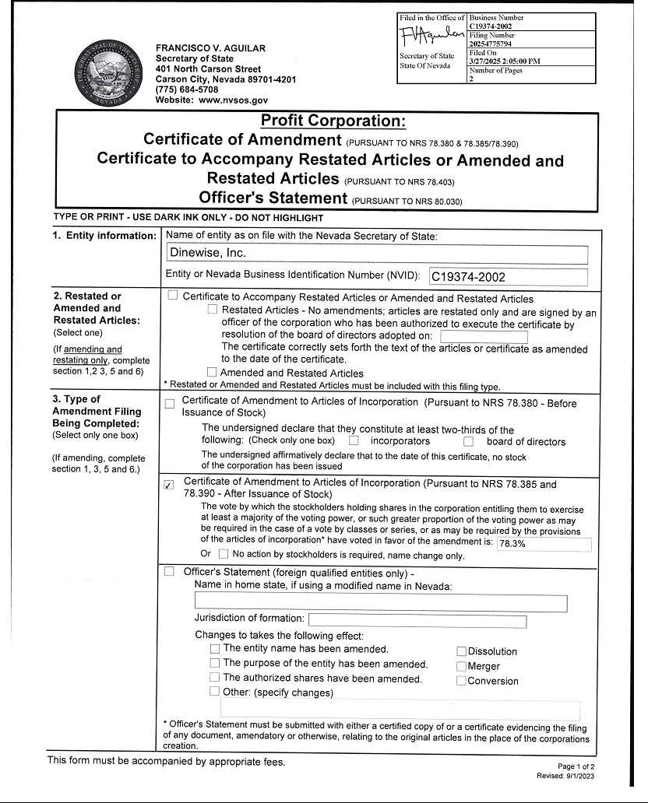

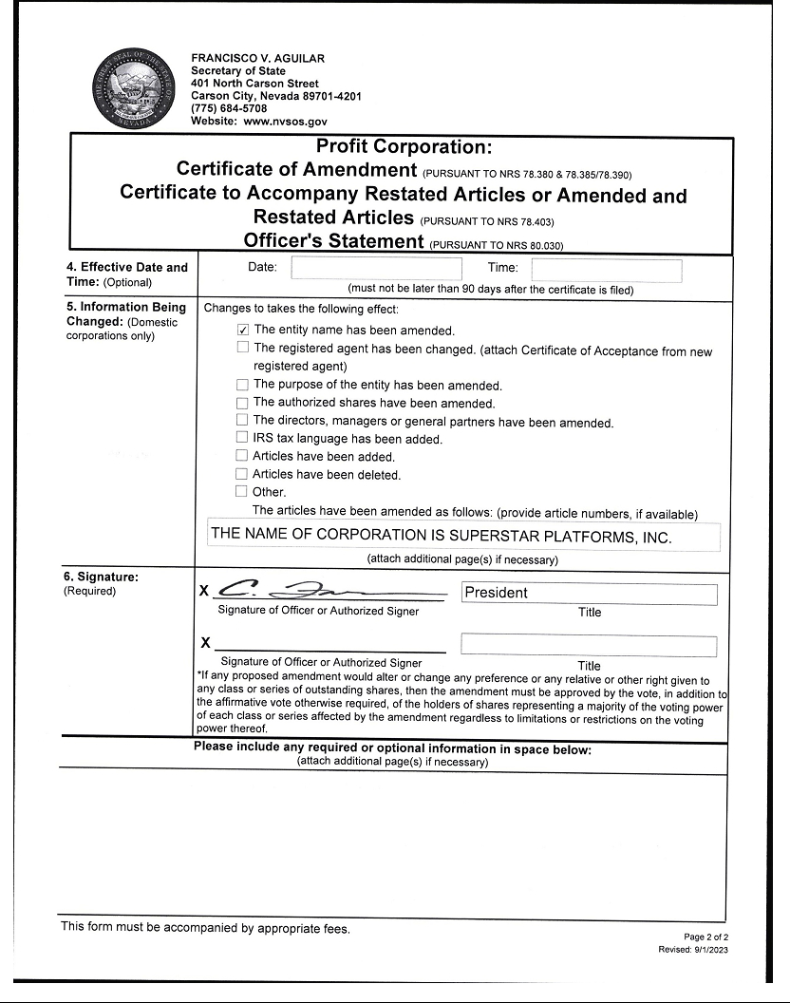

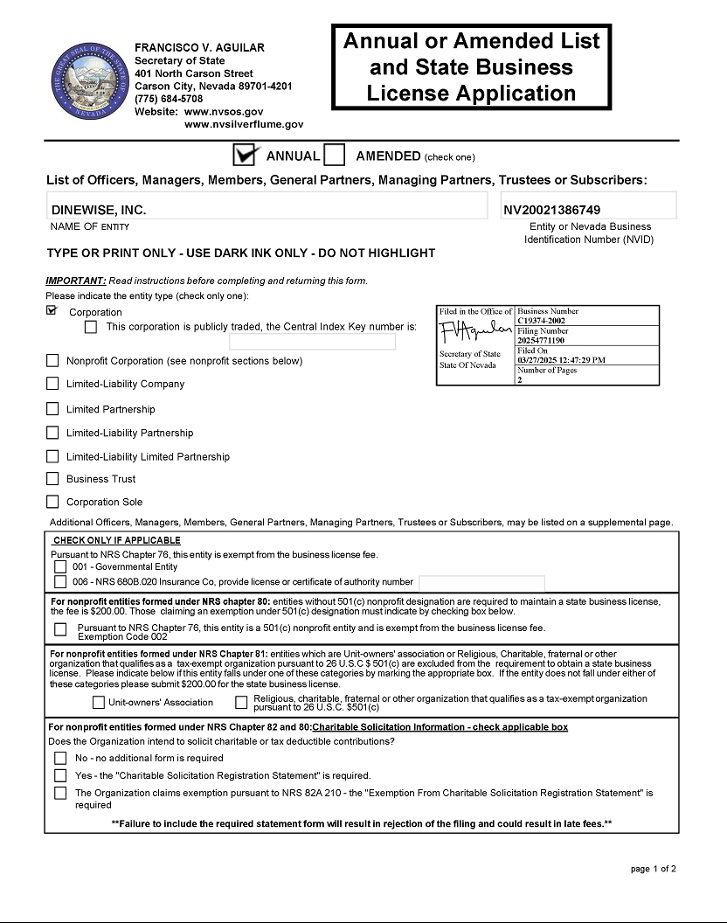

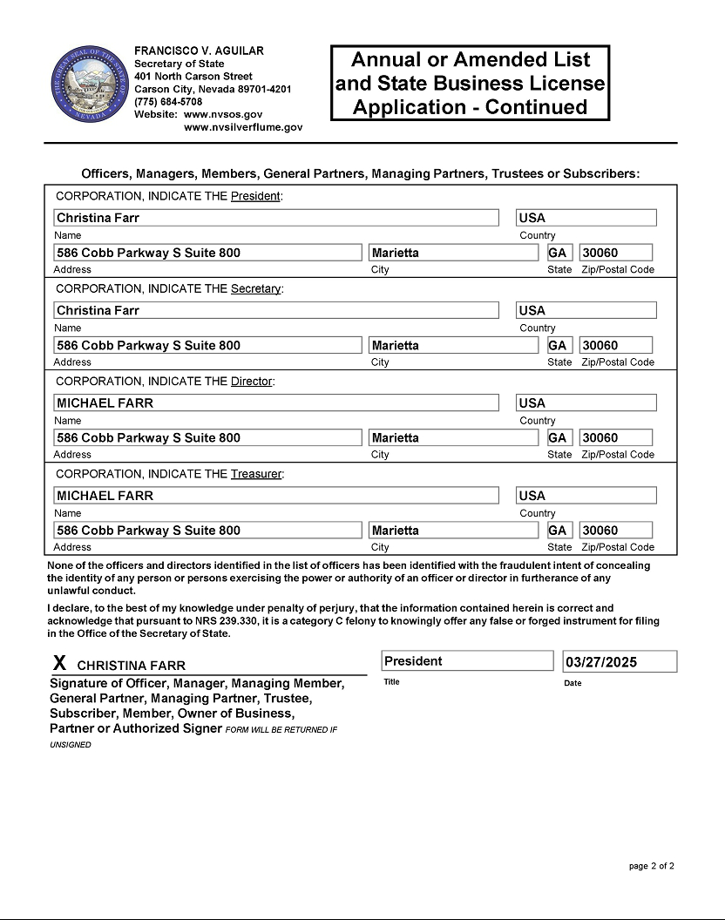

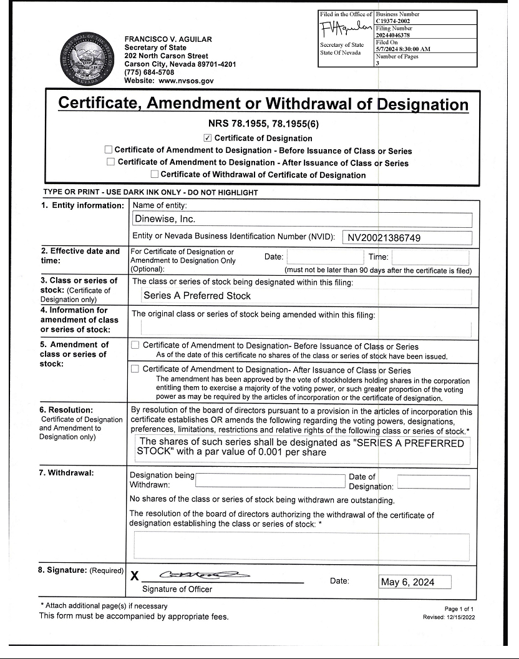

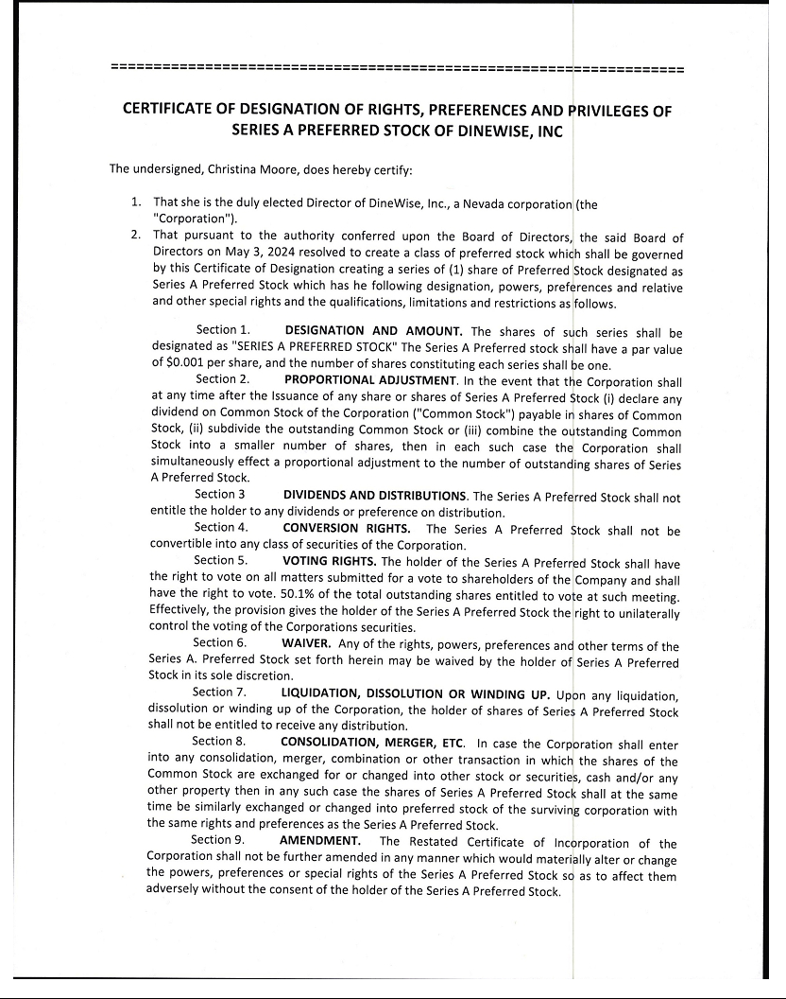

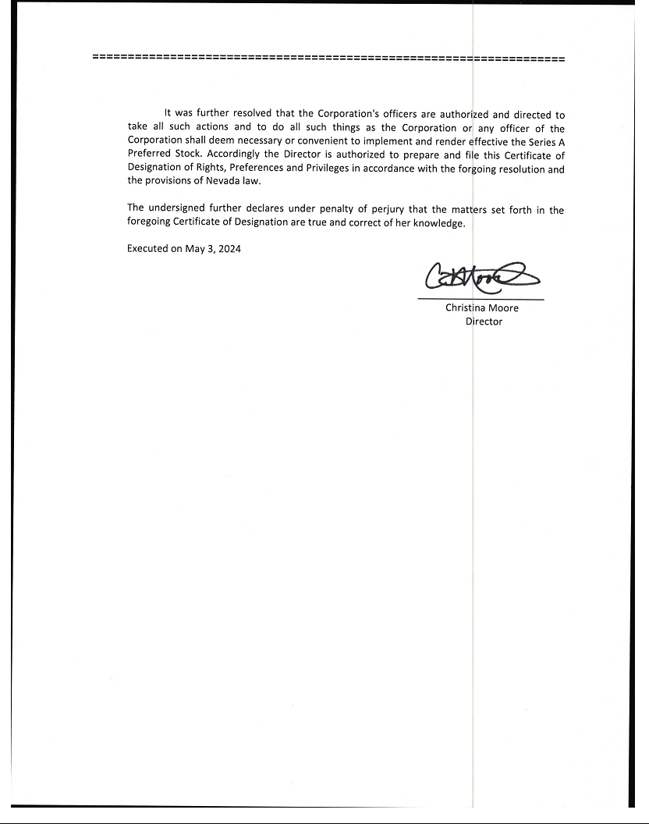

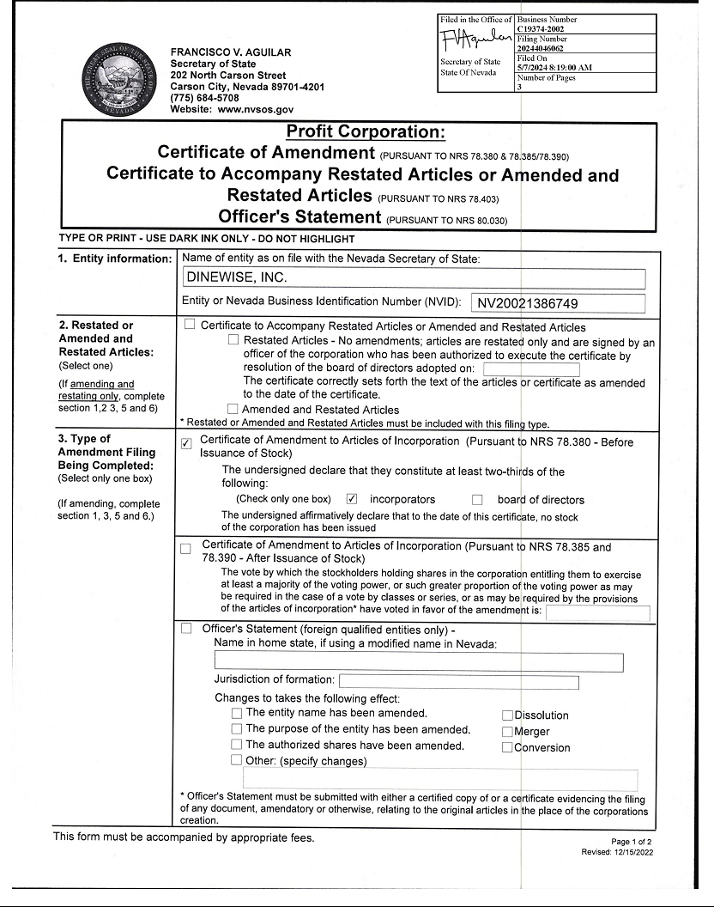

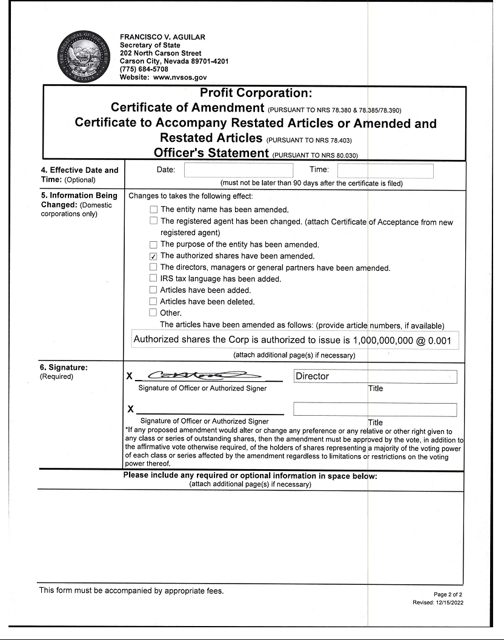

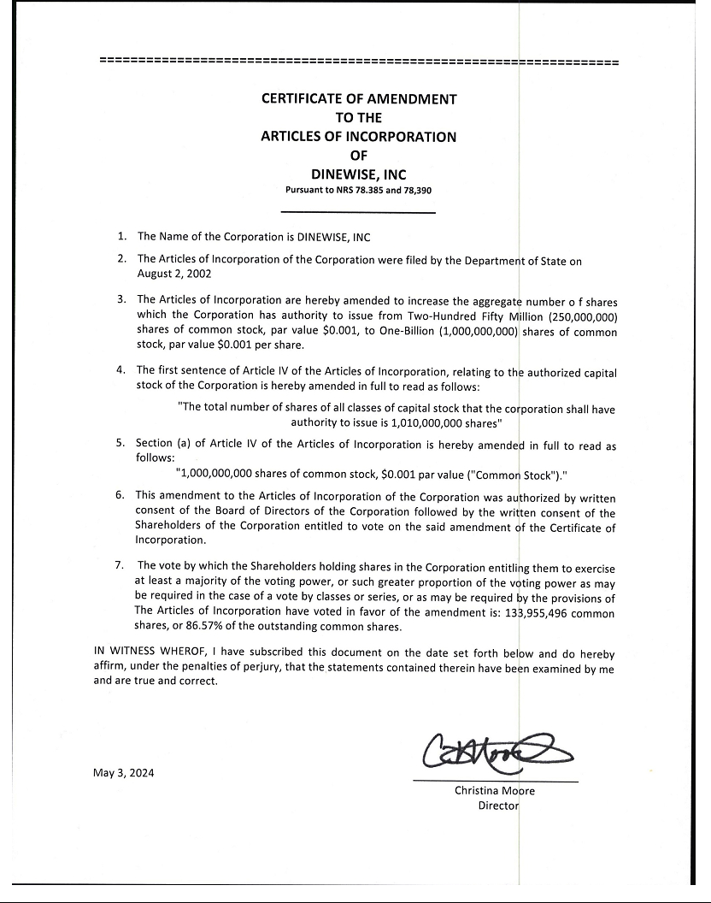

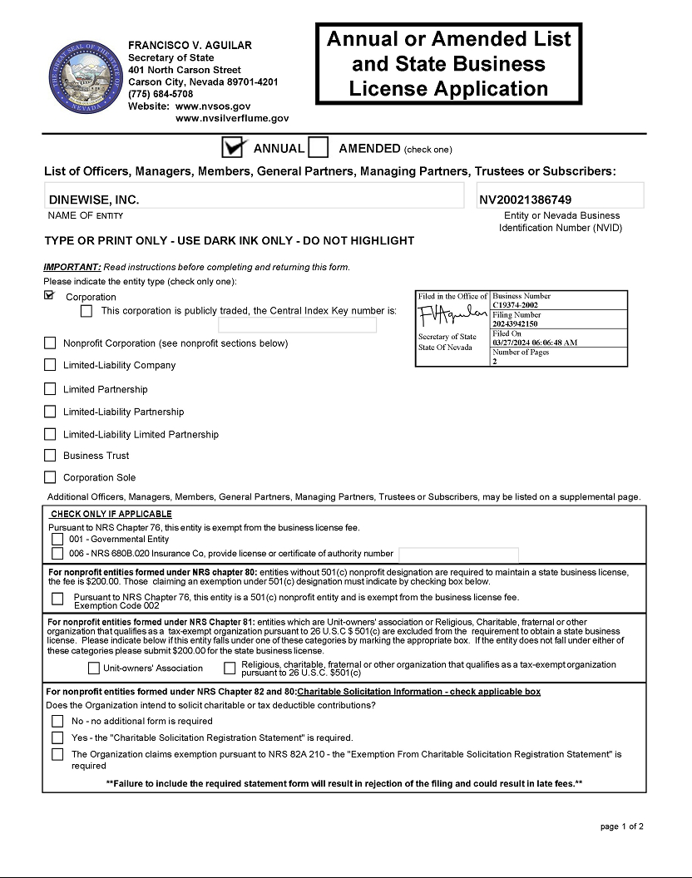

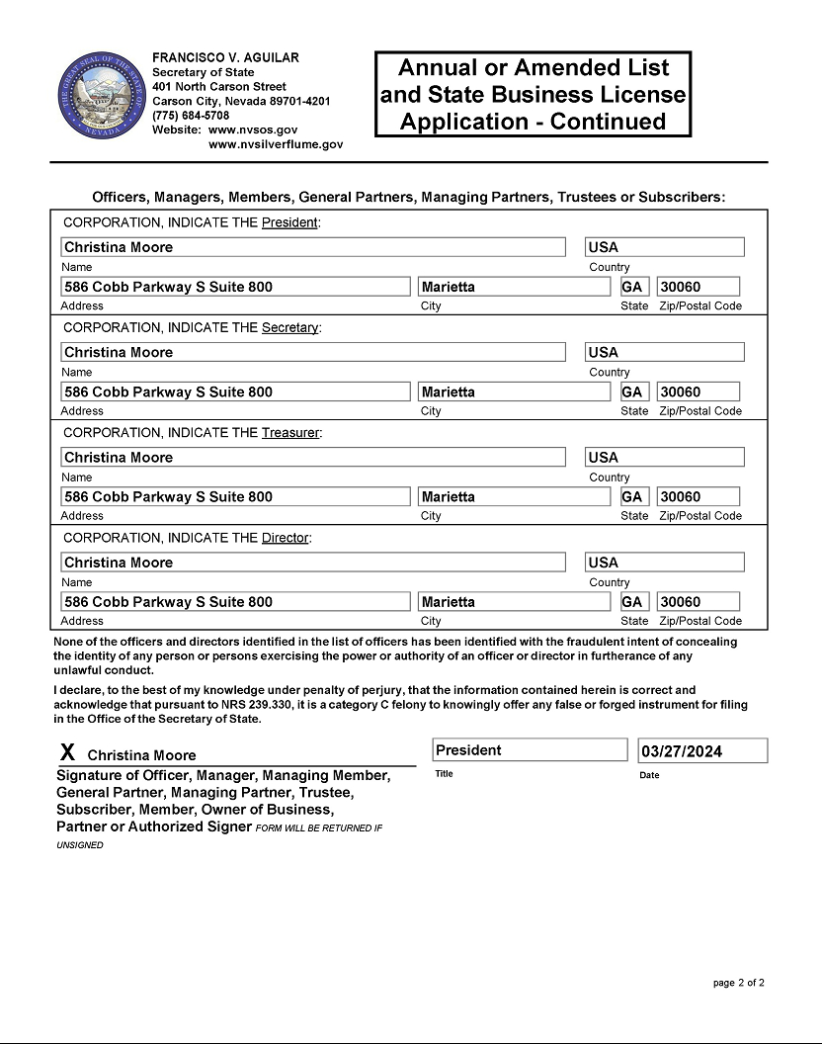

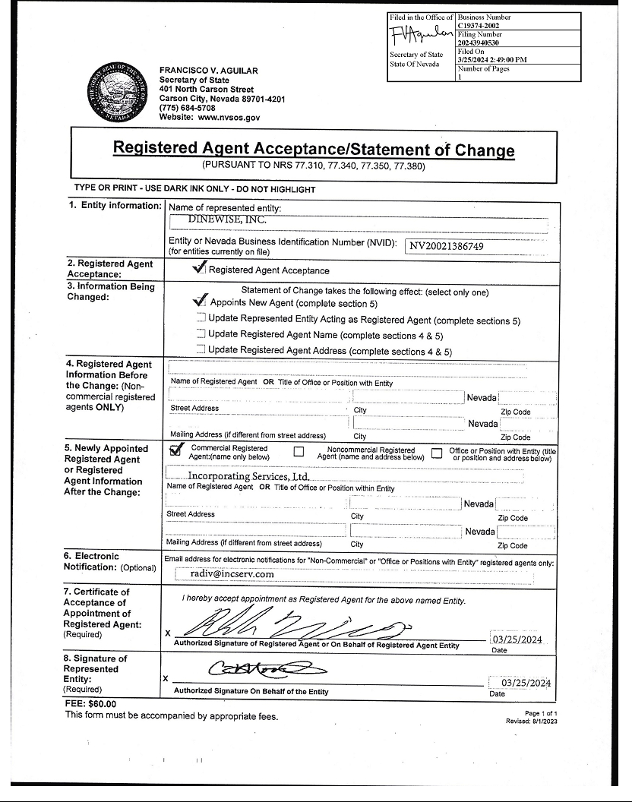

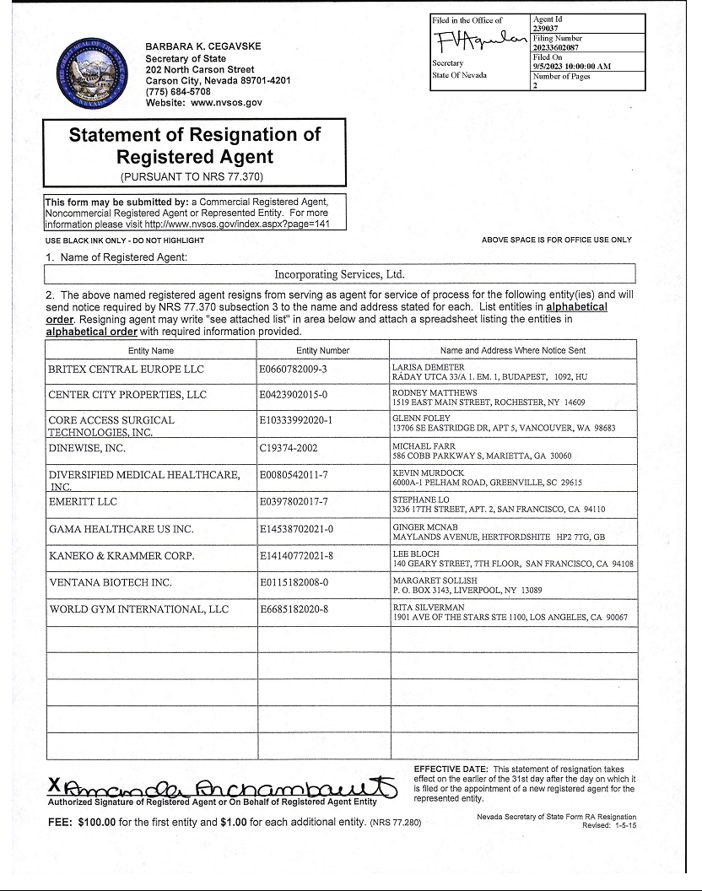



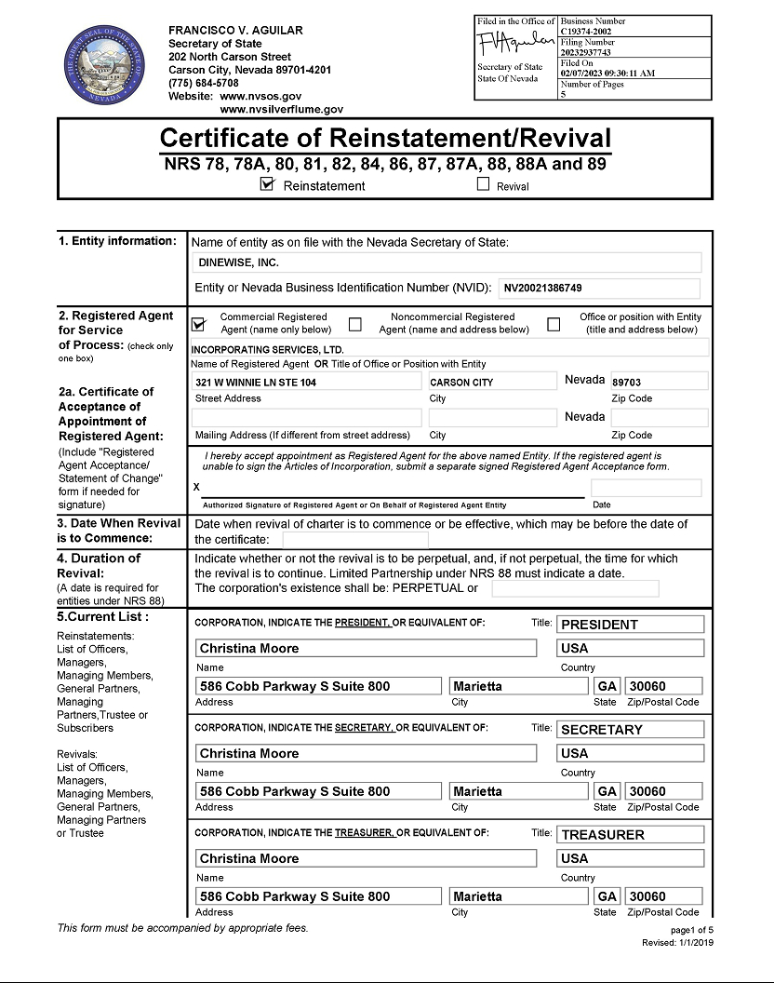

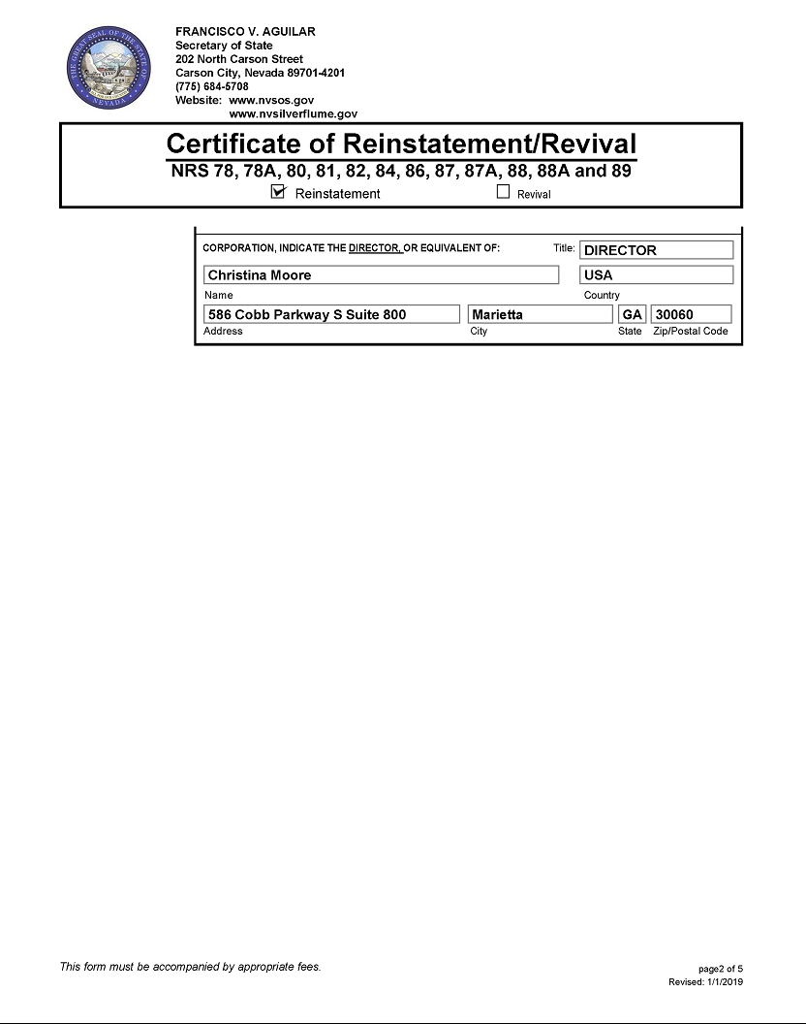

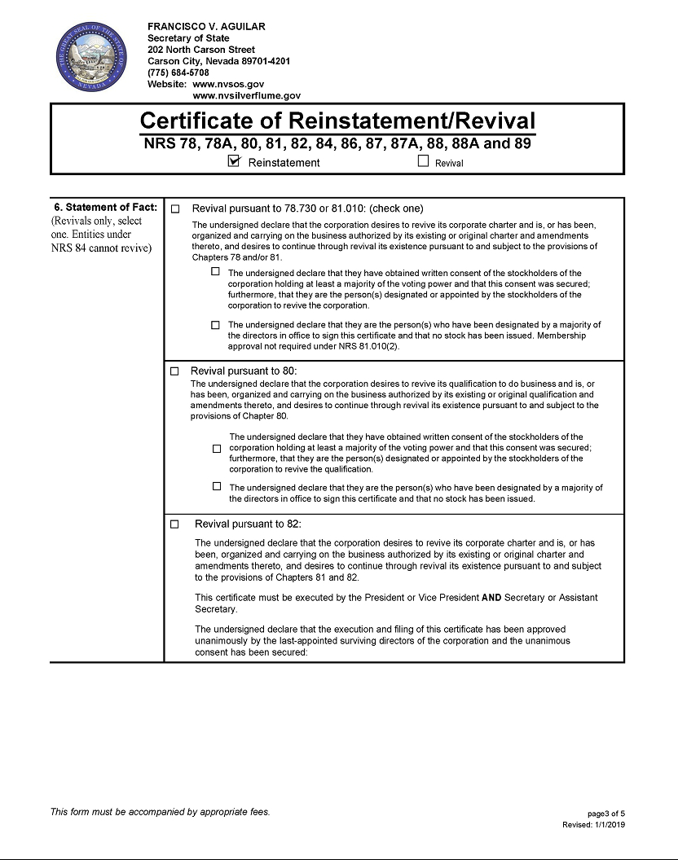

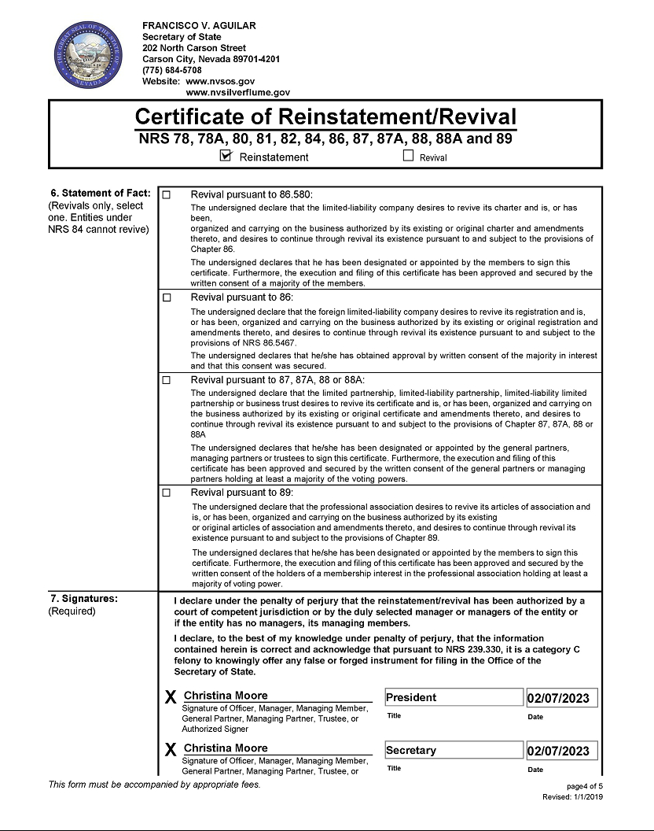

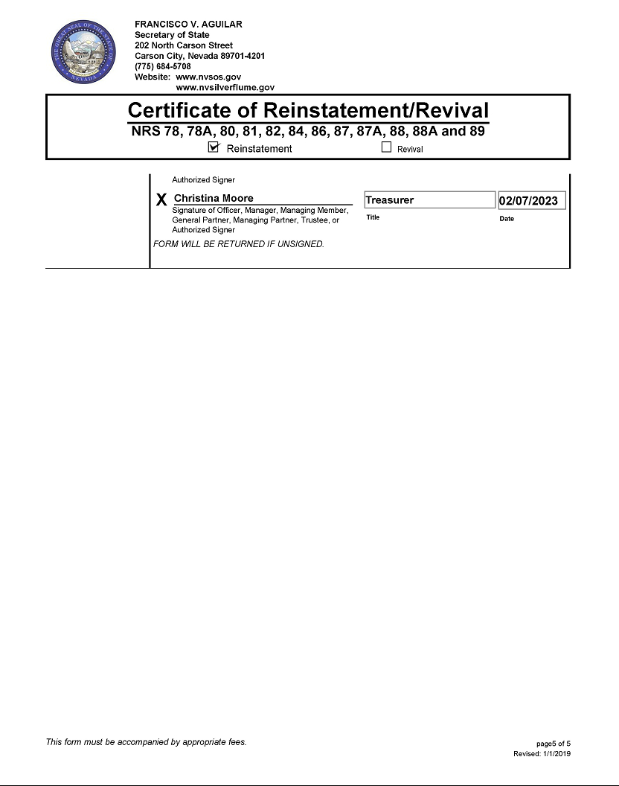

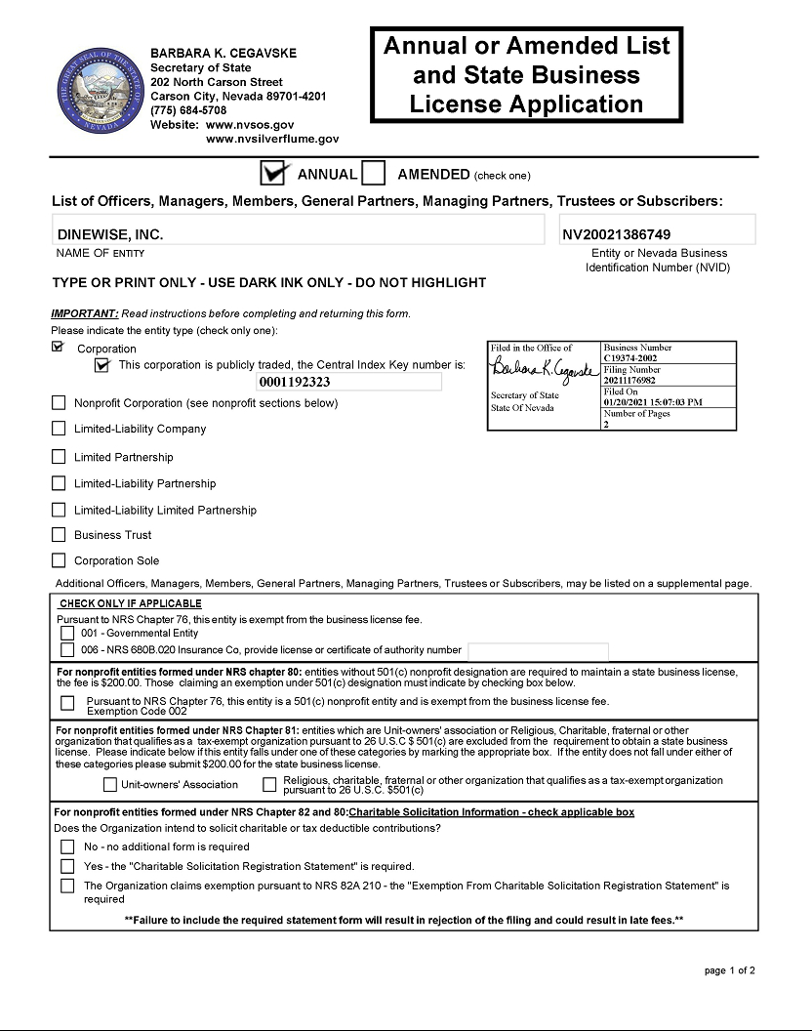

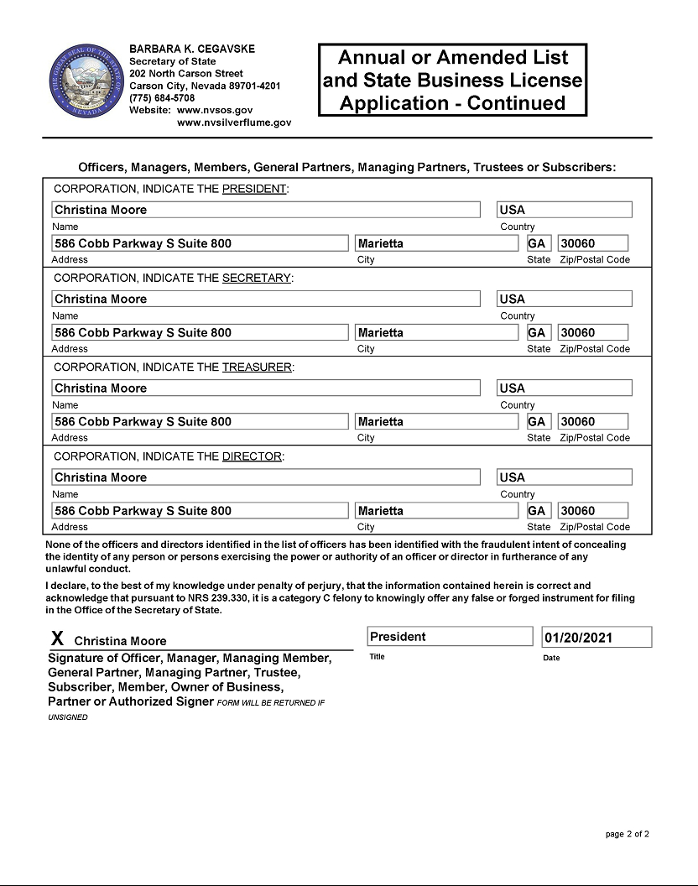

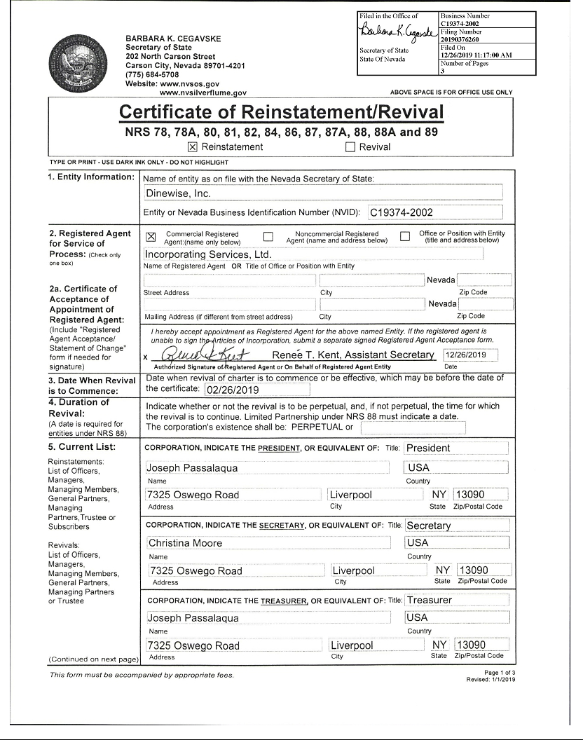

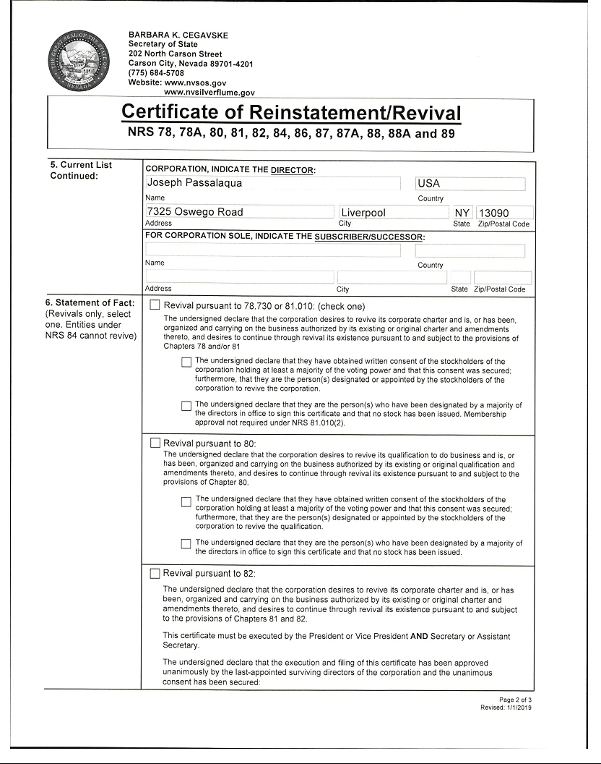

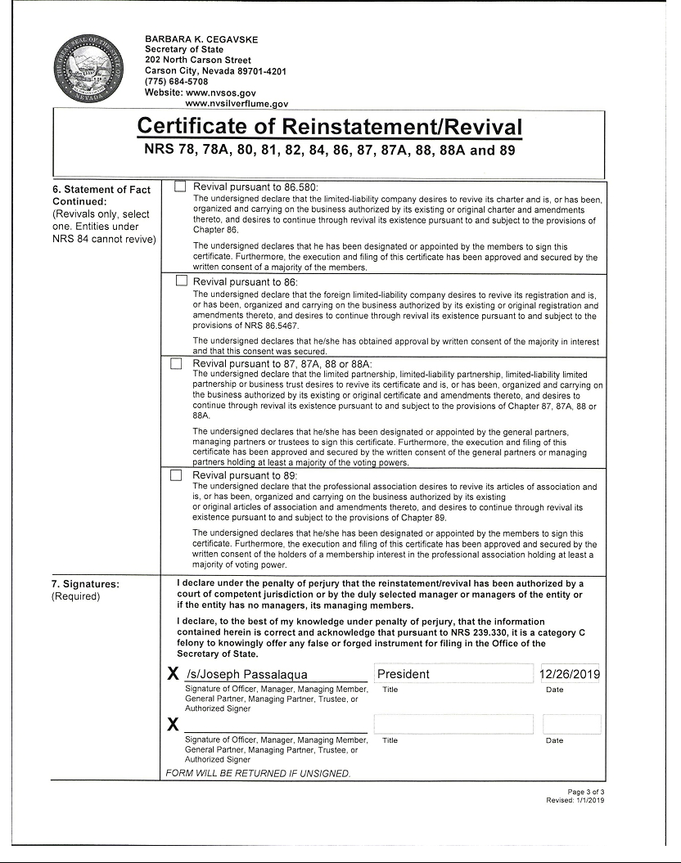

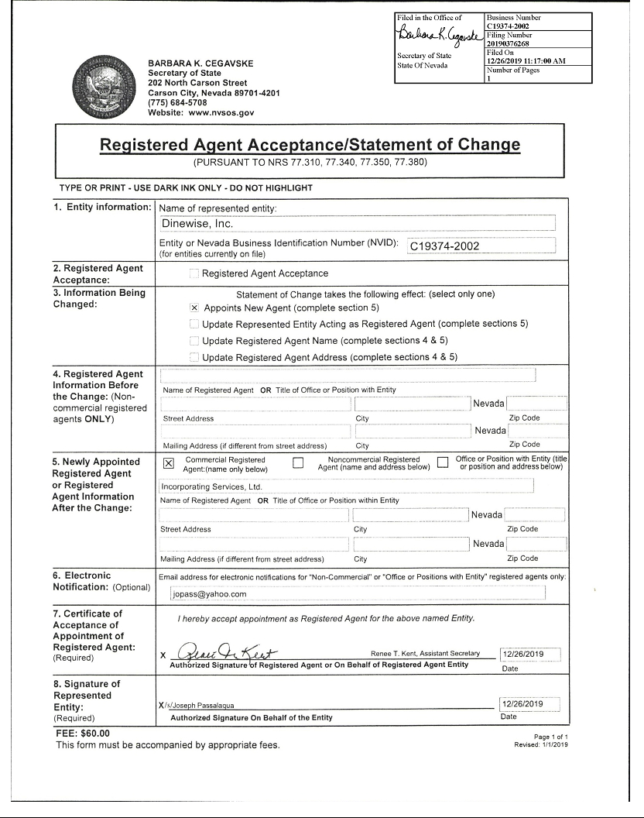

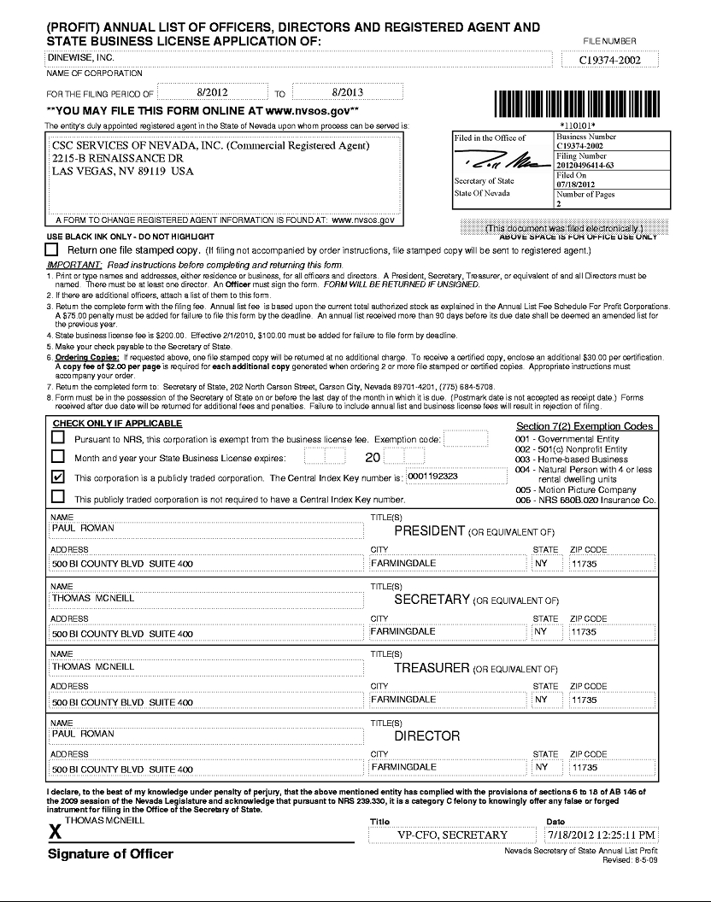

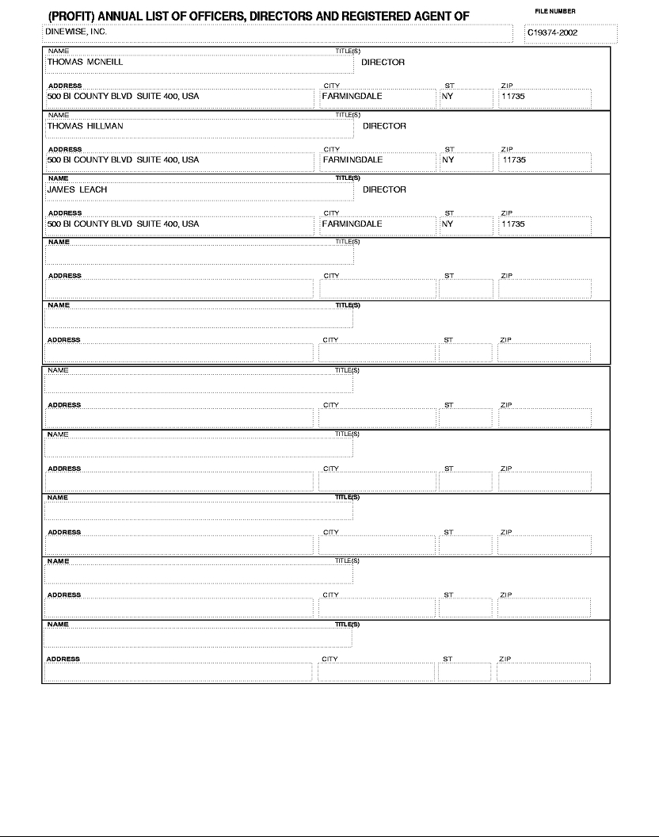

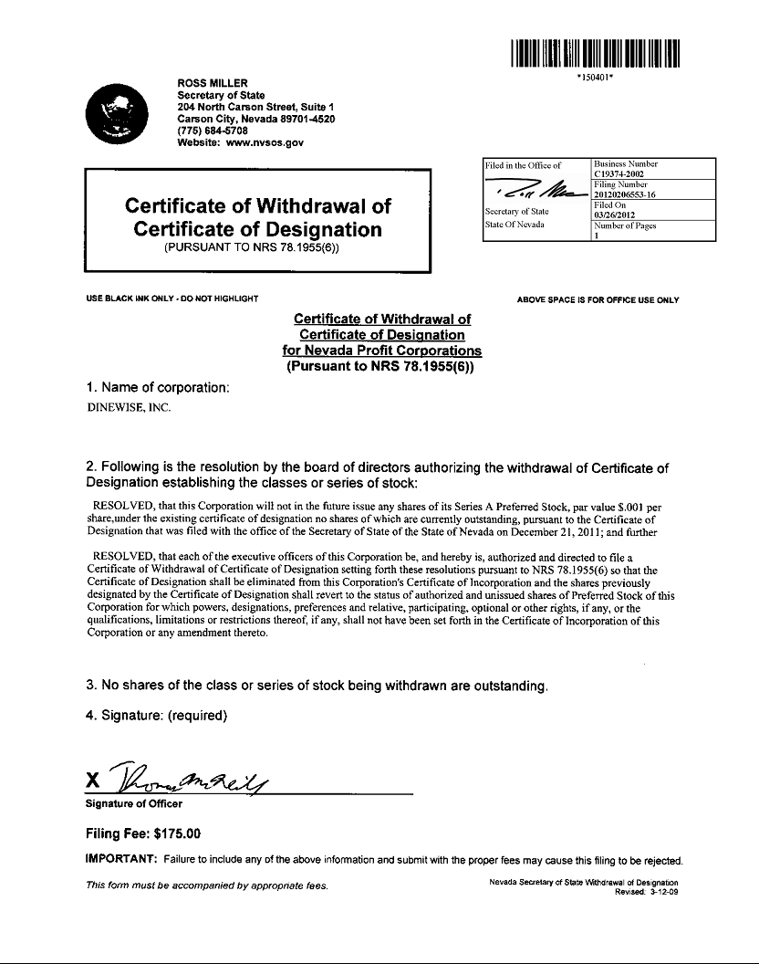

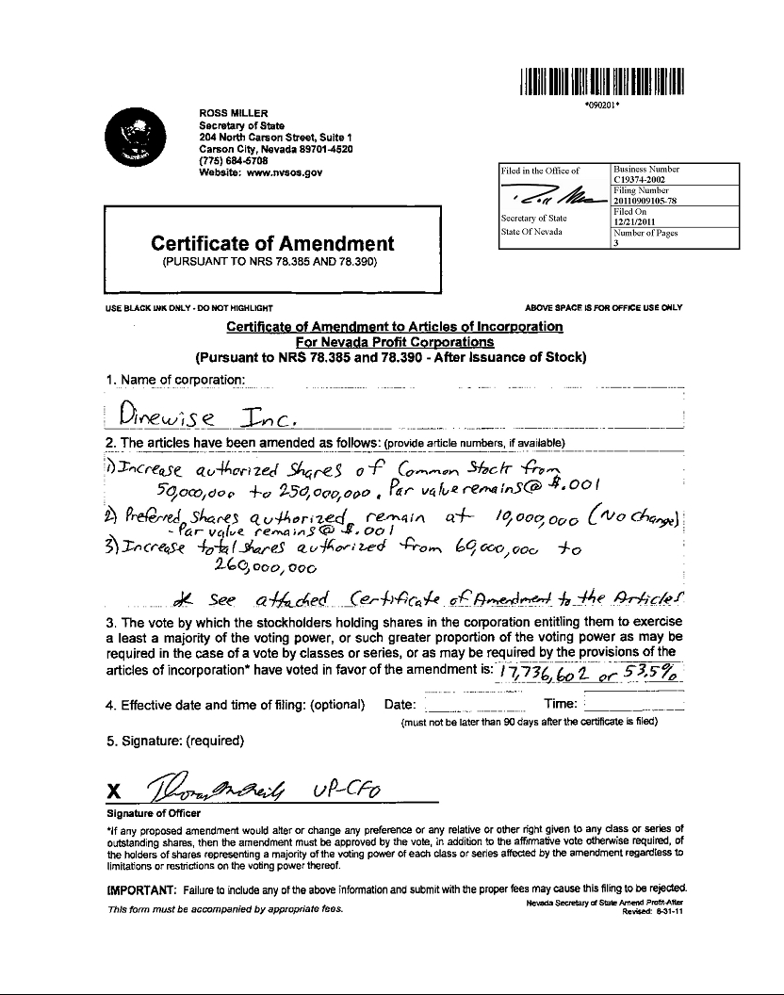

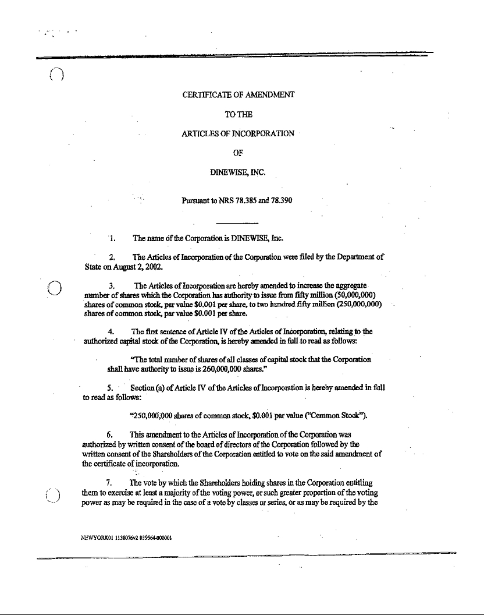

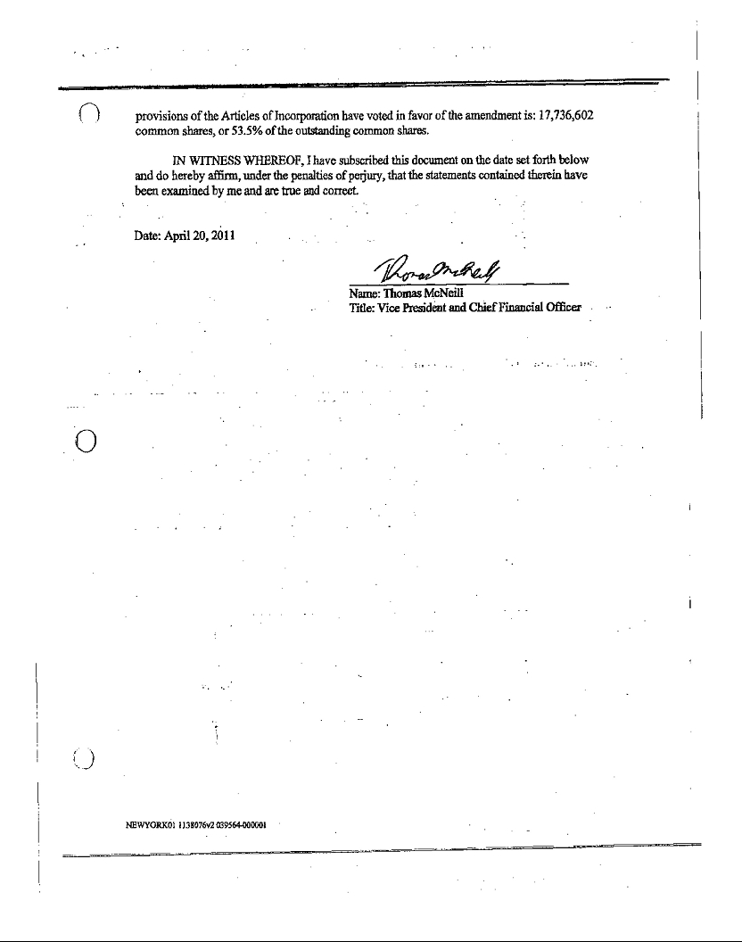

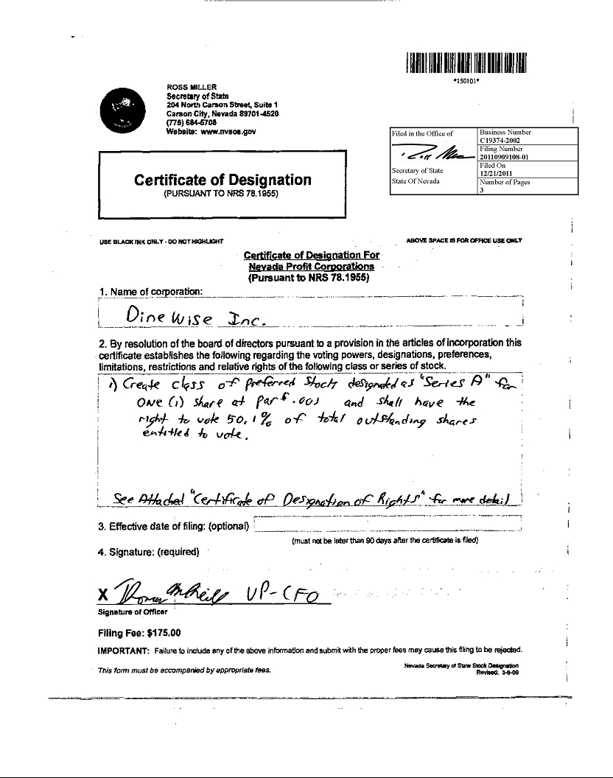

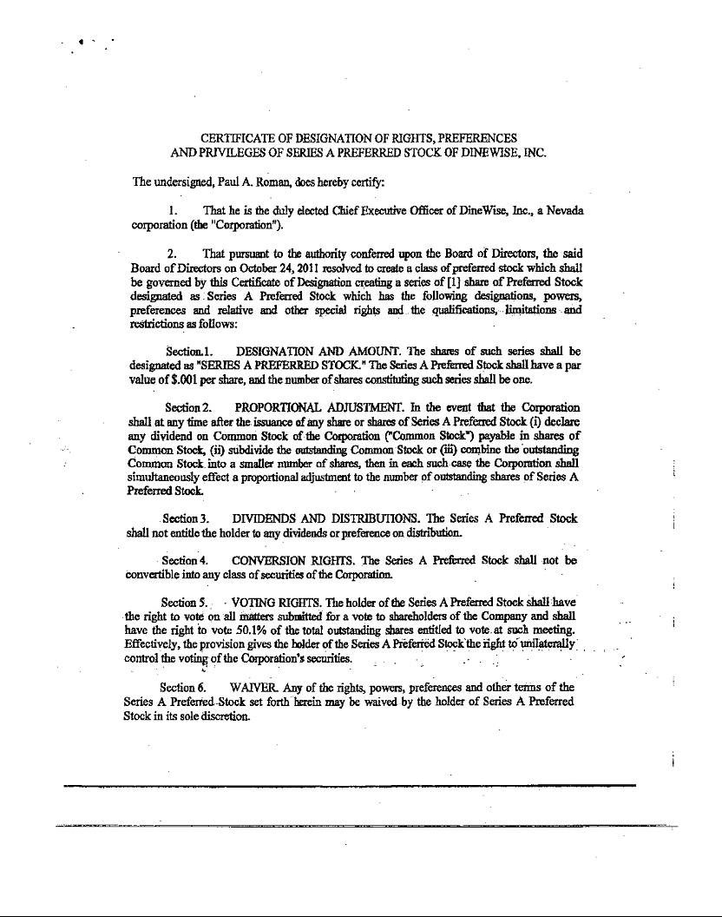

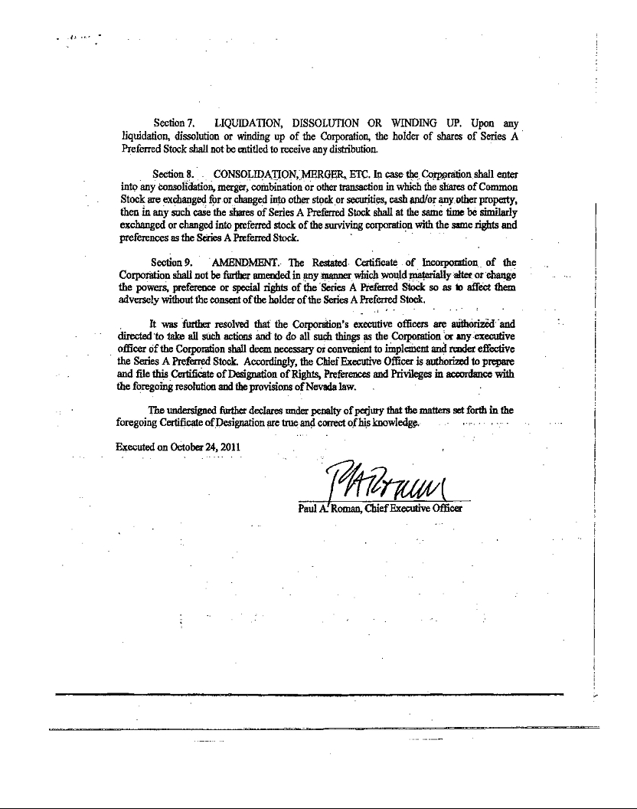

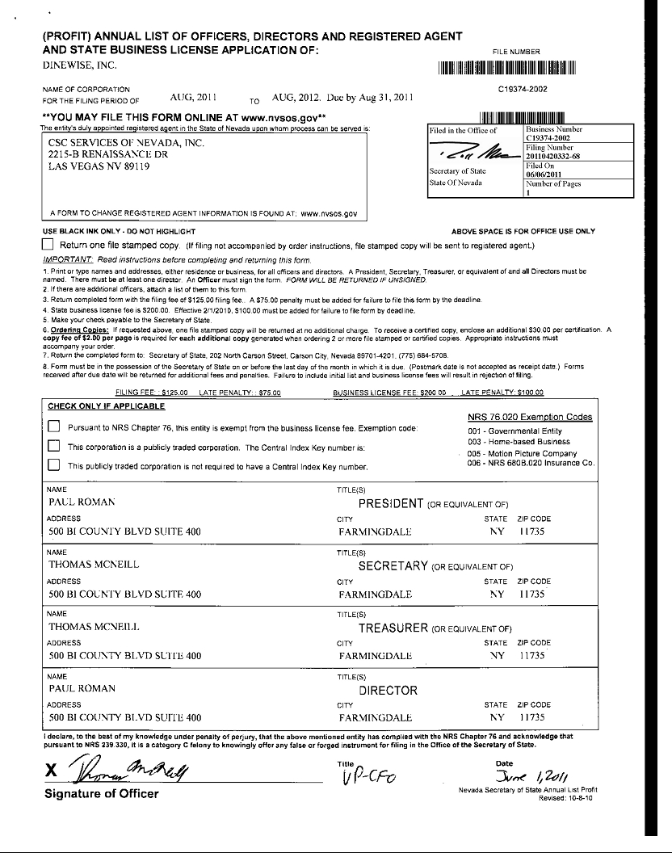

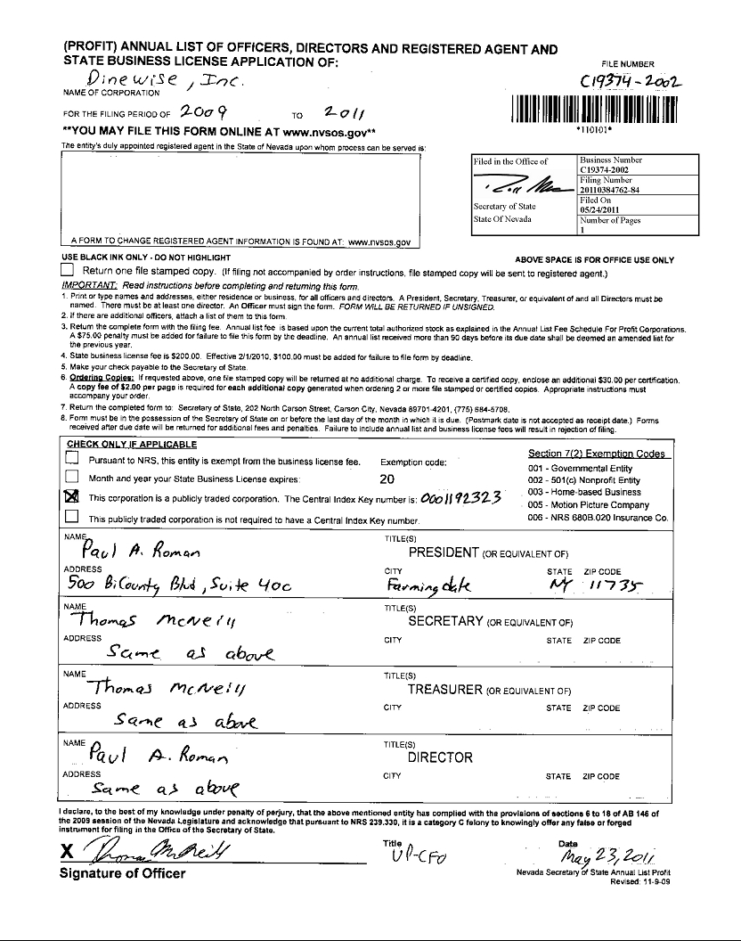

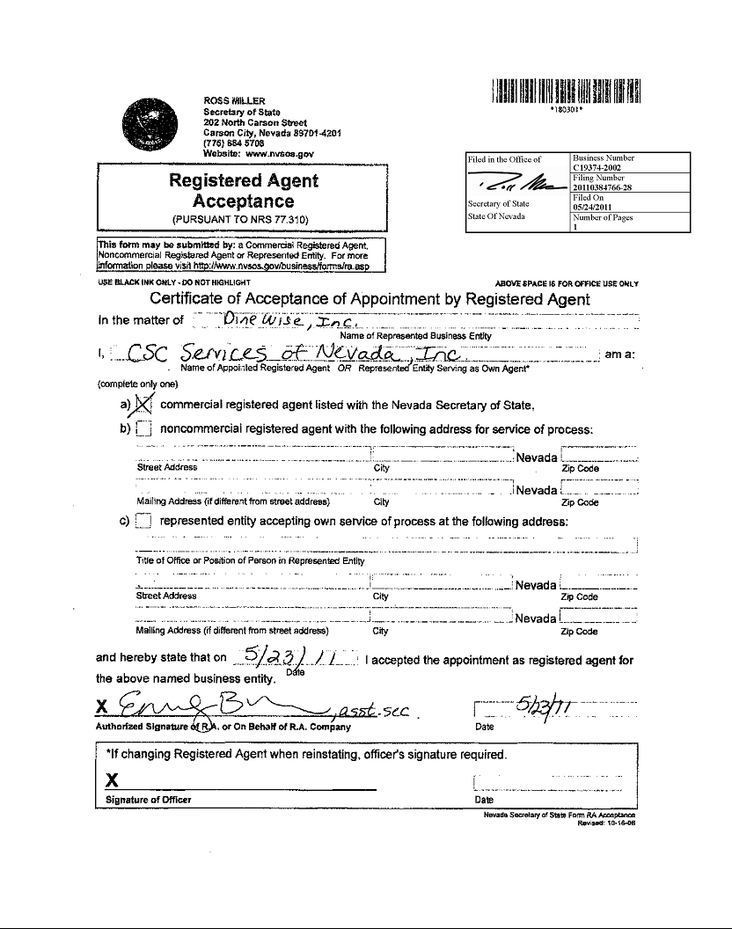

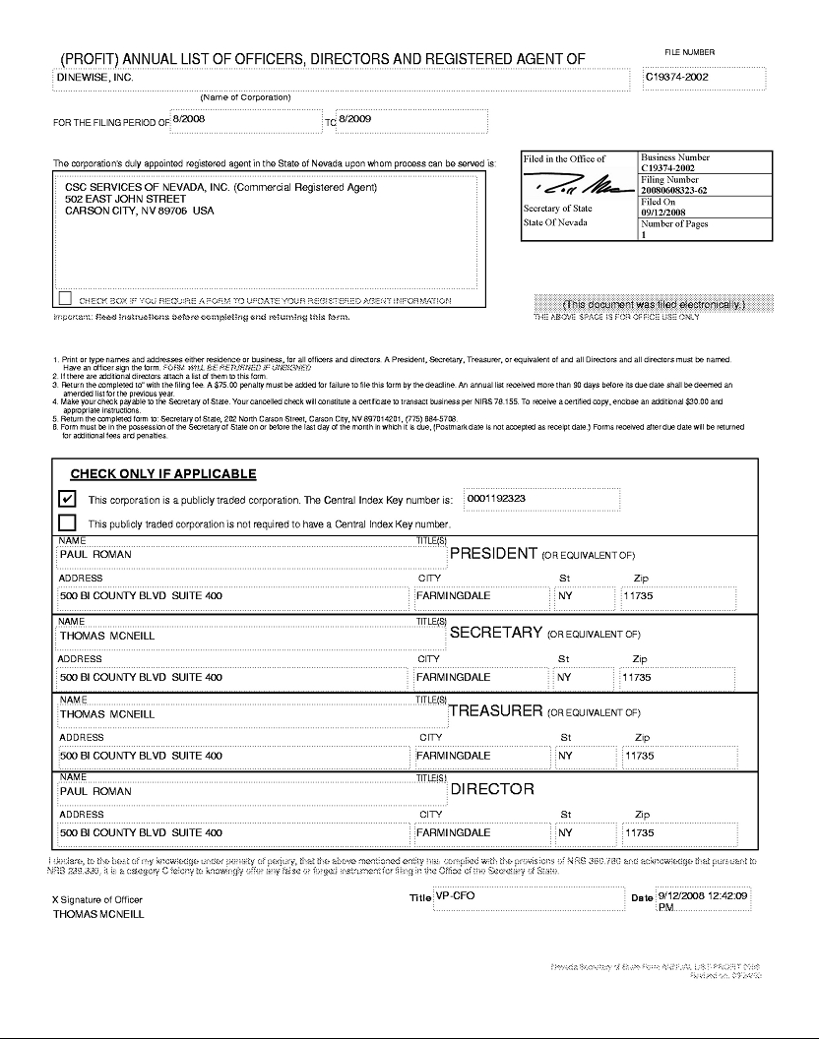

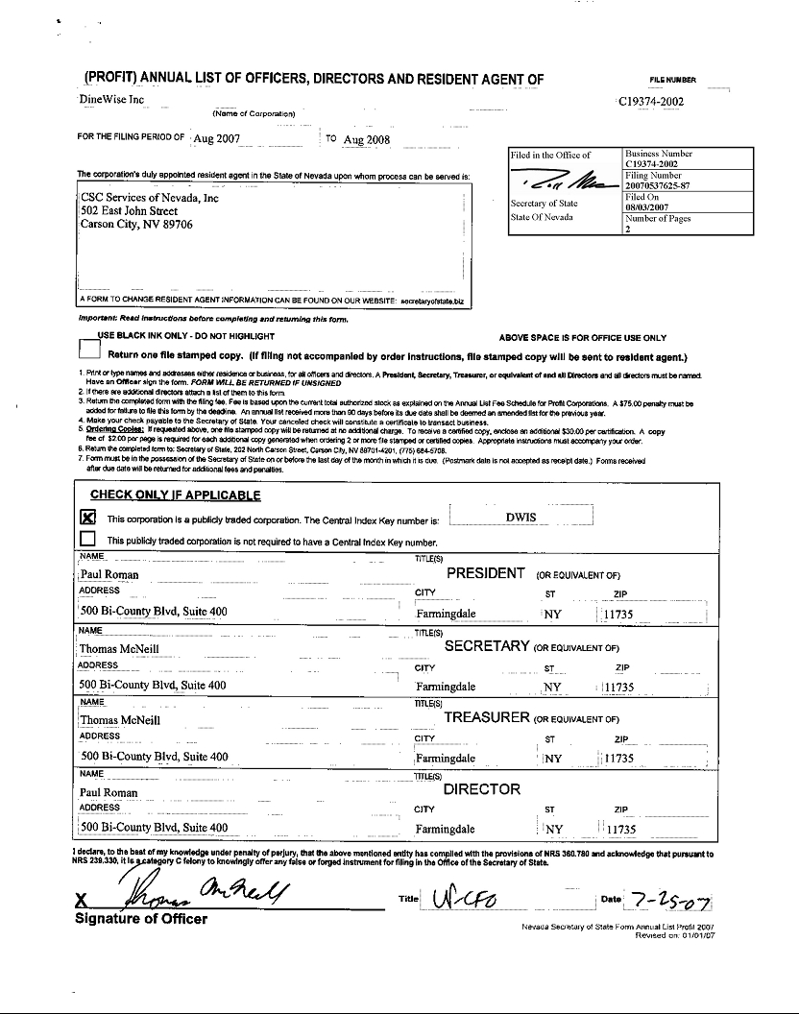

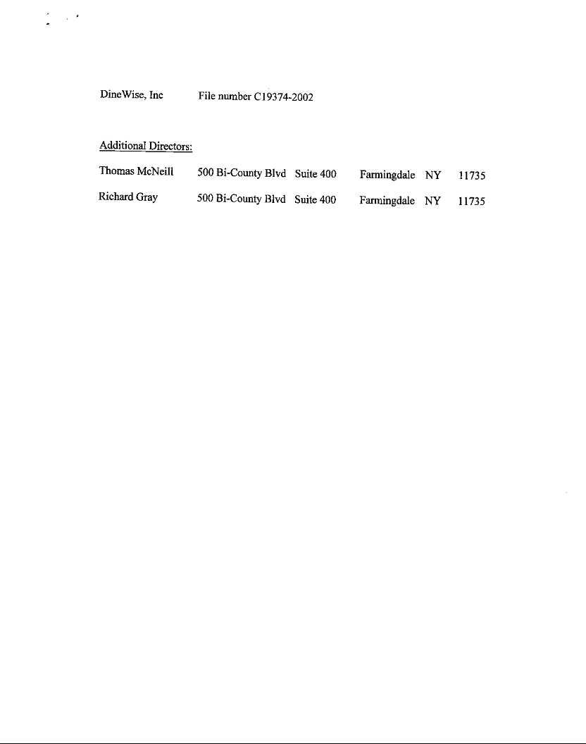

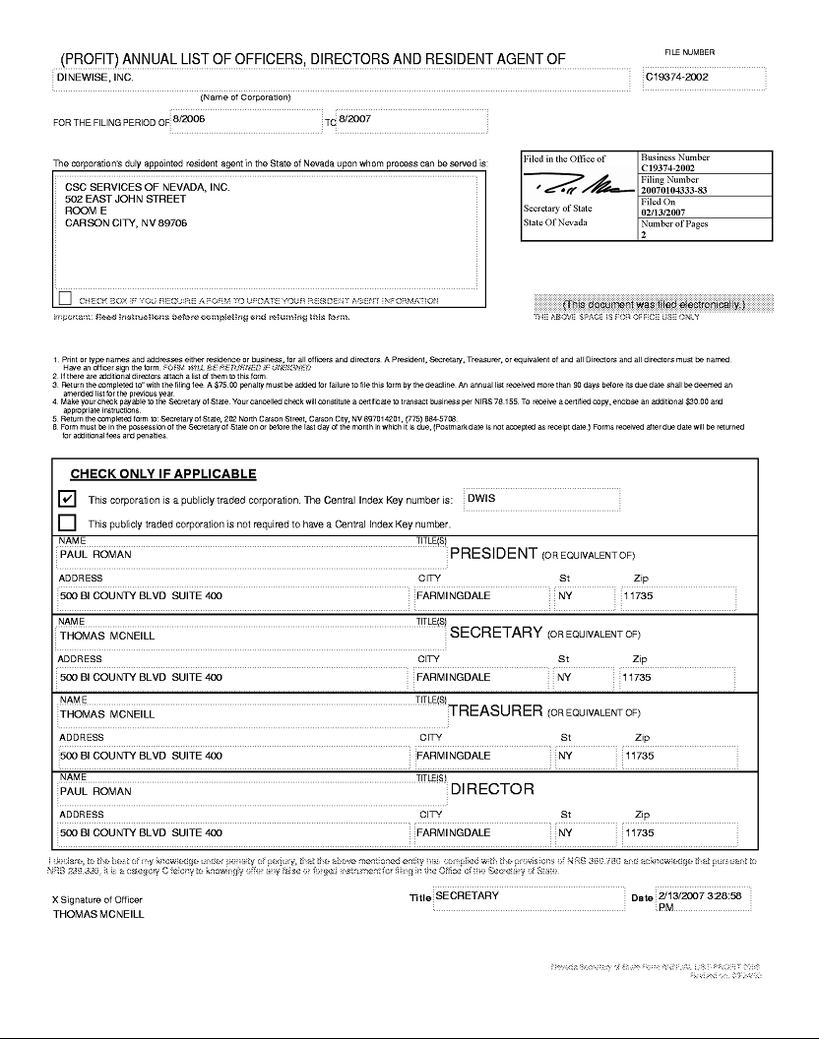

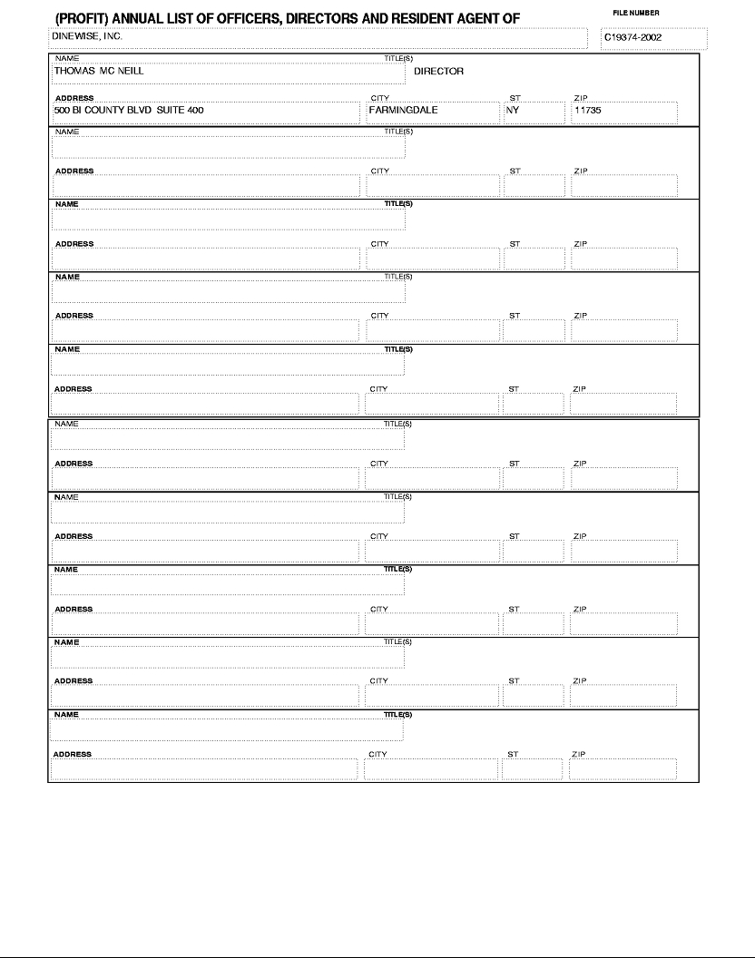

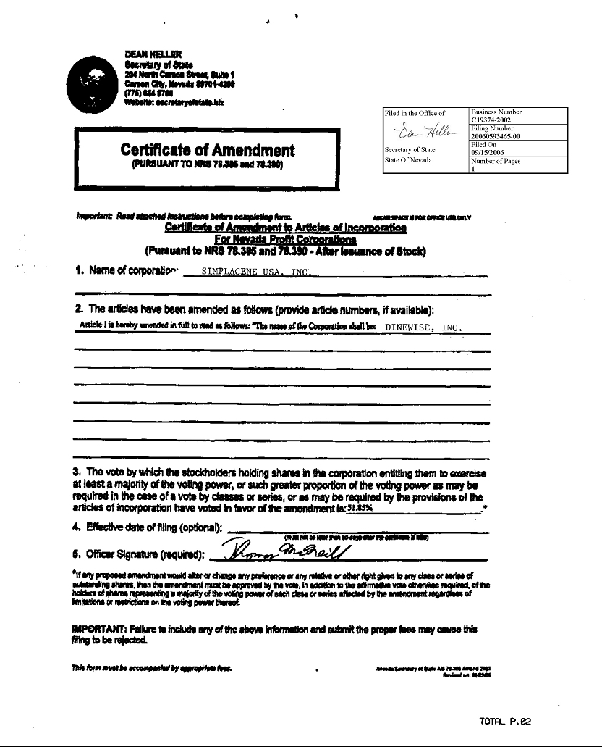

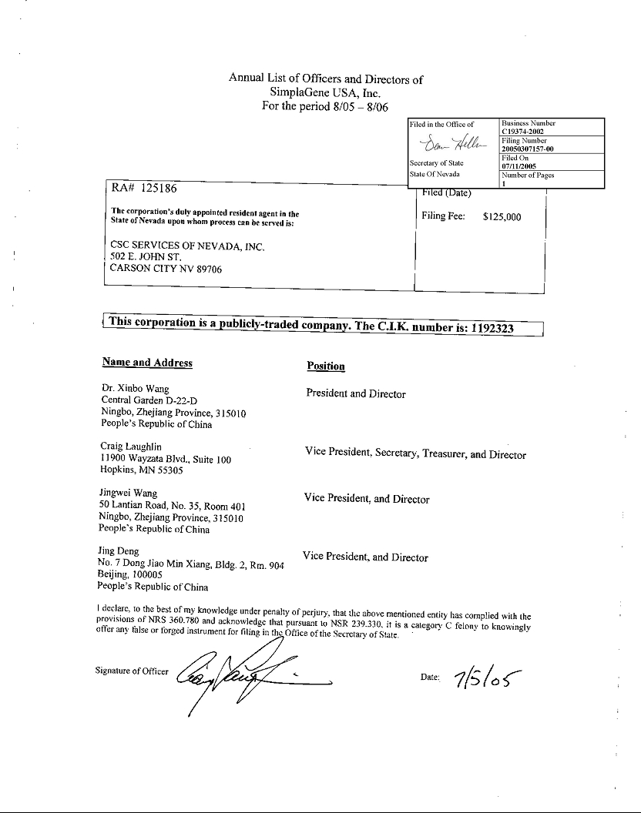

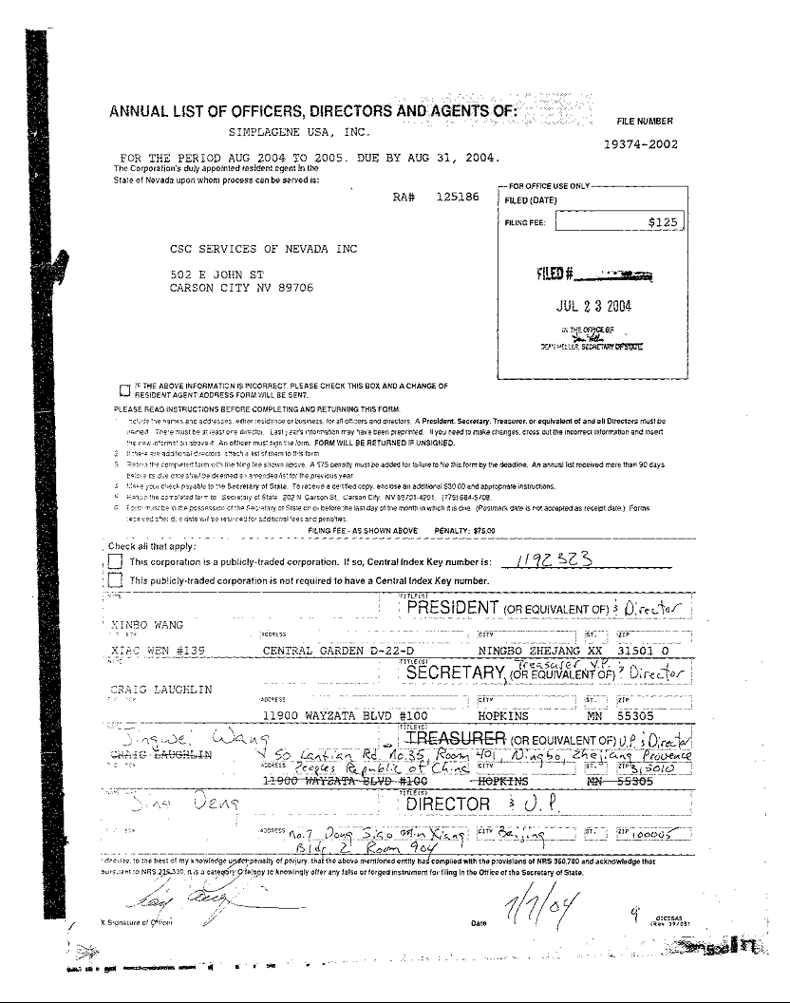

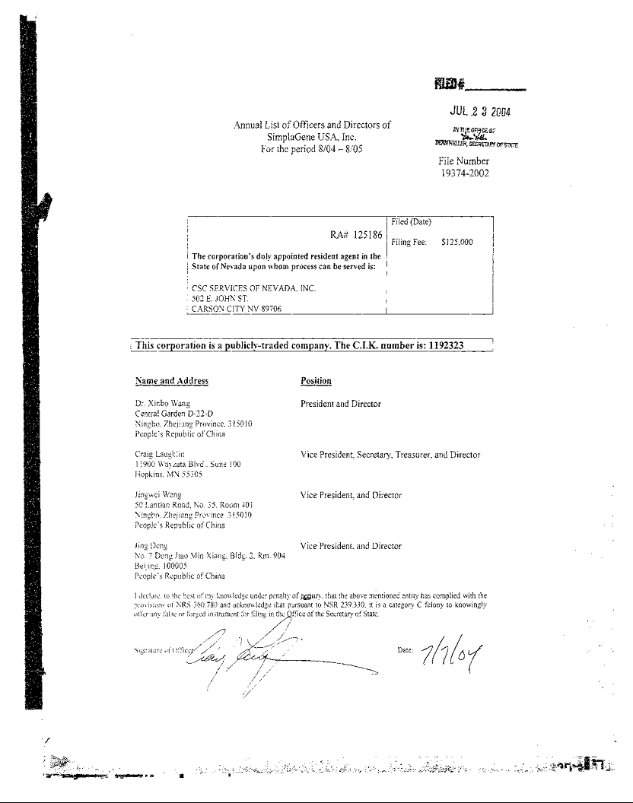

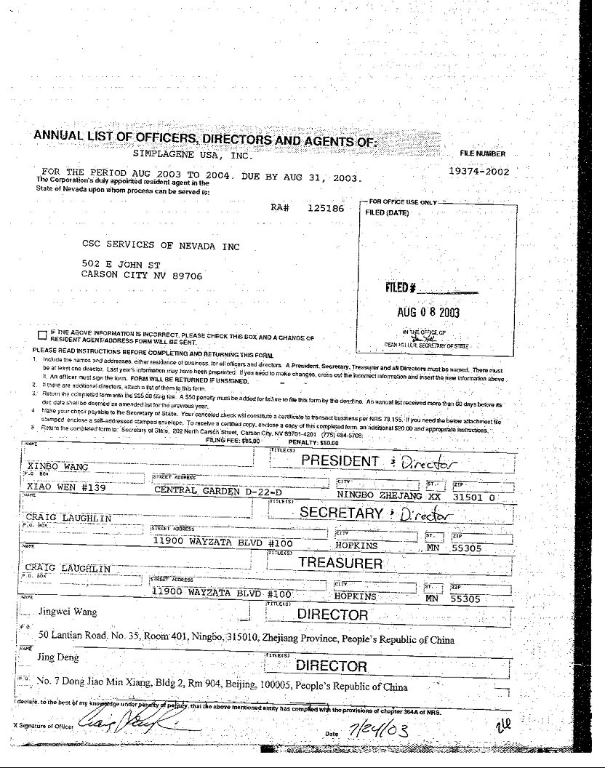



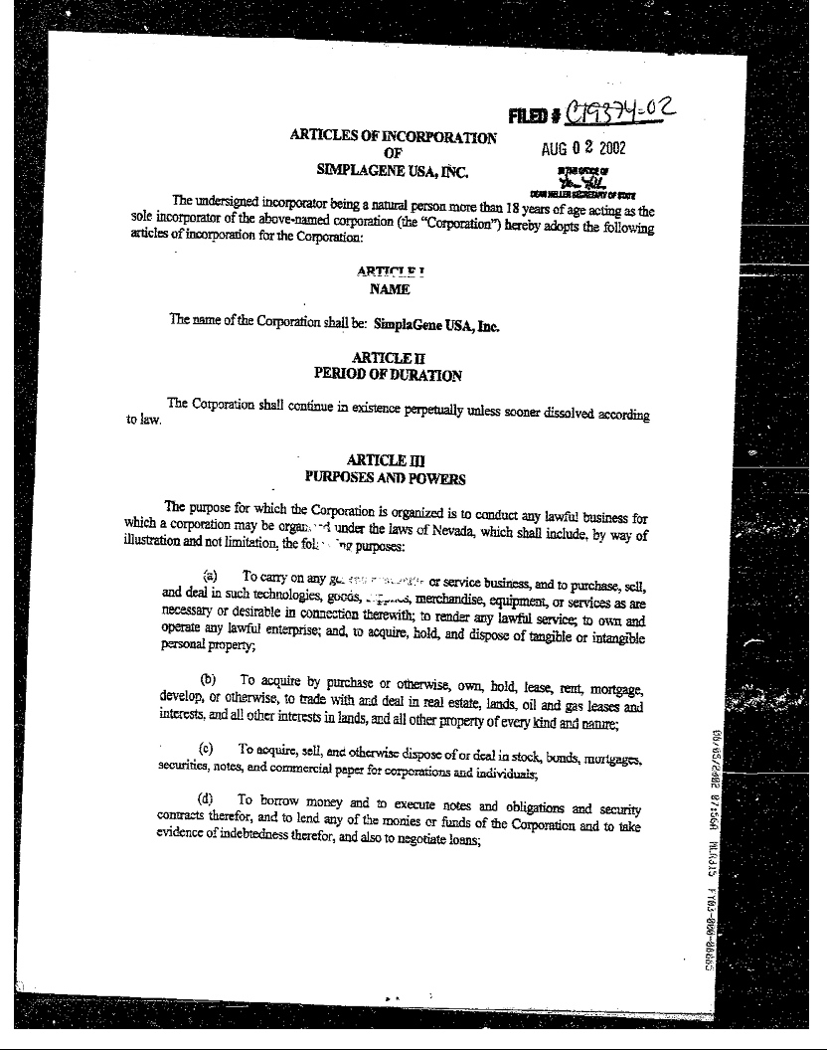

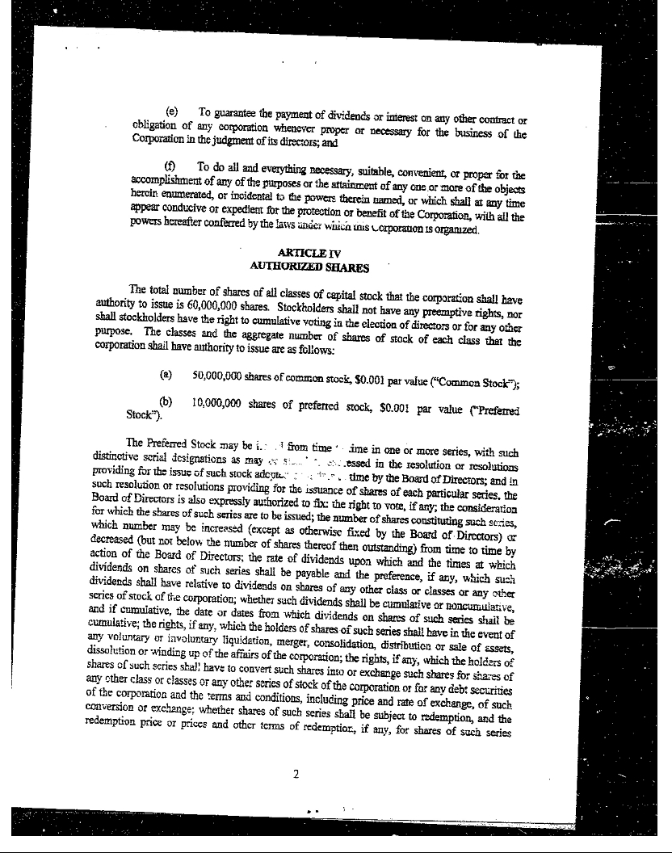

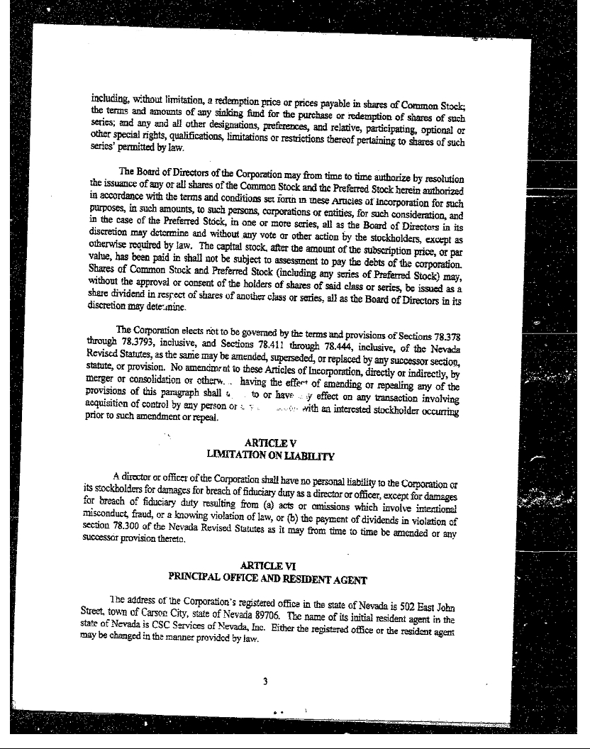

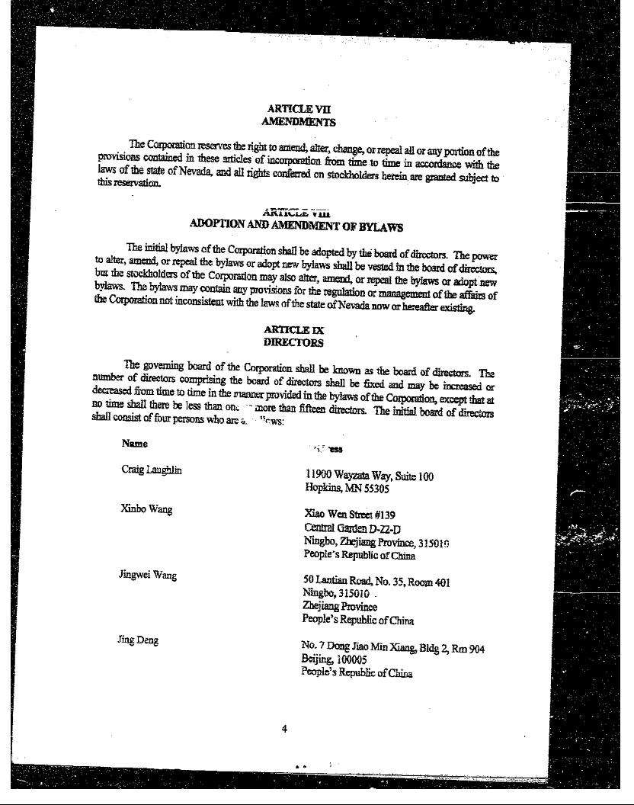

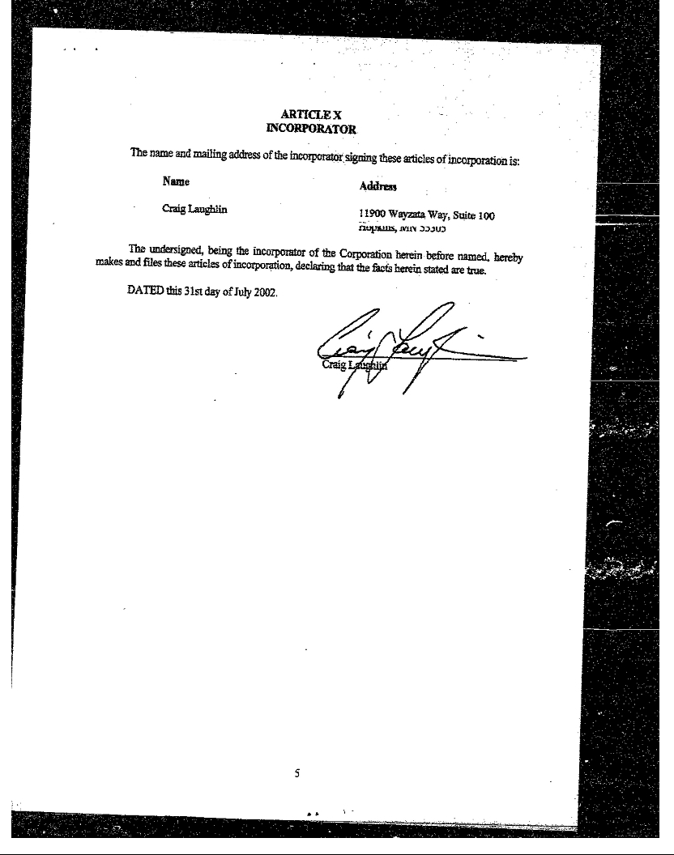



EXHIBIT B

CORPORATE BYLAWS

OF

SUPERSTAR PLATFORMS, INC.

ARTICLE I – OFFICES

Section 1. Principal Office

The principal office of the Corporation shall be located at such place as the Board of Directors may determine within or outside the State of Nevada.

Section 2. Other Offices

The Corporation may have such other offices as the Board of Directors may determine or the business may require.

ARTICLE II – STOCKHOLDERS

Section 1. Annual Meeting

The annual meeting of the stockholders shall be held each year on a date and at a time fixed by the Board of Directors for the purpose of electing directors and transacting other corporate business.

Section 2. Special Meetings

Special meetings of stockholders may be called by the Chairperson of the Board, Chief Executive Officer, a majority of the Board of Directors, or stockholders holding not less than 10% of all outstanding shares entitled to vote.

Section 3. Place of Meetings

Meetings of the stockholders shall be held at the principal office of the Corporation or at such other place (including remote communication, if authorized) as the Board may designate.

Section 4. Notice of Meetings

Notice shall be given not less than 10 nor more than 60 days before the date of the meeting. Notice may be given electronically to shareholders consenting thereto.

Section 5. Quorum

Unless otherwise required by law or the Articles of Incorporation, a quorum shall consist of a majority of shares entitled to vote.

Exhibit B (Cont’d)

Section 6. Voting Rights

Each outstanding share shall be entitled to one vote. Action is taken by a majority of votes cast unless a greater requirement is imposed by law or the Articles of Incorporation.

ARTICLE III – BOARD OF DIRECTORS

Section 1. General Powers

The business and affairs of the Corporation shall be managed by its Board of Directors, except as may be otherwise provided by law or the Articles of Incorporation.

Section 2. Number and Qualifications

The number of directors shall be fixed from time to time by resolution of the Board. Directors need not be Nevada residents or shareholders.

Section 3. Term of Office

Directors shall serve until the next annual meeting of stockholders and until their successors are duly elected and qualified.

Section 4. Meetings

Regular meetings of the Board may be held without notice. Special meetings require 24 hours’ notice unless waived.

Section 5. Quorum and Voting

A majority of directors shall constitute a quorum. The act of a majority of the directors present at a meeting at which a quorum is present shall be the act of the Board.

Section 6. Committees

The Board may establish one or more committees (e.g., Audit, Compensation, Nominating) and delegate authority to such committees.

Section 7. Action Without Meeting

Any action required or permitted to be taken at a meeting may be taken without a meeting if all directors consent in writing or by electronic transmission.

ARTICLE IV – OFFICERS

Section 1. Officers

The officers shall include at a minimum a Chief Executive Officer, a Secretary, and a Treasurer, and may include a President, one or more Vice Presidents, and such other officers as the Board may appoint.

Exhibit B (Cont’d)

Section 2. Appointment and Term

Officers are elected annually by the Board and serve at its pleasure.

Section 3. Duties of Officers

- Chief Executive Officer (Michael Farr): Has general supervision and control over the business and affairs of the Corporation. Acts as the primary public company representative.

- President (if separate): Handles daily operations and may act in the CEO’s absence.

- Secretary: Maintains corporate records and minutes.

- Treasurer: Responsible for financial management and reporting.

- Additional officers may perform such duties as prescribed by the Board.

ARTICLE V – INDEMNIFICATION

To the fullest extent permitted by Nevada law, the Corporation shall indemnify any person who serves or has served as a director, officer, employee, or agent of the Corporation against all expenses and liabilities incurred in connection with such service.

ARTICLE VI – CAPITAL STOCK

Section 1. Certificates and Uncertificated Shares

Shares of the Corporation may be certificated or uncertificated. All stock issuances shall be recorded in the share register of the Corporation.

Section 2. Transfers

Transfers shall be made only on the Corporation’s books by the record holder or an authorized agent. Reasonable restrictions on transfer (e.g., Rule 144) may be imposed.

Section 3. Lost or Destroyed Certificates

The Corporation may require a bond to replace a lost, stolen, or destroyed certificate.

ARTICLE VII – CORPORATE RECORDS AND REPORTING

The Corporation shall maintain accurate financial records and comply with all SEC reporting requirements applicable to public companies. The CEO shall be responsible for ensuring timely filings, investor communications, and material disclosures.

ARTICLE VIII – FISCAL YEAR

The fiscal year of the Corporation shall be determined by the Board of Directors and may be changed from time to time.

Exhibit B (Cont’d)

ARTICLE IX – AMENDMENTS

These Bylaws may be amended, altered, or repealed by a majority of the Board of Directors or by stockholders holding a majority of the voting power, except as otherwise required by law or the Articles of Incorporation.

CERTIFICATE OF ADOPTION

These Bylaws were adopted by the Board of Directors of Superstar Platforms, Inc. on the 30th day of March, 2025.
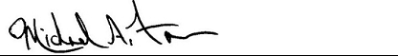

Michael Farr

Chief Executive Officer
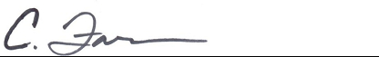

Christina Farr

Corporate Secretary

